.
Mission Statement
First United Methodist Church of Yankton:

“Our mission is to inspire all people to seek God, grow in their faith, discover their purpose, and serve others to make a difference.”

From the Pastor’s Desk
“I am the Alpha and the Omega,” says the Lord God, “who is, and who was, and who is to come, the Almighty.” - Revelation 1:8
Our church is currently in a liminal space. A liminal space is the time between “what was” and “what is to come.” This is a difficult space to be in because it is all about transition and change, which are two things extremely difficult for people to go through. While it is true that our life together is always experiencing change and growth, there are times where one thing ends and another begins, like chapters in a book. And it can be hard to navigate the space between, as one is ending and another has yet to begin.
But as Christians, we navigate liminal space every year as we enter into Holy Week. We begin the week with Palm Sunday, a joyful celebration as Jesus enters into Jerusalem amidst shouts of joy. He is welcomed into the holy city on a donkey - reminiscent of a royal triumphant return. This is how we want the culmination of Jesus’ life to go - the king of kings returning to the royal city to establish the reign of David forever. We want to stay in this moment, and perhaps Jesus had a part of himself that wished he could stay in that moment as well.
But then we enter into Holy Week. Jesus teaches at the temple, challenges the money changers and throws some tables over in righteous anger. His popularity and influence threaten the leadership enough to act to be rid of him. And Jesus knows what is coming and in doing so, teaches us what to do in liminal space.
He gathers his disciples together and breaks bread with them. He serves them. He washes their feet. He teaches them about what is to happen. And then he goes and prays. This is what he chooses to do in the time of his ministry ending and his death impending - a very real liminal space. Things are about to change drastically for him and for his disciples. And he chooses to spend that little time left gathered with the people he loved and in prayer.
If you are feeling stressed and anxious about the changes coming, that is normal and expected as we navigate through this liminal space. However, I invite you to follow in the footsteps of Jesus to spend this time gathering with the people around you, loving and serving one another and then to spend time in prayer. Liminal spaces can feel like they will last forever, but they don’t.
Easter Sunday brings with it a dawn of a new era, a new life, and new possibilities that the disciples had never imagined possible. The change they had experienced with Jesus’ suffering and death was painful but through that change they were given a new start. And that is true for this church as well. Pastoral transitions can be hard and painful full of anxiety and wondering what will come, but we serve a God of resurrection and new life. With each change and transition, possibilities abound.
So as we celebrate Easter this year, let us remember that there is always reason to hope. God will bring us through these liminal spaces into abundant life. Thanks be to God!

Happy Easter!

Pastor Katie

Easter Extravaganza
*Following Church Service*
The youth group will be helping with our annual Easter Extravaganza after church on Sunday, Mach 29th. All children aged birth-6th grade are invited!!

- Easter Egg Hunt
- Games
- Easter Activities

Maundy Thursday
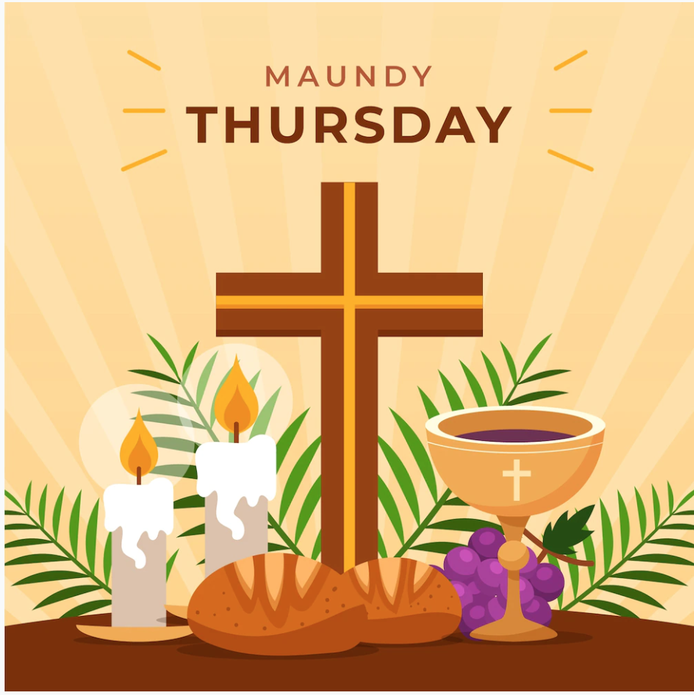
You are invited and encouraged to attend our Maundy Thursday service on April 2nd at 7pm. On this night Christians commemorate the supper Jesus shared with his disciples before his crucifixion, when Jesus washed the disciples' feet and instituted the Sacrament of the Lord's Supper.

Good Friday

You are invited and encouraged to attend our Good Friday service on April 3rd at 7pm. This will be a Tenebrae service that recounts the final moments of Jesus’ life and his crucifixion. All are welcome to attend and then to leave the worship service in silence.

Confirmation Sunday
We will be celebrating confirmation on May 3rd in the 10am worship service. Please plan to come and be witness to the amazing commitment these young people will be making in the service that day.

No Confirmation during Holy Week!
Confirmation students are required to attend at least one of the Holy Week services. Options are Maundy Thursday at 7pm or Good Friday at 7pm.

Office Closed
The church office will be closed Monday, April 6th.

Pastor Book Club - April 27th, 7pm

This will be the FINAL pastor book club and we are going to end with a classic! CS Lewis’s The Chronicles of Narnia: The Lion, the Witch, and the Wardrobe. The Lion, the Witch and the Wardrobe is a classic children's fantasy novel by C.S. Lewis, the first published book in The Chronicles of Narnia series, about four siblings who discover the magical land of Narnia through a wardrobe, where they must help the great lion Aslan defeat the evil White Witch who has trapped the land in eternal winter.
The story follows the Pevensie children as they fulfill a prophecy to restore spring and Christmas to Narnia, encountering mythical creatures and facing a great sacrifice. Read this children’s class with fresh eyes to how Lewis shared the Christian faith with many generations.

New Sunday Morning Class - Starting April 12th!
Everywhere is Jerusalem by James C Howell
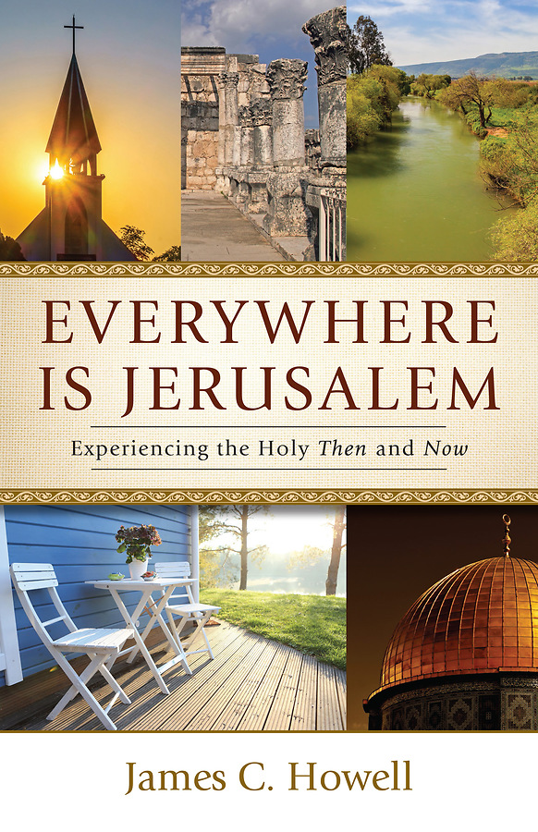
Christianity isn’t a batch of spiritual thoughts or metaphysical truths. It’s a journey of real people with their feet on the ground in real places. In Everywhere Is Jerusalem, James Howell takes you on a spiritual pilgrimage to significant places in the ongoing story of the Christian faith. You’ll go from Bethlehem to Jerusalem, from the Jordan River to Assisi, and from the Sea of Galilee to Montgomery, Alabama. Along the way, you’ll discover the profound connections between biblical stories and the places they happened. You’ll see how Christians throughout history have brought their faith to life worldwide, in their own cities and communities.
And you’ll find God calling you to bring your own faith to life right where you are, right now. Part travelogue, part Bible study, this book will take you on a spiritual journey to the places that are most important in our faith, and you’ll discover that the most important place of all is the place where you are, right now.
You can purchase your own book or order one from the church for $16 a copy. Let Pastor Katie or Lisa in the church office know. Class begins on April 12th at 8:30am.

Modern Worship Service

At First UMC!

First UMC has a modern worship service on Sunday nights at 5:30pm called The Living Light. This service will feature modern worship music (in video format), videos, scripture, prayer and preaching. It is a simplified format meant to engage people of all ages. We will still retain our Sunday morning traditional worship at 10am along with our other programming. If you struggle to make it to church on Sunday mornings, give this service a try! There isn’t a better way to start your week than worshiping God! Invite your friends to check it out! If you’d like to help volunteer to greet, usher or technology for this service, please let Pastor Katie know! Please note there will be no Living Light service on Easter (April 5th).

Volunteer Opportunity: Fellowship Coordinator

First UMC is in need of a Fellowship Coordinator that can help to recruit and train fellowship hosts for our Sunday services. This role would also include monitoring and ordering supplies for the kitchenette near the lounge. If fellowship is something you value in our church, please consider taking on this vital role. Talk to Pastor Katie or a member of SPPRC for more information.

United Women in Faith
Our March meeting of United Women in Faith is scheduled for April 6th. We meet at 1:30pm in the church lounge (right behind the sanctuary). Our speaker will be Angie O'Conner. She is on the Board for the Community Gardens here in Yankton. Carolyn DeRoos and Lydia will be the hostesses. Come and enjoy hearing from our speaker and a little church fellowship

Take Me to Your Leader Potluck
We had such a nice time at the last potluck that we are going to start a quarterly potluck every three months. The first one will be on Sunday, April 19th immediately after the church service. We will have Leadership Team Q & A to kept you up to date on things the Leadership Team has been doing.

First UMC Healthy Gardens Blessing
Join us following Sunday morning worship on April 26th for a blessing of our garden plots. They are located in the Yankton Healthy Gardens on West City Limit Road just north of the dog park. If you are interested in helping with the garden plots over the summer and fall, please contact Dan and Marilyn Elwood.

Bob Cappel Memorial Litter Pickup
Litter Pickup on Wednesday, April 29th. Please mark your calendars and join us to help keep our section of Yankton clean!

Mission Moments
What a fun event – Valentine’s Day Dinner! The kids learned about serving others…..and the parents and members of the church were able to enjoy their excitement in wanting to make sure everyone enjoyed every bit of the dinner. Thank you to Brooklyn for masterminding the efforts! It was a great way to teach youth about servanthood and stewardship.
And youth just keep on giving – the 5th grade class made bags for St. Patrick’s Day to be distributed at Loads of Love. The bags were filled with some miscellaneous food items.
Loads of Love continues to grow and increase in numbers and needs.
Please consider signing up to help on one of our nights. The signup sheet can be found on the missions table. The next opening is on March 31st. It goes from 4-6pm. And it’s as easy as putting the coins in the machine! Check out the list of dates and find one that works for you….and a friend or family member.
The community garden is just around the corner and WE NEED YOU! This is a great church project that feeds so many – salsa sales, church members – fresh produce, care casseroles, and even some of those in need served through various food organizations throughout Yankton.
Thank you to all that are always so giving of their time that makes these things happen – your time means so much!
Speaking of volunteering – Volunteer Appreciation is in April – stay tuned for more information on a day that we will celebrate YOU!
And also coming soon – a fundraiser so that we can keep on giving to our community!
Thank you!
Carla Hummel, Mission Coordinator

FUMC Leadership Meeting Minutes

March 22, 2026
Members in attendance: Pastor Katie Ricke, Diane Kisch, Laura Slowey, Bob Thue, Dan Johnson, John Schaefer, Jeannette Schaefer, Laurie Bailey, Scott Giziewski, Tammi Downs, Mikael Pietila (Steve King, Marc Mooney, Molly Hanse not in attendance.)

Recited Vision and Mission Statements

Opening prayer by Pastor Katie

Motion by Dan Johnson to approve minutes from last month. Laura Slowey seconded. Motion passed.

Motion by Bob Thue to approve financial report. John Schaefer seconded. Motion passed.

Trustee Report
John reported that parsonage is measured for carpet. Waiting on budget to continue to next step – picking carpet and figuring out date for installation. Katie let us know there was an issue with the back porch light. She thought it was a burned-out bulb but changed it and it still did not work. Scott let us know that there may have been problems dating back to Pastor Ron. They will look into it. Talked about putting line item in church budget for parsonage improvements. It was brought up that flame (FUMC cross and flame) is not glowing as bright as the cross. Laurie will contact Mayer Signs about possible bulb replacement.

Finance Report (Laura)
Reminder to fill out the survey Katie sent for the Generosity Grove Church Development Program. (We are the PILOT!) Thereafter, Dr. Alisha Vincent will work with her team to analyze and assess results and draft a strategic plan for our congregation. Think about who we’d like for a generosity team. (Must have minimum of 2-3, 4 is best. Must be able to talk to others about generosity and financial giving.)

Green Team
Dan let us know that April 29th will be litter pick up night. Roughly 20 people showed up for Hoppers at Cinema Magic. Many positive responses for the movie. “What’s The Rush?”, a film by Doug Tallamy will be screened at the church at 4 p.m. today. Rescheduled because of last Sunday’s weather.

SPPRC
Mikael brought up some concerns and questions that were passed along to her. We are hoping with our quarterly potlucks, people will take the time to chat with the leadership team about those things. April 19th after church, “Take Me to Your Leader” Q&A with the Leadership Team and potluck. Tiffany Beste is resigning so we will need to post a job opening for Jr/Sr High Youth Leader.

Pastor’s Report
After approving to go ahead with a contractor for cameras and security, we’re having a hard time getting ahold of him. Dan Swihart will attempt again this week, but may need to find another contractor if contact is this difficult. REMIND is not working like it used to. Does not push notifications. Need to look at other options to contact people in severe weather situations and other emergencies. The new worship service is going well. Would like more attendees but that will come with time hopefully. TALK IT UP!!!

Other Business
Next meeting – April 12

Closing Prayer by Pastor Katie

In Our Thoughts & Prayers
The family of Esther Kisch, Esther passed away,
The family of Rodger Johnson Jr., Rodger passed away, Carol Becker, Bill Fargo, Tyan Beste, Laurie Baily’s brother Charlie, Mary Alice Halverson, Russ & Mary Peirce, Sue Strasburg, Eric Nichols & family, Caitlin Jensen, Dawn Kabella, Connie Pruitt (Shirley Root's sister)

Church family serving in the military: all men & women serving in the military and their families.

April Birthdays

1 - Megan Sage

3 - Margaret Bartels, Levi Kabella,
Mary Pietila, Teresa Rentsch

6 - Mary Peirce

7 - Ben Mooney

8 - Ethan Ricke

10 - Derek Gravholt

11 - Chuck Nelson, Jace Hirsch

12 - Dena Den Herder

13 - Steve Jacobsen, John Schaefer

14 - Shirley Dangler

16 - Makayla Palecek, Owen Wieseler

17 - Laurie Baily

18 - Cory Frahm

20 - Alicia Cornemann, Verne Hanson

21 - Eunice Northey, Cyver Pietz

23 - Shayce Platt, Marc Mooney

25 - Leslie Johnson, Laura Johnson,
Darwin Koerner

29 - Paul Rolston, Karter Rolston

