.
Mission Statement
First United Methodist Church of Yankton:

“Our mission is to inspire all people to seek God, grow in their faith, discover their purpose, and serve others to make a difference.”

From the Pastor’s Desk
“And let us consider how we may spur one another on toward love and good deeds. Let us not give up meeting together, as some are in the habit of doing, but let us encourage one another - and all the more as you see the Day approaching.” -Hebrews 10:24-25 (NIV)
As the new year begins, these verses invite us back into the simple, powerful work of being a people together: noticing one another, encouraging one another, and turning our care into action. Community is not an add‑on to faith — it is one of faith’s primary expressions. Connection is the way God’s love moves from our hearts into our neighborhoods. Outreach is the fruit that follows when connection is steady and genuine.
It is my hope and prayer as we move into a new year together, we make community a priority in our faith journeys. In the winter months weather can often play a factor in our ability to gather together for worship, study or fellowship, but I would encourage you as much as you are able to make it to these offerings. The communion of the believers is foundational to our faith - we are not meant to live a life of faith alone. Faith cannot be sustained in that way. Rather, we need one another to grow, to encourage, and to serve. Every person is valued and important in the work that we do together as we seek to love God and love each other.
There are various ways that you can get involved in the community of faith here at First UMC. Sundays we have worship at 10am, but prior to the service there are a couple of options for study available. On the first Monday of the month our United Women in Faith meet at 1:30pm in the lounge for a time of learning and fellowship. On the final Monday of the month, join the Pastor Book Club (except for January when it’s on the 19th instead). On Tuesdays Pastor leads a Lunch Study at noon using videos for discussion.
Every other Tuesday you can head down to @ The Bar for Bibles and Brews led by Carla Hummel. On Wednesdays you can head to the church for our children and youth ministries (or help to volunteer at them!) Feeling musical? Join the Jubilee Bells Wednesday nights for rehearsal or the Chancel Choir on Thursday afternoons for rehearsal. On Thursday mornings a men’s group meets at Fryin’ Pan for study and fellowship. Every Third Thursday of the month the women of the church have Women’s Night Out – with a different fun activity every month. This is only some of what we offer - so find a way to plug in! If there isn’t something that works for you, let me know! I would love to create something that could reach people who aren’t currently being served.
The biggest blessing we have in the church is our people. Don’t miss out on this blessing but find ways to connect with one another. It is through this community that we can encourage one another and be encouraged by one another. It is through this community that we can serve and be served. It is through this community that we can learn and grow in our discipleship and help each other, as well as the next generations, know, love and follow Christ with all their hearts.
May 2026 be the year that this community of faith grows not just in numbers, but in depth of connection. May you all discover the love of God found in each other.

Blessings, Pastor Katie

Pastor Book Club: January 19th at 7pm
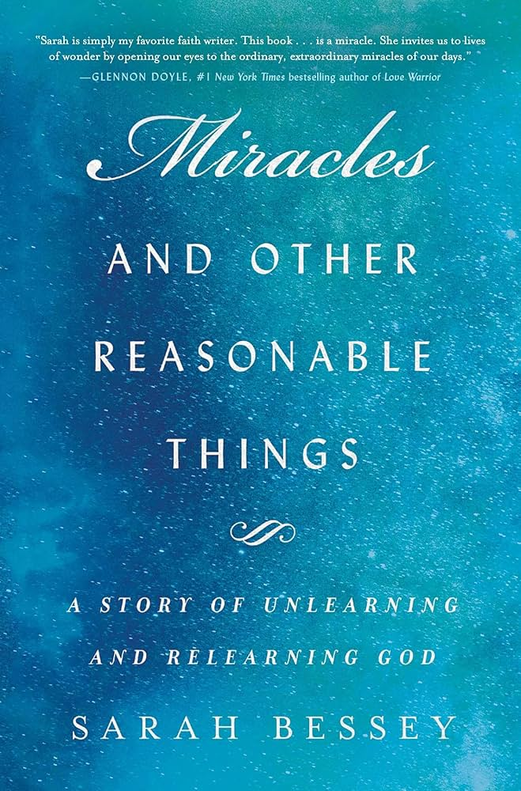
A deeply moving and life-affirming account of wrestling with faith and God and finding miracles in the most unexpected places.
In the brief instant Sarah Bessey realized that her minivan was, inevitably, going to hit the car on the highway on the bright, clear day of the crash, she knew intuitively that it would have life-changing consequences. But as she navigated the winding path from her life before the accident—as a popular author, preacher, and loving wife and mother—to her new life after, inhabiting a body that no longer felt like her own, she found that the most unexpected result wasn’t the way this shook her body, but how it shook her deeply rooted faith, upending everything she thought she knew and held so dearly.
Weaving together theology and memoir in her trademark narrative style, Sarah tells us the story of the moment that changed her body and how it ultimately changed her life. The road of healing leads to Rome where she met the Pope (it’s complicated) and encountered the Holy Spirit in the last place she expected. She writes about her miraculous healing, learning to live with chronic pain, and the ways God makes us whole in the midst of suffering. She invites us to a path of knowing God that is filled with ordinary miracles, hope in the face of overwhelming evidence to the contrary, and other completely reasonable things.
Insightful, profound, and unexpected, Miracles and Other Reasonable Things is a wild, spirit-filled story of what it means to live with both grief and faith, suffering and joy, as we wrestle with God.

Tuesday Lunch Study - Tuesdays at Noon Starting January 6th
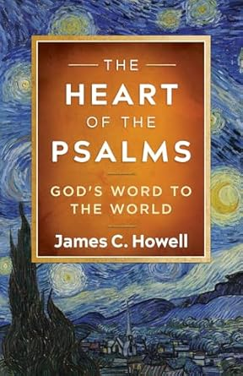
The Book of Psalms has been called a school of prayer, as these eloquent words to God become the Word of God for us and a road map to navigate life with God in this world. This study focuses on six psalms, each offering a unique glimpse into God’s heart: Psalm 8 (awe), Psalm 27 (beauty), Psalm 51 (mercy), Psalm 73 (surely), Psalm 90 (time), and Psalm 116 (love).
The Study examines why these six psalms connect so deeply with us, the church, and beyond. The text gives us a way to pray when words are hard to find, drawing from the hearts of real people seeking God. Go inside the world of these psalms, considering where they were written, their key phrases in Hebrew, and even the time of day they evoke. Throughout history, people have turned to these words at pivotal times, finding hope, comfort, and inspiration. The Heart of the Psalms will help you weigh why and how these psalms matter and how they can be transformative today for us, the church, and God’s world.

Sunday Morning Pastor’s Winter Class - Starting Sunday January 4th at 8:30am
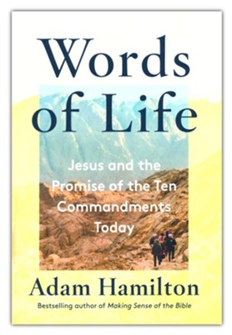
Nearly everyone has heard of the Ten Commandments, the list of “thou-shalt-nots” found in the Bible. Jesus saw these commandments not as onerous burdens, but as guideposts to help us experience a good and beautiful life. These ten ancient “words” were given to us by a loving God who longed to set safe boundaries, create order out of chaos, help communities live peacefully, and protect us—often from ourselves.
In this book of Scripture and inspiration, bestselling author Adam Hamilton brings modern eyes to the most important set of ethics in history. He considers the commandments in their historical context, considering the meaning of each commandment in Hebrew, unpacking how Jesus reinterpreted them, and showing how every thou-shalt-not was intended to point to a life-giving “thou shalt.” He also explores how the latest research in science and psychology illuminates these commandments, rightly understood, as a way of ordering one's life beautifully in the present day. In a culture marked by workaholism, materialism, and social media-driven envy, God has given us a time-tested path that leads to gratitude, confidence, and peace.

Pastor Katie Out of the Office
Pastor Katie will be out of the office from January 26-28th for the Board of Ordained Ministry Winter Meeting. Please be in prayer for the Board as they will examine the candidates for commissioning.

Leadership Team
Thank you to the members of Leadership Team who have completed their service to our church community: Eric Lancaster, Merle Brandt, Rhonda Arens, and Karen Miller. These four have gone above and beyond in countless ways over the last three years in service. We are proud to have Scott Giziewski returning to Leadership Team as part of Trustees. We are also grateful for new member Molly Hanse for taking on the Leadership Advocate role on Leadership Team. We still have two openings – one on Finance and one on SPRC to fill. These are needed positions so please prayerfully consider serving the church in this way. Ask any Leadership Team member and you will find out that the blessings outweigh the work they do together.

Worship Design Team
Pastor Katie is looking to put together a small Worship Design Team to help make our worship at First UMC the best it can be. This team will have input in the music, visual arts, special services, and creating a new kind of worship service for the church. If you are interested in knowing more about this group, there will be an informational meeting following church on January 11th, 2026.

United Women of Faith
The United Women in Faith meeting will be January 5th at 1:30. We meet in the lounge right behind the sanctuary. Our program that day is a pledge service by Diane. Lydia is our hostess.
Lydia Giziewski

Church’s Christmas Tear Down
Monday, January 5th at 1pm.

Retirement Potluck
Join us Sunday, January 11th after worship to celebrate Craig’s retirement. Bring a dish to share.

Hy-Vee Cards
We have cards in $10, $25, $50, $100 & $200 denominations. Our profit supports special projects for the church. If you have not been a regular purchaser, please consider becoming one. It is a good way of supporting our church at no cost to anyone.

Family Legacy
by Susan Thorson, Faith Community Nurse
Over the holidays we have gathered around the table having conversations about the past, the present and the future. We may have talked about our values and beliefs. We heard the stories, the achievements, and the struggles that provided us with our identity. We shared our family traditions including holiday practices and our customs. We talked about what the holidays mean to each of us. Discussions on our finances and stewardship probably come into the conversations. We focus on building strong relationships, good communication and ways we can promote a sense of belonging. There are all things that help us develop a family legacy. Today, we ask each of you to think about what you hope your legacy says about you and what you will leave behind. We aren’t just thinking about the money and the possessions we leave behind but the enduring qualities of our family. Here are some questions I have for you to ponder over in the New Year.
- Have you shared your life philosophy, what you have learned and your vision of the future?
- Have you documented your family history and written down your stories?
- Have you taught your children about wealth planning and practical life skills?
- Have you given them strong values and strong religious beliefs to live by?
- Have you given them skills to build a strong community that cares for and loves all people?
- There are probably many other questions to ponder over, but I want you to know it’s never too late to develop your family legacy. Begin today to think about what you want to leave for others.
Psalm 145:4
One generation shall commend your works to another, and shall declare your mighty acts.
Pass your legacy on as it will last for generations Peace be with you for the New Year!

Kids Hope USA Program
As we are nearing the end of this year and begin to prepare for the new year, January brings us National Kids Hope Mentoring Month. Mentoring is building life-changing relationships one at a time. A mentor shares his or her time to provide the love of presence and the hope for tomorrow. Our mentors for our 2025-2026 school year include Delores Moore, Karen Miller, Dave Cornemann and myself (Jill Wilson/sub for Dan Slowey). Please congratulate and thank our wonderful and dedicated mentors in January for National Kids Hope Mentoring Month. Also, we will be recognizing our mentors during worship sometime in January, with that date forthcoming soon.
Jill Wilson
FUMC Kids Hope Director

Amplify Media
Churches across the Dakotas now have a powerful new tool for ministry: the Amplify Dakotas Channel! Use the QR to sign up for free access! Or go to
www.dakotasumc.org/resources/forms/3142

In Our Thoughts & Prayers
Marilyn Elwood, Dee Carson, Esther Kisch Laurie Baily’s brother Charlie, Rodger Jr. Johnson (Mary Johnson’s son), Dan Slowey, Mary Alice Halverson, Russ & Mary Peirce, Sue Strasburg, Caitlin Jensen, Dawn Kabella, Connie Pruitt (Shirley Root's sister)

Church family serving in the military: all men & women serving in the military and their families.

January Birthdays

2 - Corinne Ditmar

4 - Kaleb Swihart

5 - Steve Pietila

6 - Tyler Kaiser

8 - Ken Bevers

- Cooper Cornemann

9 - Marlene Konopik

13 - Mary King

- Connie Sawatzke

16 - Scott Giziewski

- Paul Pietila

18 - John Wiechmann

19 - Mike Cauwels

21- Jean Droppers

- Kristi Hunhoff

- Rita Rolston

22- Angela Herrmann

- Linda Herrmann

23 - Carol Skonhovd

24 - Claire Mooney

25 - Tate Beste

- Brooklyn Glaser

- Jaxx Olson

- Randy Hummel

- Monte Schavee

- Abigail Ricke

27 - Rick Daugherty

- Carol Wiechmann

31 - Matt Pietz

- Julius Schaefer

