.
Mission Statement
First United Methodist Church of Yankton:

“Our mission is to inspire all people to seek God, grow in their faith, discover their purpose, and serve others to make a difference.”

From the Pastor’s Desk
For to us a child is born, to us a son is given; and the government shall be upon his shoulder, and his name shall be called Wonderful Counselor, Mighty God, Everlasting Father, Prince of Peace. -Isaiah 9:6
As we enter into the Advent season once again, I am always struck by the words of Isaiah, written 800 years before the coming of the Christ child. These words spoke of a longing for God to intercede in a broken world. They were words of hope that God had heard the cries of the people and was sending someone who could change everything.
Once again, I read these words of Isaiah and they are the answer to the very longings that I have in my own heart. It is clear that hundreds of years before Jesus came to Earth, the world needed him. People were lost, angry, bitter, oppressed, downtrodden and more. And it is clear to me that thousands of years after his coming, even though we have been given Christ, we are still a world full of people who are lost, angry, bitter, oppressed, downtrodden and more. And the answer is still the same: Jesus Christ. Isaiah longed for a day when the Messiah would come. Today, we long for a day when the Messiah would be followed.
Once again, as we look around the world, we need the Wonderful Counselor to guide us on paths of righteousness and love. We need the Mighty God to overthrow the powers that be in this world that cause more harm than good. We need an Everlasting Father whose love for us knows no bounds. And we need a Prince of Peace that can show us a way to live without war, without division, without sides, and without hatred. May we find in this Christ child the answers to our deepest longings and hopes. And may we truly celebrate all that God has done for us this Christmas.

Merry Christmas!
Pastor Katie

Pastor Katie Out of the Office
Pastor Katie is taking vacation December 25th -January 2nd and will be out of the office.

Advent Sunday School

Join Pastor Katie and newly hired Children’s Coordinator Brooklyn Glaser for a fun Advent experience! During the season of Advent (Starting November 30th) we will be doing a study for the whole family called The Heart That Grew Three Sizes which incorporates Biblical themes of the Christmas story with the classic children’s book How the Grinch Stole Christmas by Dr. Seuss. This study is for everyone from children to adults. It will be a fun, interactive and engaging experience. Each week will be a stand alone lesson, so no worries if you have to miss one or two! Come anyway! Sunday mornings from 8:30 to 9:30am starting November 30th .

NO December Pastor Book Club
There will not be a book for December for Pastor Book Club. We will resume in January. Let Pastor Katie know if there are any books you think we should be reading!

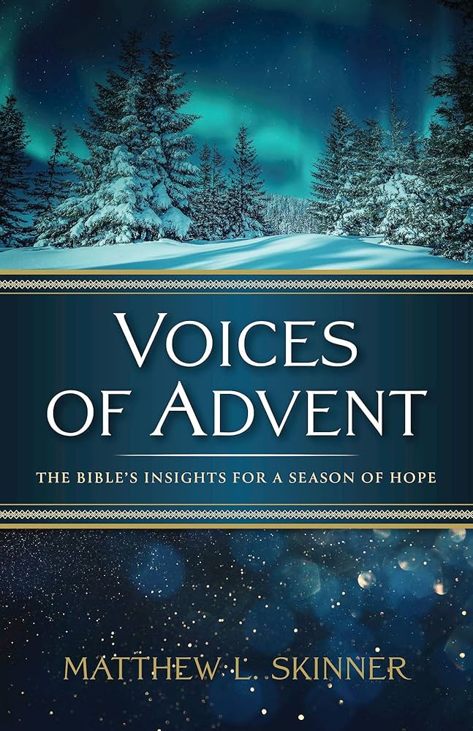

Tuesday Lunch Study - Starting December 2nd
Join us on Tuesdays at noon for an advent study on The Voices of Advent by Matthew Skinner. This class doesn’t require any outside work, just come to watch a video and join in the discussion!
In Voices of Advent, Matthew L. Skinner leads readers through biblical texts and explores how they shape our lives and Christmas celebrations. We listen as Jesus promises to return to us in the future, to John the Baptist as he prepares the way for the Messiah, to the faithful people and poets who anticipate the magnificence of Jesus’s birth, and to the angels and visionaries who praise God when Christmas dawns. Listen carefully to the Bible’s various perspectives that shape our preparations for Christmas; you’ll hear hope in all of them. Voices of Advent helps readers experience Advent not only as the start of the Christian Church Year, but also as the powerful overture that sets the tone for the incredible story of Jesus.
Thank you to the ladies who decorated the First UMC tree at the Mead Museum! Check it out and don’t forget to vote for your favorite!

All- Church Choir - Sunday, December 7th
We are looking to have a special choir performance in worship on Sunday, December 7th with as many people as we can fit in the front of the church. We will be singing The First Noel, and all are welcome and encouraged to join in this special event.
Invite your friends, your neighbors, your family and your coworkers to this special worship! We will rehearse Sunday, December 7th at 9:30am in the sanctuary.



Christmas Eve Services: 4:30pm and 7pm
We will hold two Christmas Eve services this year and no Christmas Day service. During the 7pm service we will offer Holy Communion along with the other Christmas traditions you have come to know and love. We look forward to celebrating the birth of our savior with all of you this Christmas Eve

Amplify Media Churches across the Dakotas now have a powerful new tool for ministry: the Amplify Dakotas Channel! Use the QR to sign up for free access! Or go to
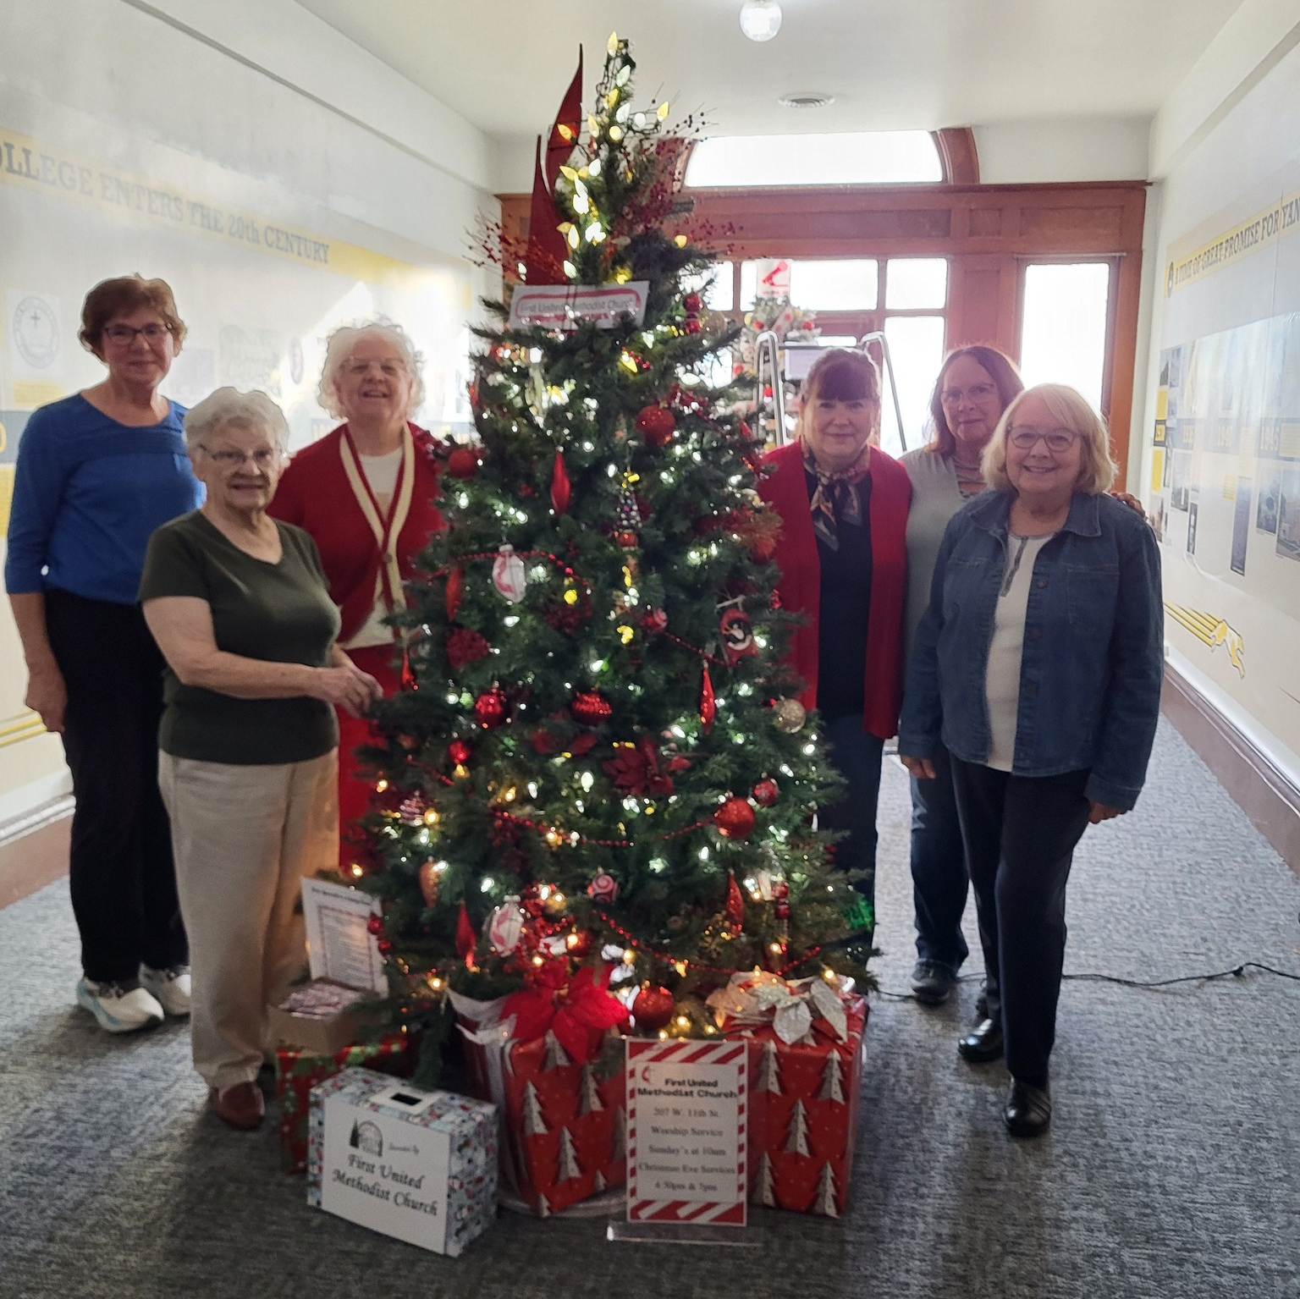
www.dakotasumc.org/resources/forms/3142


Leadership Team Update
The Leadership Team met on Nov 16th. Diane reported that our income is down a bit from last year but so are our expenses, so we are still in the black year to date with our operating budget.
The security task force is still working on collecting bids for the security system. The 605 program is looking at purchasing a GA-GA pit for the children to use inside the church and an energy efficient, upright freezer, the cost of these items will be covered by funds from the Richardson Investment with the Dakotas Foundation that is to be used every year for Children and Youth ministries.
Diane K reported that 60 estimate of giving cards were returned for a total of $268,039 in total pledges and there is a estimated negative budget of $83,826 in 2026. There was discussion on this topic and the need to inform the congregation of this deficit. Bob T made a motion to approve the 2026 budget. Laurie B seconded the motion. All Unanimously agree to accept the 2026 budget as presented.
Brooklyn Glaser was hired as the Children’s Ministry Coordinator with a start date of December 1. Craig Sherman’s position has been announced and working on best way to advertise this position, also Sara Klawonn, Worship Team Leader has informed Karen Miller she will be done in the near future.

SPPR – Leadership Team

I am pleased to announce that Brooklyn Glaser has accepted the position of Coordinator of Children’s Ministry. Our target date for her to start is December 1st.
We have an openings for Facility Manager and Worship Team Director. Craig Sherman has submitted his resignation effective December 31st. This is a part time position 20 plus hours per week with more hours required if special events, weddings or funerals are occurring at the church. The Worship Team Director is a part time position of 5 hours per week.
Please contact the church or Karen Miller if you need more information or would like to apply.

Dear Church Family,
I am grateful and honored for the opportunity to be able to serve as the new Children’s Ministry Coordinator. My desire is to cultivate a safe, nurturing, fun, and Christ- centered ministry where children can grow in their faith and experience the love of God. I am looking forward to being able to serve in this important ministry. Please feel free to reach out with any questions or ideas. Additionally, I would like to invite you to the Children’s Christmas Program on Sunday, December 14 held during worship time at 10 A.M. With refreshments to follow the service. The children have been working hard to share the story of Jesus’ birth through song and Scripture. We hope the congregation can join the children and celebrate the joy and wonder of Christmas together. Blessings, Brooklyn Glaser

United Women of Faith
The United Women in Faith meeting will be Dec 1, 2025 at 1:30. We meet in the lounge right behind the sanctuary. Please come share a Christmas memory and enjoy fellowship. If you'd like to bring a Christmas snack, cookies, treats to share and also think of a special Christmas story from your past to share. We will have a few Christmas games to play. Please come and join us at church. Prayers for your Christmas Holiday may we remember the Reason for the Season.

Lydia Giziewski

Gratitude by Susan Thorson, Faith Community Nurse
During the time I have been a faith community nurse I have had the privilege to be a part of the lives of many of you. I am very thankful to God who has guided me in this ministry. Not long ago I was asked “How did you know I was having a difficult day? I didn’t call you and I don’t think my family called you. But yet you showed up.” At times, it seems to be a mystery to me but I usually say “God places me where He feels I can be of help.” I am grateful for His guidance and presence as I journey with people in joy and happiness, in sadness and despair, in illness and good health, at birth and death and in just ordinary daily life. “Thanks be to God for his indescribable gift.” 2 Corinthians 9:15. There are times I have a plan on my visits but many times what my plan is to accomplish may not be the plan of the family or the individual. This is when God gently places the brakes on me, and asks me to do nothing but listen attentively. This too is a mystery to me and I am not exactly sure how it happens but it does. It’s almost like God is touching me on the shoulder, saying “Hey Susan, slow down, take the time to be ‘present’ in the moment.” I am in gratitude for this to happen as I minister to others. My heart is warmed with spontaneous prayer from family and individuals who pray for me and my family even when they need more prayers than I am worthy of receiving. Toward the end of our visits I often ask “What shall we pray about today?” Some will say “ I am going to have to think about this first.” Others will say pray for my health, pray for my wife who is my caregiver, pray for our nation, pray for peace and understanding, or pray for my doctors who are trying to put the pieces of my health puzzle together. The prayer time is a time we connect with our Savior. As we approach each day in good health or in times where our body, mind, and spirit aren’t always working together, we can always open our hands to God for help or in gratitude for how He has guided each of us to this point in our life. Each day is a gift and we must use the days to reach out to others and be the hands and feet of Jesus. Blessings to each of you. “Give thanks to the Lord for he is good; His love endures forever.” Psalm 107:1

Missions in Action!
Thank you to Scott & Beth Parr, Alicia Cornemann, and Jeanette Schaefer for serving at Loads of Love in November. They were EXTREMELY busy! We could feel the anxiety as many talked about the crunch of delayed assistance, reduced assistance, interruptions in paychecks and hours, and just the general feeling of wonder. As we all know – a car payment or a house payment/rent has a due date. Most bills have a due date…..but things like laundry or groceries – it is whatever is left in the budget (often not much). We are in need of 1-2 more volunteers on December 30th – this will be the last Loads of Love for the year.

HSC Patient Gift drive is finishing up and will be delivered soon. Thank you so much for your response on this drive. The box is overflowing and so are our hearts with the love of gifting to those in need. The 5th Sunday (Bucket Sunday) offering will also be going to this cause.

The Angel Tree is next! The names are ready so they will be up and ready to take. Don’t forget to sign up on the sheet next to the tree. We are hoping to have all gifts returned by December 10th. With a late Thanksgiving, this is a short shopping time. We appreciate your attentiveness to these needs as well.

Thank you for entering all of these mission fields and more!

Carla Hummel
Mission Coordinator

In Our Thoughts & Prayers
Dee Carson @ Sister James, Esther Kisch, Ken Bevers, Laurie Baily’s brother Charlie, Rodger Jr. Johnson (Mary Johnson’s son), Dan Slowey, Mary Alice Halverson, Russ & Mary Peirce, Sue Strasburg, Caitlin Jensen, Dawn Kabella, Connie Pruitt (Shirley Root's sister)

Church family serving in the military: all men & women serving in the military and their families.

December Birthdays
1 - Dustin Gusso

3 - Tyan Beste

- Loy Gravholt

4 - Liza Lancaster

5 - Merle Brandt

- Jordyn Cunningham

- Jane Gilmore

6 - Bonnie Gusso

- Shaylor Platt

7 - Mary Hladky

9 - Robert Burgel

12 - Mary Lepp

13 - Mike Miller

14 - Chris Jacobsen

17 - Steve King

19 - Jeff Skonhovd
- Nnea Garvey

20 - Jim Sawatzke
- Hali Hirsch

22 - Dan Guthmiller

23 - AJ Downs

26 - Dennis Kisch

- Brook Thurman

- Bailey Wieseler
27 - Jace Guthmiller

- Andrea Jaquith

- Madisyn Jaquith

- Gene Kisch

29 - Lance Palecek

30 - Susan Becker
- Linda Fox

2025 Income | Cash Flow
Month | Income | Expenses | Amount
January | $79,292.08 | $39,031.57 | $40,260.51
February | $34,378.71 | $29,067.56 | $5,311.15
March | $28,192.29 | $32,502.95 | ($4,310.66)
April | $28,262.38 | $26,597.62 | $1,664.76
May | $27,303.00 | $25,809.59 | $1,493.41
June | $26,086.07 | $34,262.32 | ($8,176.25)
July | $29,063.55 | $33,987.80 | ($4,924.25)
August | $25,051.33 | $27,234.45 | ($2,183.12)
Sept | $30,754.46 | $34,654.34 | ($3,899.88)
October | $29,189.83 | $26,190.37 | $2,999.46
Totals | $337,573.70 | $309,338.57 | $28,235.13
Projected 2025 Expenses are $425,605.22
* Income for January is generally higher than other months as we have some members that give their annual pledge in one month.

Poinsettia Order

Advent and Christmas are fast approaching. This means it is time to order poinsettias for the Sanctuary and around the church. This year, the cost of the plants will be $14.50 (6 ½ inch pot).

You may mail this form to the church office (First UMC, 207 W. 11th St., Yankton, SD 57078), bring it to the church office, or you may place it in the offering plate on Sunday and mark your envelope “Poinsettia”. Please designate if your plant is “In Memory” or “In Honor” of someone on this form. (Please check one so the office knows how to designate it for the bulletin insert.)

You may pick up your plant following the Christmas Eve Worship Service, or you may leave it here for the church family to enjoy. Please indicate whether or not you plan to take your Poinsettia home with you. Thank you.

Please turn in your order by December 7th

Your Name: _____________________________________________

(Please check one) _____In Memory of _____In Honor of

I will take the poinsettia I ordered: _______Yes ______No

Please enclose your payment of ($14.50) with this order form.

