.
Mission Statement
First United Methodist Church of Yankton:

“Our mission is to inspire all people to seek God, grow in their faith, discover their purpose, and serve others to make a difference.”

From the Pastor’s Desk
For this reason, I remind you to fan into flame the gift of God, which Therefore, since we are surrounded by such a great cloud of witnesses, let us throw off everything that hinders and the sin that so easily entangles. And let us run with perseverance the race marked out for us, fixing our eyes on Jesus, the pioneer and perfecter of our faith. -Hebrews 12:1-2a
Is it just me of does November get overlooked? For so many, November seems to be a buffering zone between the ghoulish antics of Halloween and the joys of the Christmas season. It is a time where many ask themselves, when is it acceptable for me to put up my Christmas tree? But in doing so, we rush over some very important holidays, recognitions and rituals that the month of November offers us. And I would suggest that we would benefit from giving November its proper attention.
First, in November we celebrate All Saints Day. All Saints Day, which was originally a major holiday for the church that ultimately spawned Halloween (All Hallow’s Eve), is a time when we honor and remember the saints that have gone before. In our worship, we offer time and space for those who have lost loved ones to honor them in the service. We name those who we have lost in the last year, and we also let everyone who is honoring and remembering a loved one to offer flowers in their memory. It is good for us to honor those who have gone before and paved the way for us. It is good for us to pause and be grateful for their lives and legacy that lives on in the kingdom work that they did and through the impact they made.
In November we also have Veterans Day in our country where we honor those who have served in the armed forces in times of war and times of peace.
It is again being aware of how what we have now has been made possible through the sacrifices of those who have come before and those willing to sacrifice on behalf of others. So, we recognize this service and offer gratitude.
This leads to what is arguably the most recognized holiday in November, Thanksgiving. At this point, I have argued that we should be giving thanks throughout the month for those who have gone before, but Thanksgiving is an opportunity to name the blessings that God has provided. We do this by gathering, by sharing a meal, and by intentionally saying our gratitude’s out loud.
I think it is incredibly important that we don’t skip over a month dedicated to recognizing our dependence on what others have done and recognizing our gratitude for what we have before moving into the Christmas season. It is good for us and our souls to be thankful and hopefully that will also move us to ask what kind of legacy and sacrifice God is asking of us. As we look to the future of our church, what are we doing and contributing so that future generations will look back on us and our time and be grateful?

Happy November!

Pastor Katie

New Member Class
Pastor Katie will be offering a three-week New Member Class following worship starting on November 2nd and will run through November 16th.

Help Decorate the Church!
We will need help decorating the church for Advent and Christmas. Advent begins November 30th this year, so we will plan to decorate the church on Saturday, November 29th at 10am. Please come and help transform our worship space for the season! The more hands, the lighter the load! Snacks will be provided.

Leadership Team Update
The Leadership Team met on October 5th following worship. The electronic sign sub-committee recommended a sign from Sign Tech which was approved by the Leadership Team. The funding for this sign and the laptop purchased to run it comes from a private donation and the memorial fund. This covers about 80% of the $6,000 total cost. If you would like to donate to the new digital sign, please stop by the church office or make a note on your donation for “digital sign”.

The financial report stated that we are still sitting positive for the year and that the staff and ministries are working slightly under budget. The Finance team is working on a proposed budget that will be discussed once the figures come in from the estimates of giving. It was also moved to remove the kiosk and text payment options from Vanco as they are not being utilized and we pay a fee to have them.

Carpet has been installed in two of the classrooms on the upper level of the education wing.

The Pastor’s Compensation Form was approved and will be voted on at Charge Conference.

Upcoming events noted at the meeting were Soup Kitchen, Trunk or Treat, and Fall Litter Pickup.

Leadership Team is working on prayerful recruitment to fill the upcoming openings hopefully to be approved at Charge Conference on October 28th.

Next meeting will be November 16th, 2025.


Amplify Media Churches across the Dakotas now have a powerful new tool for ministry: the Amplify Dakotas Channel! Use the QR to sign up for free access! Or go to
www.dakotasumc.org/resources/forms/3142

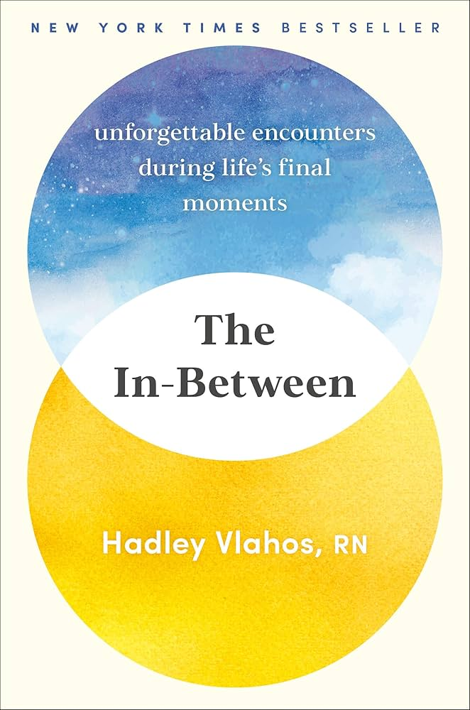
Pastor Book Club - November 24th 7pm
For November, Pastor Book Club will be reading The In-Between: Unforgettable Encounters During Life’s Final Moments by Hadley Vlahos, RN. Meeting Monday, November 24th at 7pm.
Talking about death and dying is considered taboo in polite company, and even in the medical field. Our ideas about dying are confusing at best: Will our memories flash before our eyes? Regrets consume our thoughts? Does a bright light appear at the end of a tunnel? For most people, it will be a slower process, one eased with preparedness, good humor, and a bit of faith. At the forefront of changing attitudes around palliative care is hospice nurse Hadley Vlahos, who shows that end-of-life care can teach us just as much about how to live as it does about how we die.

All-Church Choir - Sunday, November 30th
We are looking to have a special choir performance in worship on Sunday, November 30th with as many people as we can fit in front of the church. We will be singing The First Noel, and all are welcome and encouraged to join in this special event. Invite your friends, your neighbors, your family and your coworkers to this special worship! Look for more information in your bulletin in the month of November!

United Women of Faith
Please come join us for the United Women of Faith meeting Monday, November 3rd at 1:30pm. Our group meets in the lounge (behind the sanctuary). We have a short business meeting and some fellowship. Our program this month is World Thanks Offering & Memorial Service. All women are invited to come see what our group does!
Lydia Giziewski

Missions in Action!
Loads of Love – Thank you to those that have signed up. We are just short a couple volunteers for the December 30th date. It’s a great way of serving others!

Mead Museum – Christmas Tree – We would love to have your helping hands to decorate this year’s Christmas Tree. And if you are inspired by an idea – please share! We are going to try and set it up on Friday, November 14th in the afternoon.

5th Sunday offering – November 30th is a 5th Sunday and we would like to put some focus on the needs of the patients at the Human Services Center. We will donate the offering but would also like to put out a box for the following items:
Shirts, Sweatshirts, sweatpants (all sizes).
XL and XXL flannel shirts
Gloves and hats
Pajamas of all sizes
Socks (fuzzy and gripper)
Slippers
Lotion, body spray, hairbrushes, chapstick
Playing cards and board games
Fidget and sensory items
Stationary, art kits, activity books, and/or coloring books
Candy bars, snack cracker packs, individual sized chips, pudding, decaf pop, and sugar free sweets.
Note: No used items, no glass bottles, cans, mirrors, or anything with peanuts or caffeine per hospital policy.
Donations will be due by November 30th (day of the 5th Sunday offering).
Watch for the collection box soon after Halloween.

Angel Tree – As we get closer to Christmas, please keep in mind and memory that the Angel Tree will soon be going up! It’s an annual tradition you won’t want to miss!

Thank You
Thank you to all who gave us well wishes and helped us celebrate 70th wedding anniversary.
Gene & Esther Kisch

There is no greater gift than one which can lift up a child. On behalf of the Boys & Girls Club thank you for your gift of 263.68. Your support makes it possible for us to carry out our mission – to do whatever it takes to provide much needed care for our youth, helping them to reach their full potential and creating opportunities for a brighter future, not only for them, but for our entire community.
Jody Hernandez
Chief Executive Officer

We at the Yankton Area Banquet wish to thank you for serving our guests on September 18th. The generosity in sharing of your time and talents was appreciated very much!

In God’s Peace, Julie Stevens Correspondence Secretary

Thank you for your continued support. Your donation helps us serve the less fortunate.
Pathways

In Our Thoughts & Prayers
Mark Frahm, Dani Frahm’s husband, passed away.
Jan (Marilyn Elwood’s sister) passed away.
Rodger Jr. Johnson (Mary Johnson’ son), Laurie Baily’s brother Charlie, Dan Slowey, Ken & Judy Bevers, Mary Alice Halverson, Russell & Mary Peirce, Sue Strasburg, Caitlin Jensen, Dawn Kabella, Connie Pruitt (Shirley Root's sister)

Church family serving in the military: all men & women serving in the military and their families.

November Birthdays
2 - Monte Gulick
- Jo Watkins

3 - Sara Olson

5 - Alix Peterka
- Bailey Peterka
- Cassi Pietz
7 - Lisa Irwin
- Jim Strasburg

9 - Mary Olsen

10 - Suzanne Tessier

11 - Delores Moore

12 - Ellen Slowey

13 - Barb Hirsch
- Andrea Tramp

15 - Jenae Norton
- Warren Peterson

18 - Lily Lawrence
- Mary Malchow
- Jason Ricke

19 - Lara Cunningham

21 - Russell Peirce

22 - Craig Sherman
- Jane Walser

23 - Kenny Doering
- Shar Peterson

24 - Karen Miller
- Sue Strasburg

28 - Julie Moderegger
- Jerry Wilson

30 - JoAnne Roach

