.

Mission Statement

First United Methodist Church of Yankton:

*“Our mission is to inspire all people to seek God, grow in their faith, discover their purpose, and serve others to make a difference.”*

# From the Pastor’s Desk

*Therefore if you have any encouragement from being united with Christ, if any comfort from his love, if any common sharing in the Spirit, if any tenderness and compassion,**then make my joy complete by being like-minded, having the same love, being one in spirit and of one mind. Philippians 2:1-2*

One of the unexpected blessings of the summer was bookending the summer season with two outdoor, joint worship services with Trinity Lutheran Church and Yankton United Church of Christ. The first was a service celebrating and highlighting the work of Vacation Bible School, which has been a shared endeavor over the last few years. The second service again lifted up the importance of our children by including a backpack blessing as the students prepared to go back to school. Children is one ministry focus that is easy for churches to agree upon and gather around to support. And it was a blessing as a pastor, as a parent and as a Christian to see so many gather together, united not only in their love of Christ, but around a common cause.

Looking around the world and around our country, it is too easy to find examples of where people have set themselves apart from one another, have made enemies of one another, and have done harm to one another in the name of their beliefs, their politics and even their religion. Division has become normative for our culture and our world, and we, as the church, must live countercultural to this narrative. We must seek out the ways in which we are like-minded, grace-oriented, and committed to loving God and our neighbors. The services that we shared in this summer are only the beginning of ways that we can show our unity as Christians, within our own church, and with other Christians of other traditions. This year, we will continue to explore ways that we can come together, work together, and be in ministry together to a hurting world. But it begins with us, remembering that we have been united with Christ and therefore must operate out of the love of Christ, in unity with the Holy Spirit, toward the will of God. Let us shake off the temptations to focus on our differences and instead focus on the ways in which this community of faith, and this community of Yankton can work together to be a blessing to all.

John Wesley, in his sermon “A Catholic Spirit” says, “Though we cannot think alike, may we not love alike?” This was in response to the doctrinal differences so evident between the Roman Catholic believers and the people called “Methodist.” We may not agree on everything, but can we at least agree on loving? It is my hope and prayer that we, First United Methodist Church, will be the leaders in finding every opportunity to show the genuine love of God at every opportunity, even if it means setting aside some differences in order to do so.

So, here’s to another school year in the church and a new opportunity to share the love of God within the walls of this church and especially outside of the walls of this church.

Blessings,

Pastor Katie

# Sunday Morning Adult Study

Join Pastor Katie for 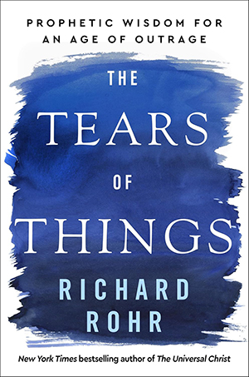a 10-week study based on the book *The Tears of Things: Prophetic Wisdom for an Age of Outrage.* This study will be Sunday mornings at 8:30am starting on Sunday, September 14th. You can order the book online or stop by the church office to order a copy. Deadline for ordering from the church is September 7th.

*How do we live compassionately in a time of violence and despair? What can we do with our private disappointments and the anger we feel in such an unjust world? In his most personal book yet, Richard Rohr turns to the writings of the Jewish prophets, revealing how some of the lesser-read books of the Bible offer us a crucial path forward today.*

# Tuesday Lunch Adult Study

Join Pastor Katie for a 7-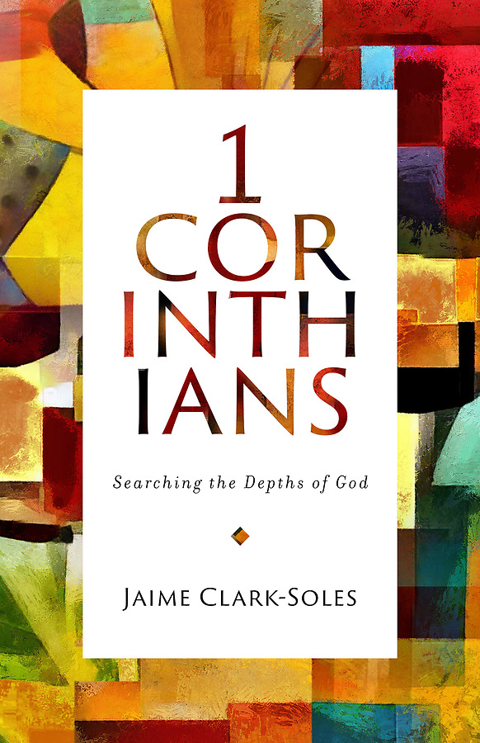week study based on the book of 1 Corinthians. Pastor Katie will be drawing from the book, *1 Corinthians: Searching the Depths of God* by Jaime Clark-Soles for this class. (This book is not required reading.) This class will be Tuesdays at Noon, starting on September 16th.

*In 1 Corinthians: Searching the Depths of God, Jaime Clark-Soles explores these topics and the awe inspiring, breathtaking world of the first-century church. Examining the teachings of Paul, she addresses church history, the logic of the cross, spiritual gifts, death, afterlife and the resurrection, human sexuality, and the joys and challenges of living in community.*

# Pastor Book Club

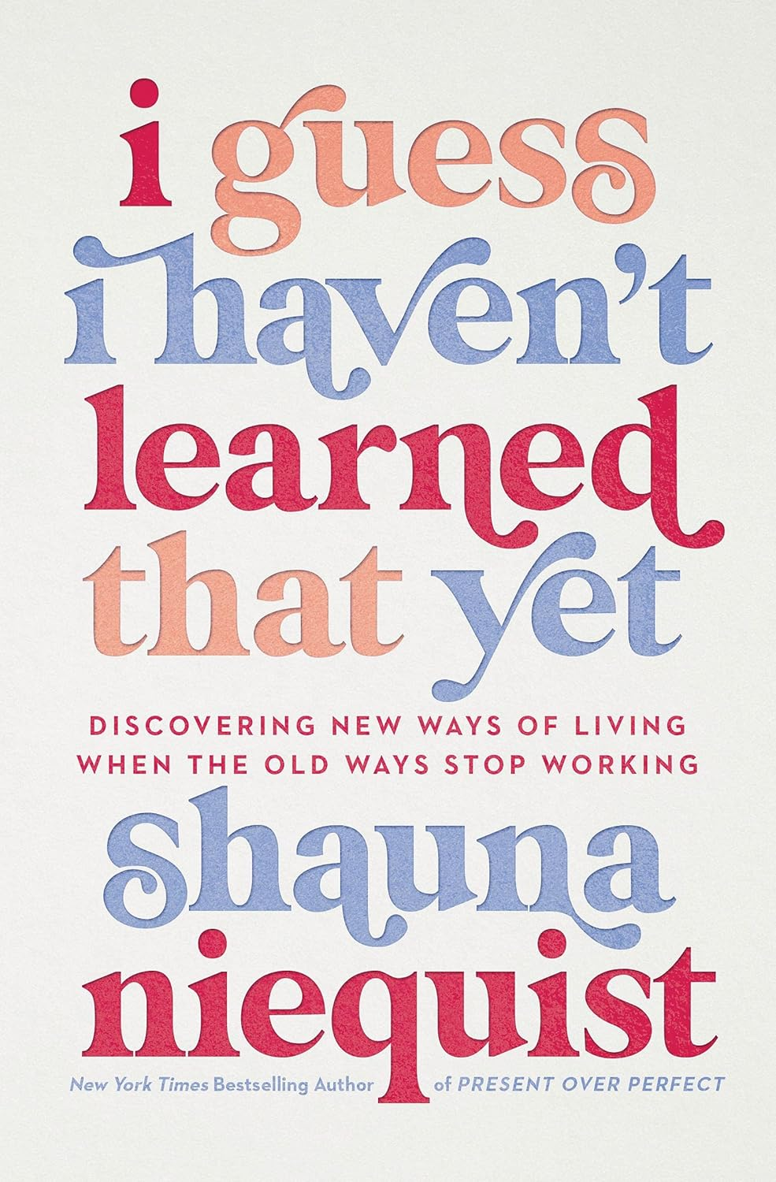Join Pastor Katie September 29th for the return of Pastor Book Club, a monthly book club where we will explore various authors and viewpoints from a Christian perspective. The Pastor Book Club meets on the final Monday night of the month at 7pm (unless otherwise advertised.) This month’s selection is *I Guess I Haven’t Learned That Yet: Discovering New Ways of Living When the Old Ways Stop Working*  by Shauna Niequist.

*Just after her 40th birthday, author Shauna Niequist found herself in a season of chaos, change, and loss unlike anything she'd ever faced. She discovered that many of the beliefs and practices that she usually turned to were no longer serving her.*

# Confirmation

If you have a student in 7th grade or above that hasn’t been in confirmation, let us know in the church office so we can order supplies. Open house for confirmation will be on September 3rd at 5:30pm. This is a great time to stop by, ask questions and learn more about the program. First night of confirmation will be Wednesday, September 10th starting at 5:30pm. Students will need to have a non-related church member as a mentor.

# Leadership Institute at Church of the Resurrection

Pastor Katie will be attending Leadership Institute again this year at Church of the Resurrection in Leawood, KS. This is a great opportunity for continued learning, inspiration and personal growth. Speakers this year include Adam Hamilton, Bishop Tracy Malone, Andy Stanley, Matt Miofsky, Jason Moore, and more! The cost is $349 to attend the conference and the pre-conference workshops. Pastor Katie will cover the travel expenses to and from the conference. Other expenses will include a hotel/airbnb for the duration of the conference. If you are interested in attending, please let Pastor Katie know.

# What’s Going On - Pastor Podcast

Tune into What’s Going on (found on Youtube or Spotify) in September! Episodes include:

* Interview with Laurie Bailey about 605 meals and redecorating projects in the church
* Interview with Carla Hummel, missions coordinator about serving the Banquet on September 18th
* Pastor Book Club - *I Guess I Haven’t Learned That Yet*

605

Parents & 605 Kids – plans are made for a fun year! We will have a meet/greet/registration on Wed., Sept. 3rd @ 5:30pm. The official kickoff for 605 will be Wed., Sept. 10th with a meal, music, lessons & crafts. Teachers for all grades are in place, but we could use some help in a few other areas. Thank you to the teachers, Laurie Baily, kitchen helpers and everyone else that makes 605 a success. If you are interested in helping with 605 please contact Karen Miller, Mikael Pietila, or Tammi Downs. Join us for the fun!

# Youth Group

Youth Group will start Wednesday, September 3rd! It will run every Wednesday from 7-8pm. Text @1fumcyouth to 81010 to receive up-to-date announcements and information.

# Youth Bell Choir

All 3rd grade and up are invited to be a part of the Youth Bell Choir. We will meet in the Music Room, starting Wednesday, September 10th at 4:50pm. We will have a great time learning to read music and play in church. Contact Jill Wilson if you have any questions.

# Jubilee Bells

Our adult bell choir that plays bells and chimes will meet on Wednesday nights from 6:00-7:00 starting September 10th. We have lots of fun ringing together and sharing our love of music with the church in worship once a month. Contact Jill Wilson if you have any questions.

# Chancel Choir

Chancel Choir offers opportunities for those who love to raise your voice in thanks and praise to God. There is a place for you in this music ministry.  If you have been thinking of joining the choir, or if you are new to town or to the church, the Chancel Choir family within our larger church family is an excellent starting point. We are eager for you to join us as we sing a wide variety of music from contemporary to gospel. Practice starts Thursday, September 11th at 4:00pm in the Sanctuary. **(Note time change from last year.)**

# Sunday Women’s Bible Study

All women are invited to join us for our fall study: A Jesus-Shaped Life by Lisa Harper. This study will explore how biblically sound theology deepens our relationship with God and each other.  Classes begin September 14th, at 8:45am

Please contact Marsha Bertsch  (660-5804) by September 1st if interested in purchasing an accompanying study guide.

# Yankton Area Banquet

On Thursday, September 18th our church is scheduled to serve the Yankton Area Banquet. We will serve meatloaf, cheesy potatoes, apple sauce and bars. We are seeking volunteers to help cook, serve and clean up. There are sign-up sheets located on the Missions table. If you would like to contribute monetarily toward the purchase of food, place it in an offering envelope and mark it banquet.

# Missions

**> Healthy Yankton Garden** – Please sign up to help!  We need you!  This is a great project for everyone to get involved with.  The watering has been made easy – special thanks to Elwoods and Schaefers!  The gardens are a mission of the church so please find time to be a part of the great things growing!

***\** Loads of Love** – Please sign up!  Once again – it’s easy!  Easy to serve people in such a meaningful way.  We ran out of funds this last time – luckily at the very end.  It’s as easy as putting coins in the machine and being there for conversations and just a heart to serve.  There are openings through the rest of the year – please check out the signup sheets on the Mission table!  September 16th, September 30th, November 18th, and December 30th .

**\*** August 31st – **Bucket Sunday Offering** for the Boys ad Girls Club of Yankton.

# KYNT Sponsors Needed

**Available dates are Sept. 21st & 28th.** The signup folder is located on the table in the Church Lounge. The cost to sponsor a Sunday broadcast is $45.00.

# Big Thank You

Our faithful counters are retiring on September 1st. Delores Kafka, Carol Peterson and Corinne Ditmar have counted and deposited incoming funds to our church every Monday for many many years.

Thank you to all 3 of you for your service and dedication to our church. We appreciate all you’ve done.

New counters start September 1st. They are Liza Larson, Paula Keehr and Jill Huetig, alternate Shar Peterson.

# Leadership Team Notes

Leadership team met on August 24th.

Dan & Marilyn Elwood presented info on a digital sign for the church. Trustees will follow up.

# Financial

2024 audit completed with no issues. Reviewed the financial statements for past 3 months. Funds for painting and decorating voted on.

# Trustees

The trustees have been very busy working on updates for cameras, front door locks, and elevator maintenance.

**SPPRC**

Coordinator of Children’s Ministry has not been filled.

Working on filling the position for Member Care.

**Children's and Youth Ministries**

605 will have a meet & greet on September 3rd and the official start date is September 10th. A special thank you to the teachers and helpers who have worked hard to get everything ready for the upcoming year.

Tiffany Beste is looking forward to another busy year with Youth Group.

**Green Team**

# Looking into some energy saving projects and making plans to do landscaping around church.

**Pastoral Report**

Pastor Katie expressed gratitude for her time off and is busy with church and conference duties.

Next meeting will be October 5th.

# Builders Club: Growing and creating new ministries

The Builders Club provides financial support to four churches each year as they undergo building, remodeling, or expansion projects. By granting funds to these churches, the Builders Club not only allows congregations to have new and updated spaces, but also lets them grow current ministries–or build new ones–to reach people in their communities for Jesus Christ.

In 1956, Lay Leader John Moshure had a vision of individuals across South Dakota joining together to support the building projects of United Methodist Churches throughout the state, and he formed the South Dakota Builders Club. North Dakota established their own Builders Club in 1963 to support their United Methodist Churches. In 1994, these two organizations merged to become the Builders Club of the Dakotas Annual Conference. Since the merger, over $900,000 has been distributed to United Methodist Churches across the Dakotas for building projects within their church communities.

If you would like to join Builders Club contact the Dakotas United Methodist Foundation by info@dkmnmf.org or phone 605-990-7790.

# Improving Spiritual Health

*by Susan Thorson, Faith Community Nurse*

Keeping our body, mind, and spirit is a full-time commitment. We’re always thinking of ways to improve our spiritual health along with our physical health. Can we do both at the same time in our busy lives? We can do this by being intentional and by planning ahead. There are many ways to improve our spiritual health, and this can happen with some ideas listed below:

Take time to pray every day in a quiet space. It is known that meditation helps our bodies relax which also is a great benefit for our hearts. By focusing on a prayer for the entire day, it can help clean our minds and give us a vision for the day.

As always, remember to attend church regularly where you can connect spiritually to the music and hymns, we share. Meeting new people at church opens our world to others and gives us a chance to make new friends and help feed our spirit. Really listen to the pastor’s message.

Going for a walk everyday helps our physical bodies stay healthy and contributes to our mental wellbeing and spiritual health. Seeing God’s creations in nature lifts our spirits. Do a prayer walk thanking the Lord for water, food, fresh air and shelter.

Working to make our world better and more peaceful through social justice issues like feeding the hungry, volunteering for good causes, and sharing meals with others helps feed our spirit. Be open to all people and those different from us.

These past weeks have been warm and humid. As we drink water during these times, it cleanses our bodies and restores us. Water helps replenish our spirit which is a part of our bodies.

Take time to rest and recover each day which means getting adequate sleep. While you sleep you dream which is essential for mental and emotional health, it helps our brains process our daily life experiences and consolidate memories plus helps us regulate our emotions.

The key components to spiritual health are finding meaning and purpose which gives us a sense of direction and feeling connected to something greater than we are. Spiritual health helps us have guiding principles like values and beliefs to live our lives by making good decisions and acting appropriately daily. Spiritual health includes looking ahead in challenging times for hope. Peace be with you and give yourself a boost in your spiritual life by practicing a few of these suggestions.

# Thank You

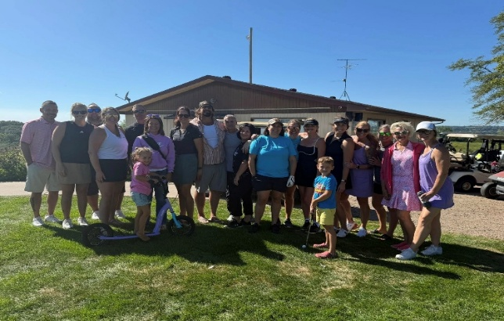

We want to thank the Men’s Bible study group for making and serving the food for the golf fundraiser in honor of our grandchildren for Cystic Fibrosis. Addi was also presented with her trip with Make a Wish! We appreciate all you did very much! You can check it out on Facebook, Kendra Baily page.

*Gregg & Laurie Baily*

# In Our Thoughts & Prayers

Ken & Judy Bevers, Mary Alice Halverson, Jan (Marilyn Elwood’s sister), Russell & Mary Peirce, Sue Strasburg, Caitlin Jensen, Dawn Kabella, Connie Pruitt (Shirley Root's sister)

Church family serving in the military: all men & women serving in the military and their families.

# September Birthdays

1 - Gage Guthmiller

2 - Ron Olson, Morgan Rodig

4 - Sam Mooney, Ken Olsen, Kylie Rodig,

Larry Guthmiller, Stetson Brandt

5 - Brinnleigh Novak

6 - Denise Erickson

7 - Harlan Teichroew

8 - Carol Becker, Brady Jaquith

10 - Lydia Giziewski

11 - Rick Petersen, Anna Nickles

13 - Anne Withrow, Tom Downs

14 - Lindsey Hale, Shirley Root

15 - Harper Den Herder

18 - Bob Walser

19 - Marilyn Elwood

20 - Chris Peterka, Chrissie Wieseler,

Brennan Novak

21 - Aron Eddy

22 - Arlys Cauwels

25 - Deklan Olson, Will Dangler

26 - Paul Nielson

28 - Julie Mudry

29 - Kami Cornemann, Dave Holzwarth,

Scott Enfield

