.***Reminder***

#### First United Methodist Church, Yankton

**May 28, 2025**

**Church Office: (605) 665-2991**

**1stumcyankton@gmail.com**

Mission Statement

First United Methodist Church of Yankton:

*“Our mission is to inspire all people to seek God, grow in their faith, discover their purpose, and serve others to make a difference.”*

**From the Pastor’s Desk**

*“Be still, and know that I am God.” -Psalm 46:10*

Many years ago, I counseled at a church camp where one of the crafts for the week was to design and paint your own prayer flag. That week, I chose to paint a sunset over the water as that was my favorite scene at Lake Poinsett Camp. I found the sunsets to be so peaceful and beautiful and a great reminder of all the beauty and wonder of God’s creation. And underneath that sunset I painted the words: be still and know that I am God.

As I enter into a time of renewal leave, that is my prayer for the summer - to be still enough to remember the truth that God is God and I am not. That whatever lies ahead for the church, for the community, for my family, and for me is not in my control, but God’s. It can be very easy for me and for other pastors to get into a place where we believe the success or failure of any ministry begins and ends with us. But the reality is that God is ultimately in control and that God is at work. And periodically, we need time to be still and remember that reality.

So, I invite you to take some time as well this summer, even if it is only for a day, or an afternoon, or even just a few moments to still your body, your mind and your spirit to remember that God is God. God sees and God knows whatever you worry about. God knows your thoughts, God knows your cares, God knows your joys. And that very same God is working for your good. Pause and take time to sit in that truth and to really let yourself believe it. And then live your life according to the truth you know.

I will be spending some of my renewal time in stillness. I will spend some of it with my family, intentionally creating memories together, and I will spend some of it in spiritual direction to help discern how God is working in me and how to best lead whatever comes next.

I thank you for your respect of my time away. My leave runs June 9th through August 3rd. There will be no What’s Going On podcast during that time.

The church is in good hands and you can read in this newsletter about some of the people coming to worship with you this summer. I hope you make a point to come hear what God will say though each one of them and welcome them in Christ’s love.

I look forward to being with you again in August, and until then - be still and know that God is here, God is good and God is with us.

Blessings, Pastor Katie

# Summer Guest Preachers

Rev. Dr. Joel Allen will be 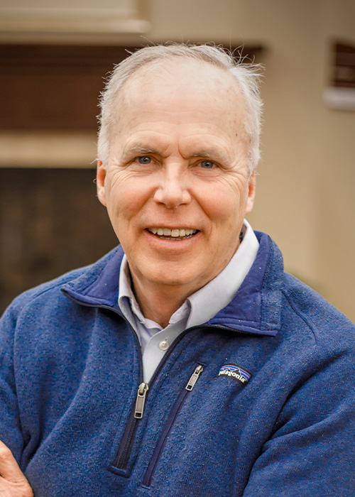leading worship multiple times this summer at First UMC. Dr. Allen is the Professor of Religion and Philosophy and the Director of the McGovern Center at Dakota Wesleyan University in Mitchell, SD. He is also an ordained elder in the Dakotas Conference of the United Methodist Church. Along with several articles, he is author of *The Despoliation of Egypt in Pre-Rabbinic, Rabbinic, and Patristic Traditions* and *Jewish Biblical Legends: Rabbinic Wisdom for Christian Readers*.

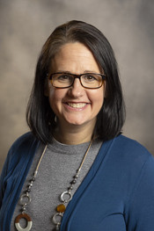Rev. Rebecca Trefz is the Assistant to the Bishop for Connection and Communications of the Dakotas Conference. A Yankton high school graduate and former District Superintendent for the Southeast District, Rebecca is no stranger to First UMC. Rebecca has also served the Dakotas Conference as the General Conference clergy delegate and brings with her a wealth of knowledge, not only as a pastor, but as an integral part of our connectional system.

Rev. Brandon Vetter currently serves as the Southeast District Superintendent of the Dakotas Conference. Previously he served as Senior Pastor at Bismarck Legacy Church, chair of the Board of Ordained Ministry, and in Campus Ministry at Dakota Wesleyan University. Brandon is pursuing a Doctor of Ministry from Fuller Seminary.

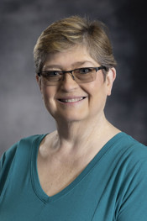Rev. Laurie Kidd is retiring this summer from full-time ministry after finishing up her last appointment in Hettinger, ND. Laurie is making her home in Sioux Falls, SD and is looking forward to supporting ministry in retirement. Laurie has a special gifting in music that has been used throughout her ministry to the delight of her congregations.

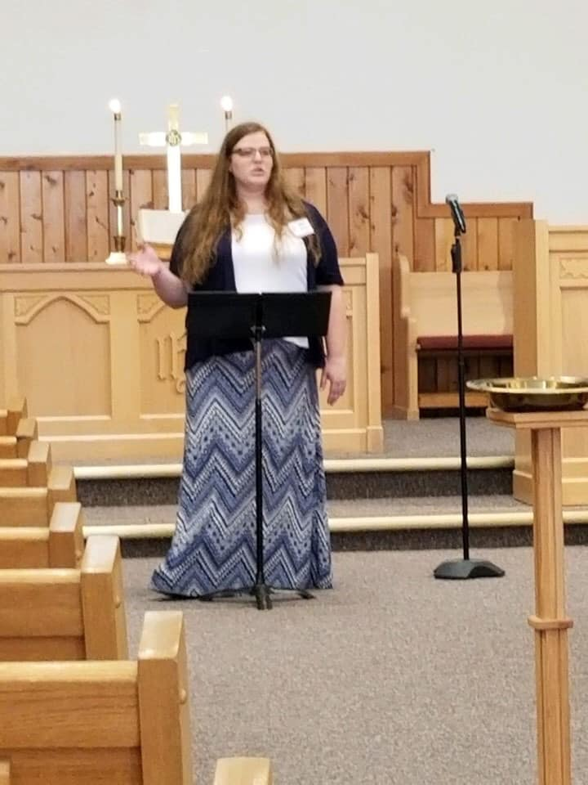Allison Jensen is a candidate for ministry from Beresford, SD. She is currently in the candidacy discernment process for ministry through the Dakotas Conference with Pastor Katie serving as her mentor. Allison currently works for Head Start in Vermillion, and will be going before the District Committee on Ministry this fall. She has preached in Beresford, Gayville and Spearfish UMCs.

# Pentecost Sunday

We will be celebrating Pentecost on Sunday, June 8th. Please wear red (if you have it) to worship that day as a part of the celebration. If you don’t have red, any color representing fire would be appropriate.

# Mission Moments

Check out the Missions table!  UMCOR is a great way to impact others when they need it most.  There are some handy shopping lists so that you can help put together a few kits or help fill the basket.  There will be a donation coming up as well.  Check out the information on what this means for those they serve….correction that we all serve with our contributions.  Thank you for your generosity!

Loads of Love – We NEED You!  In groups of 3-4 or individually, we need people to sign up and volunteer to help.  It’s as easy as putting coins in a machine and talking to a few people – brightening their day one load of laundry at a time.  We supply the coins.  You supply the hands that put the coins in the machines.  It’s an easy way to help those in need – right here in Yankton!  This ministry has definitely witnessed an increasing need.  Your help is greatly appreciated!  If you are wanting to donate – Laundry detergent needs to be the PODS.  Dryer sheets work well.  And of course – monetary donations – write it to the church with Loads of Love designated.  Thanks again for your generosity!

Healthy Yankton Gardens – What a great ministry that impacts so many!  And we have great leaders putting tools in place to make it even easier to volunteer.  Watch for the sign up – it will also be located at the mission table.  Come join us in being a part of the gardens and all that they serve as well!

What an amazing church!  Filled with servants of all kinds!  Thank you for living John Wesley’s quote:  Do all the good you can. By all the mean you can. In all the ways you can. At all the times you can.  To all the people you can. As long as every you can.

# Pathways Shelter

Pathways Shelter for the Homeless provides compassionate care to individuals and families experiencing homelessness in our community. Last year, 90 children were sheltered with their families. Most of these families had a prior address in Yankton. In addition, Pathways assisted 45 individuals in avoiding homelessness.  The public relations team at Pathways desires for Yankton Community Churches to unite in lifting up our shelter in prayer!   During the month of June, please pray for Pathways: for the staff, that they might be wise and encouraged; for the clients, that they would find hope for a better future. If you would like to support Pathways financially: please fill the banks on the Missions Table with coins, cash or a check.  These will be available on the Missions Table starting in June. Thank you so much for your support.

# Summer Camp Information

Even though the Early Bird deadline is past you can still register for camp. The cost would be at full price. The church and UWM will still cover ½ of the early bird cost for one camp per youth (K-12th grade) you are responsible for the balance.

# God’s Creations

*by Susan Thorson, Faith Community Nurse*

During this past weekend, the rain finally came to areas of South Dakota, Minnesota, and Iowa. I remember as a child living on the farm we prayed for rain after my father and brothers planted the crops. There were times we’d wake up in the night hearing the rain and would meet in the kitchen to rejoice over the rain. Some years the rain came at the right times and other years we experienced droughts. After the rains we as children often took turns going out to the rain gauge to see how much rain God blessed us with. After the rain, we would all pile in the car and go look at the crops. Oftentimes, we would end up at a neighbor’s home to visit and replenish ourselves with good conversation and a special treat. On these tours around the farm, I was and still am amazed at the freshness the rain brought to the fields of grain, the trees in the shelterbelts, and to the gardens. Often clouds parted and the sun came out so we would see a beautiful rainbow in the sky.

God’s creations are filled with fullness by the sights, sounds, and smells after a rain. In our busy days of working, caregiving, and just maintaining our own lives we don’t see what God has provided for us. So, this week I want you to take some time away from your busy lives and really look at God’s creations in nature. Notice the bright green colors of spring, the plants coming up in the garden, and the trees and flowers blooming. Listen to the sounds of spring as you walk. Maybe it’s the gentle breeze through the pines, the many birds singing , the buzzing of bees or the water gently flowing down a stream.

Genesis 1:29-31 God said, ‘See, I have given you every plant yielding seed that is upon the face of the earth, and every tree with seed in its fruit; you shall have them for food. And to every beast of the earth,and to every bird of the air, and everything that creeps on the earth, everything that has the breath of life, I have given every green plant for food.’ And it was so. God saw everything that he had made, and indeed, it was very good. God, we thank you for the sights of an incredible world, the sounds of your creation, and the fragrances we smell to fill our world. May our senses bring awareness to your greatness and what you have provided for us. In your Holy Name, Amen. Blessing to each of you.

# Thank You

Thank You Dani Frahm has resigned from her position as Parish Member Care Coordinator effective May 31st. Thank you Dani for all the work you’ve done coordinating our coffee fellowship after church, lining up greeters & ushers and caring for our members. We appreciate all you’ve done.

# In Our Thoughts & Prayers

Russell & Mary Peirce, Sue Strasburg, Caitlin Jensen, Dawn Kabella, Connie Pruitt (Shirley Root's sister)

Church family serving in the military: all men & women serving in the military and their families.

# June Birthdays

1 - Laura Gulick

2 - Anna Sawatzke

3 - Analis Dannen

4 - Kristi Peterka

6 - Jacko Noecker

7 - Elliotte Lancaster

10 - Becki Stoddard

11 - Reid Sawatzke

12 - Jill Huetig

13 - Norma Christensen

- Virginia Larson

- Mark Nickles

14 - Jeannette Schaefer

15 - Kathy Fiscus

16 - Kami Guthmiller

- Carol Hesla

17 - Gena Brandt

18 - Patsy James

19 - Brooke Lancaster

20 - Ken Bertsch

- Jimmie Cunningham

- Anabelle Taylor

- Nicholas Taylor

22 - Sandy Skinner

- Bode Thurman

26 - Lesley Hale

- Kristi Palecek

- Birch Hilton

27 - Erica Garvey

- Rynne Garvy

28 - Lonnie Root

29 - Val Tieszen

30 - Tom Gilmore

- Shana Platt

- Greg Gusso

