.

Mission Statement

First United Methodist Church of Yankton:

*“Our mission is to inspire all people to seek God, grow in their faith, discover their purpose, and serve others to make a difference.”*

# From the Pastor’s Desk

*The Ninevites believed God. A fast was proclaimed, and all of them, from the greatest to the least, put on sackcloth. When Jonah’s warning reached the king of Nineveh, he rose from his throne, took off his royal robes, covered himself with sackcloth and sat down in the dust. - Jonah 3:5-6*

On March 5th we will observe Ash Wednesday and begin the penitent season of Lent in the church. While many of you may be familiar with Ash Wednesday and its observance, I wonder how many know how it came to be and why we do what we do on Ash Wednesday. So, this is a little primer on Ash Wednesday that you can read before joining worship on March 5th at 7pm at First UMC.

Ash Wednesday is the first day of the season of Lent, which marks 40 days prior to Easter. This count does not include the Sundays because they are always a celebration of the Lord’s day. On Ash Wednesday, Christians from all around the world share in some common practices, the most well-known is the placing of ashes on the forehead of believers in the shape of a cross. But why do we do this?

The ashes represent two themes prominent on Ash Wednesday: our own mortality and repentance. When we receive the ashes, we hear the words, “Remember that you are dust, and to dust you shall return.” In the creation account found in Genesis 2, we read, “then the LORD God formed man from the dust of the ground and breathed into his nostrils the breath of life.” (Genesis 2:7) Just as we were made from the dust, we will return to the ground when we pass away. Ash Wednesday is a reminder that our lives here are limited, and we must not delay in doing what is right.

The second theme is repentance. Ashes were used as a sign of repentance throughout the Bible, and I have shared one from Jonah at the beginning of this article.

To wear dust or ashes is a sign of humility and repentance for the sin and wrongdoing we have committed. It is a visible sign of inward, spiritual contrition.

So, when we come on Ash Wednesday to receive the ashes, we are to confess our sin, repent, and remember our own limitations in this life. This practice then leads into a season called Lent where we spend this time in self-reflection, deliberate spiritual disciplines, and perhaps some kind of fasting. I would recommend adding into your lenten practice (if you have typically observed Lent by giving something up) some kind of spiritual discipline. Perhaps find a Lenten Devotional to read each day or pick one of the other spiritual disciplines: prayer, worship, or service to add into your life for the next 6 weeks.

During Lent, I will be preaching a series looking at the people who would have witnessed Jesus’ death on the cross and what we can learn from them as we contemplate the life, death, and resurrection of Jesus. May this season be fruitful for you as you devote yourself wholly to the Holy Lord, our God.

Blessings,

Pastor Katie

# March Pastor Book Club - March 31st at 7pm

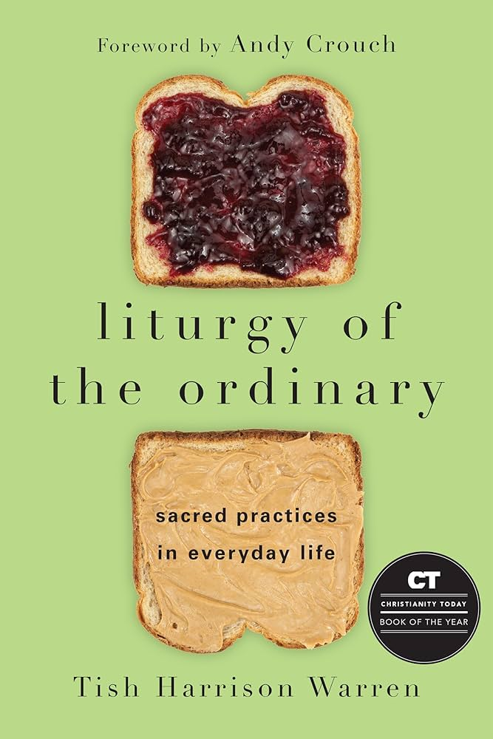Join Pastor Katie for Pastor Book Club as we read *Liturgy of the Ordinary: Sacred Practices in Everyday Life* by Tish Harrison Warren. We will gather on Monday evening, March 31st at 7pm at First UMC to discuss. All are welcome!

In the overlooked moments and routines of our day, we can become aware of God's presence in surprising ways. How do we embrace the sacred in the ordinary and the ordinary in the sacred? Framed around one ordinary day, this book explores daily life through the lens of liturgy, small practices, and habits that form us. Each chapter looks at something―making the bed, brushing her teeth, losing her keys―that the author does every day. Drawing from the diversity of her life as a campus minister, Anglican priest, friend, wife, and mother, Tish Harrison Warren opens up a practical theology of the everyday. Each activity is related to a spiritual practice as well as an aspect of our Sunday worship. Come and discover the holiness of your every day.

# Tuesday Lunch Study 91Y4IxYOX-L.jpg- Starting March 4th!

Join Pastor Katie on Tuesdays at noon for a new series by United Methodist Bishop Tom Berlin called *Reckless Love: Jesus’ Call to Love Our Neighbor.* All are welcome!

In his exploration of Jesus’ teaching and travels with his disciples, Berlin suggests that Jesus teaches us how to love God with heart, soul, mind, and strength by showing us how to love our neighbor. While many hope to learn to be better family, friends, leaders, and neighbors by finding a deeper relationship with God, what if becoming a better neighbor leads you to that deeper love of God?

In Reckless Love, you will consider your life, and learn how loving the people around you will completely renew your faith and give you a new experience of loving God.

This is a VIDEO SERIES! NO READING REQUIRED!

# Camp Registration is OPEN!

During March we will be celebrating our United Methodist Camping Ministries and encouraging children, youth and adults to sign up for camp! The Dakotas Conference has 3 United Methodist camps: Lake Poinsett Camp, Storm Mountain Center, and Wesley Acres Camp. Each site offers unique opportunities for campers of all ages. Camp brochures are here – if you did not get one in the mail, you can find them in the lobby downstairs.

The deadline for the Early Bird price is April 30th.  Don’t forget that the church will pay 50% for all children to attend one camp! If your youth is going to more than one camp, you are responsible for the cost of the other camps.  If you register after April 30th – the church & UMW will only pay for ½ of the early bird cost. You will be responsible for the difference between early bird and full price.

Call the office for the camping code so you get the discount when you register. You can register for camp online at:

<https://www.dakotasumc.org/camping>

# Pastor Katie Featured in Dakotas Conference Lenten Study

Pastor Katie was tapped to provide one of the weekly sessions for this year’s Dakotas Conference Lenten Study on the book by United Methodist Bishop Tom Berlin *Third Day.* Pastor Katie shares the first week’s sermon. You can access this series by going to the conference website at [www.dakotasumc.org](http://www.dakotasumc.org) or looking for the links provided in our First UMC Yankton Online Facebook Group. Call the church office for more information or if you need help accessing this Lenten resource.

# United Women of Faith (UMW)

United Women of Faith meeting will be March 3rd at 1:30pm.  Our program is to be Leah Biorn sharing about the "The Foster Closet".   Delores Kafka will do our devotion, and Lydia Giziewski is our luncheon hostess this month.  All ladies are invited to come, we meet in the lounge upstairs for this event.  Hope you can join us for this time of fellowship.

# Youth Group (7th-12th grade)

Every Wednesday evening from 7:00-8:00

To sign up for Updates and Information, text **@1fumcyouth** to **81010**

Please let Tiffany know if you have any questions

[1stumckidsyankton@gmail.com](mailto:1stumckidsyankton@gmail.com)

# Youth Bell Choir

All 3rd grade and up are invited to be a part of the Youth Bell Choir. We will meet in the Music Room, on Wednesday evenings from **5:00-5:30pm.** We will have a great time learning to read music and play in church. Contact Jill Wilson if you have any questions.

# Camp Scholarship Funds with the Dakotas Foundation

            This fund was established to assist youth with camping registrations and/or expenses. The main sponsor of this scholarship came from Ethel Schenk who originally contributed $3,750. This amount, along with other memorial gifts from various people who designated the funds to be used towards camp scholarships, made up the balance. This money is invested with the Dakotas Foundation. This money is intended to assist families that have youth (1st grade through graduating seniors) attending camp that express the need for additional financial support to cover their share of the cost.

Any family that would like a little extra financial help needs to fill out a Camp Scholarship Card located in the church office and place it in the decorated box by Sunday, April 20th.  It is the hope of the Finance and Education Committees that people will contribute to this fund and the size of our investment will grow so that the amount of money we are able to distribute grows.

# Mindful Eating

*by Susan Thorson, Faith Community Nurse*

Making healthy choices when it comes to eating makes a difference in our health. We need to be aware of our eating habits. By being aware of what we eat, how much we eat and making healthier choices is all a part of mindful eating.

First off, set times for meals and avoid distractions like television, cell phones, and video games. Share a meal with others. Think about where your food comes from and be thankful for those who provided the food for all of us. Most of us are on a schedule so we want to eat fast and get it over with. It is best to slow down savoring each bite and really focus on the flavors and textures of the food. We know we need food to survive but ditch any judgement about food or your body. Sometimes, we eat out of boredom or when stress comes, it is easy to pick up an unhealthy treat thinking this will help us.

Instead, know the difference between physical hunger and hunger caused by other things like stress. If you have just had a meal and you don’t feel satisfied yet, give your body time to process the food. Sometimes, it takes some distraction like a short walk, being creative, or talking to someone when you still feel physically hungry. Using mindfulness in eating can help us enjoy our food more, avoid overeating, and unnecessary weight gain. We learn more about our bodies and what really are hunger cues.

Mealtime can be an enriching experience and give you energy to start the day, keep you going throughout the day, and help you finish your day in good health. Consider the following when planning out your weekly meals: The nutrition value of the food being prepared Using fresh foods over processed foods Planning the weekly menu prior to grocery shopping. Be flexible and be creative with the foods you have in the refrigerator and the cupboard

If you are concerned about your eating causing too much weight gain, decreased weight, binge eating or emotional eating, try contacting a local dietician to receive guidance. It really helps to talk with an expert to get you going on the right track and maintain healthy eating habits. “So, whatever you eat or drink or whatever you do, do it all for the glory of God.” From Corinthians: 10:30 Blessings to each of you!

Photo: Todd Quackenbush (unsplash)

**Bye, Bye to Buy, Buy**

*Constantly bombarded with ads that promise a better, easier life, Christians find it challenging to remain faithful to the One who said, “Consider the lilies of the field…” and “Where your treasure is….” (Luke 12:13-34)*

*To love God and neighbor, planet and people, cut through the noise with these practices.*

**Ask yourself the basic questions:** Is this a want or a need? Are there alternatives that are more sustainable, ethically sourced, and less harmful?  What is a responsible way to dispose of this item at the end of its usefulness? Choose the greater good.

Review your financial statements. Look especially for monthly subscriptions you’ve forgotten about. Cancel them. Instead, **make a monthly contribution to support** an organization that is doing good, like the United Methodist Committee on Relief ([UMCOR](https://gmail.us4.list-manage.com/track/click?u=e01fe6f2d3fb98b7ae10252ad&id=e8a829814e&e=2f1c970e71)), which helps people recover from climate-related disasters.

**Explore your library.** Many lend more than books—things like tools, art supplies, works of art, telescopes, 3-D printing equipment. Many provide access to computers, seeds, tutoring and mentoring programs, music and art lessons, movie screenings, writing workshops, and book clubs. Follow John Wesley’s advice: “Save all you can; give all you can.”

**Fashion up without filling up a landfill**. Thrift stores allow try-ons and so cut out the bulk of “returns” that result from online shopping. Returns rarely ever go back into stock for purchase. Some are harvested by liquidators who resell, but the majority end up in landfills. Thrift stores often have a secondary mission of supporting local charitable works, as well.

**Reduce emissions,** which fuel climate change, by thoughtfully combining errands, eliminating a second car, sharing rides, using public transit or taxi services, driving a hybrid or electric vehicle, biking, or walking. You’ll help save the planet and your money.

The initial installation of solar will seem expensive, but as electric bills continue to rise, your costs will not. You’re going solar also encourages neighbors and friends to do so too, which helps drive down the costs and **sends a message to the fossil fuel industry** that the future needs to be clean and renewable.

Gardening season is calling your name! **Choose native plants and other perennials.** The more of them you plant this year, the less you will need to buy in the future. Butterflies, bees, birds and your budget will be happy.

In rainy weather it’s easy to forget the long dry spells caused by climate change. **Look for ways to conserve water**: Set up a rain barrel, plant tea bags with your flowers and veggies to hold moisture longer, and donate leftover pet water to the plants. Inside, fix leaks, add a low-flush toilet, and install a fine-spray shower head. Beware of sneaky plastic bottles that will end up in landfills and waterways. Those 70 billion plastic water bottles sold in the US in one year will take1,000 years to biodegrade.

**Use refillable containers with water from home.** Buy a filter if your taste buds need it. Much of what is sold as bottled water is tap water anyway.

**Curb potential food waste**. Set a regular day for using up leftovers, scavenging through the pantry, or raiding the freezer. Put glass—not plastic—containers with leftovers on an easily seen shelf in the fridge. Food waste is a major contributor to methane, which  spurs climate change. Anything you don’t eat up, compost.

The United Methodist Creation Justice Movement is providing these Tips as a tool to equip church members, families, and individuals to respond to God's call to care for creation and do justice with our neighbors. For more about the UM Creation Justice Movement, go to umcreationjustice.org.

*Providing monthly newsletters and Tips, plus other resources and events*, *volunteers give their time and talents to advancing the crucial work of the Creation Justice Movement. If this service is helpful to your ministries, please consider a financial donation to support the efforts. Make your gift through the*umceationjustice.org.

**To sign up for the mailing list**:

[umcreationjustice.org](https://umcreationjustice.org/)

Share these Tips with your family, friends, and congregation. Choose any or all. Forward them to someone you care about. Cut-and-paste to put them with your email signature, in your letters and emails, worship bulletins, newsletters,  social media, or website.

Each month 10 Tips will arrive in time for you to choose and use.  The service is free.

# Thank You

On behalf of the Yankton/Brookings Sleep in Heavenly Peace chapter, I wish to thank you for your generous donation. Thanks to donors 340 children in Yankton now sleep in their own beds.

*Gratefully Mary Milroy, Sleep in Heavenly Peace Coordinator*

# In Our Thoughts & Prayers

Marilyn Elwood’s sister Phyllis passed away.

Allison Spak’s granddaughter Mercy.

Dan Swihart, Mary Peirce, Analis Dannen, Prayers for Alexandra Stowe, Sue Strasburg, Doug Baily, Caitlin Jensen, Dawn Kabella, Kate Patrick (Diane Kisch’s niece), Connie Pruitt (Shirley Root's sister)

Church family serving in the military: all men & women serving in the military and their families.

# March Birthdays

1 - Morgyn Jaquith

4 - Delores Kafka, Tim Irwin

6 - Sue Olson

9 - Ketty Cornemann, Gabe Slowey

11 - Jeffery Mraz

12 - Carol Peterson

13 - Kyle Hirsch

14 - Pastor Katie Ricke

16 - Pippa Pietila

18 - Jack Slowey

19 - Mark Peterson, Johnathan Stowe,

Ezra Lancaster

21 - Conner Nickles, Dawn Kabella, Ken Nebola

22 - Amber Reaney, Camden Pietz

23 - Eric Lancaster

24 - Katie Rodig

25 - Carla Hummel, Daylie Pietila

26 - Linda Hagen

28 - Allan Wieseler

29 - Lindsey Davidson

