.

Mission Statement

First United Methodist Church of Yankton:

*“Our mission is to inspire all people to seek God, grow in their faith, discover their purpose, and serve others to make a difference.”*

# From the Pastor’s Desk

*Whoever does not carry the cross and follow me cannot be my disciple. - Luke 14:27*

As we begin the year 2025, I am dreaming for the future of our church by recommitting once again to our calling to make disciples of Jesus Christ. Every United Methodist Church has as its mission, “To make disciples of Jesus Christ for the transformation of the world.” So, we will kick off the year with Epiphany Sunday - where we will continue our tradition of receiving a star word that will be a spiritual touchpoint for us in the coming year. We will also start a new sermon series leading up to Lent called *The Renegade Gospel* based on the work of Rev. Mike Slaughter. This series may sound familiar to you as it was published 10 years ago, but what is written is as powerful today as it was then.

Central to the Christian faith is a man who denies all our pre-conceived notions about what God should look like. Joining his movement will mean coming to terms with the real Jesus, the rebel Jesus. Jesus didn't come to start a religion. The rebel Jesus came with a renegade gospel to start a revolution. You and I are invited to be a part. Read the red letters and discover Jesus all over again.

This is a series that will challenge us to see Jesus for who he really was and to challenge ourselves in our own discipleship. Let us, as a church, recommit once again to following Jesus, Emmanuel, God with us by digging deeper into what he really said, what he really did, and what he really calls each one of us to do.

I would also encourage you to make another discipleship commitment this year. For some, I would encourage you to make a commitment to joining us for worship in person on a regular basis. Perhaps that is once a month or once a week. For some, that means taking the next step in joining the church as a member and committing to living out your faith in this community (and we would love to have you). For some, it might mean taking the next step and committing to a small group or study like the ones listed in this newsletter. Let 2025 be the year that you take the next step of faith and discipleship - because following Jesus is truly worth it!

Blessings and Happy New Year!

Pastor Katie

# Pastor Katie Out of the Office

Pastor Katie will be out of the office January 6th-7th for the Bishop’s Epiphany Gathering. Pastor Katie will be out of the office January 27th-29th for the Board of Ordained Ministry Winter Meeting.

# Disciple Bible Study - New Testament

Disciple Bible Study returns on Sunday, January 12th with an in-depth look at the 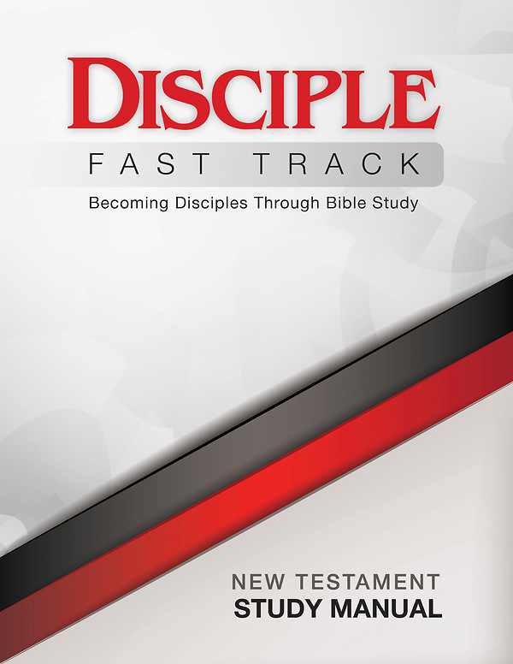New Testament! Join us on Sunday mornings at 8am to learn more about scripture, discipleship and the other amazing people in this class! Childcare and coffee are provided. If you would like a workbook, please let Lisa know in the office. Workbooks are $20.

# New Members Class

Interested in joining First UMC? Would you like to know more about the church, about United Methodists, or faith in general? Pastor Katie will be offering a 3-session New Members Class after worship on January 12th, 19th and 26th. Everyone is invited - even if you are already a member and would just like a refresher!

# Tuesday Lunch Study

Tuesday Lunch Study will 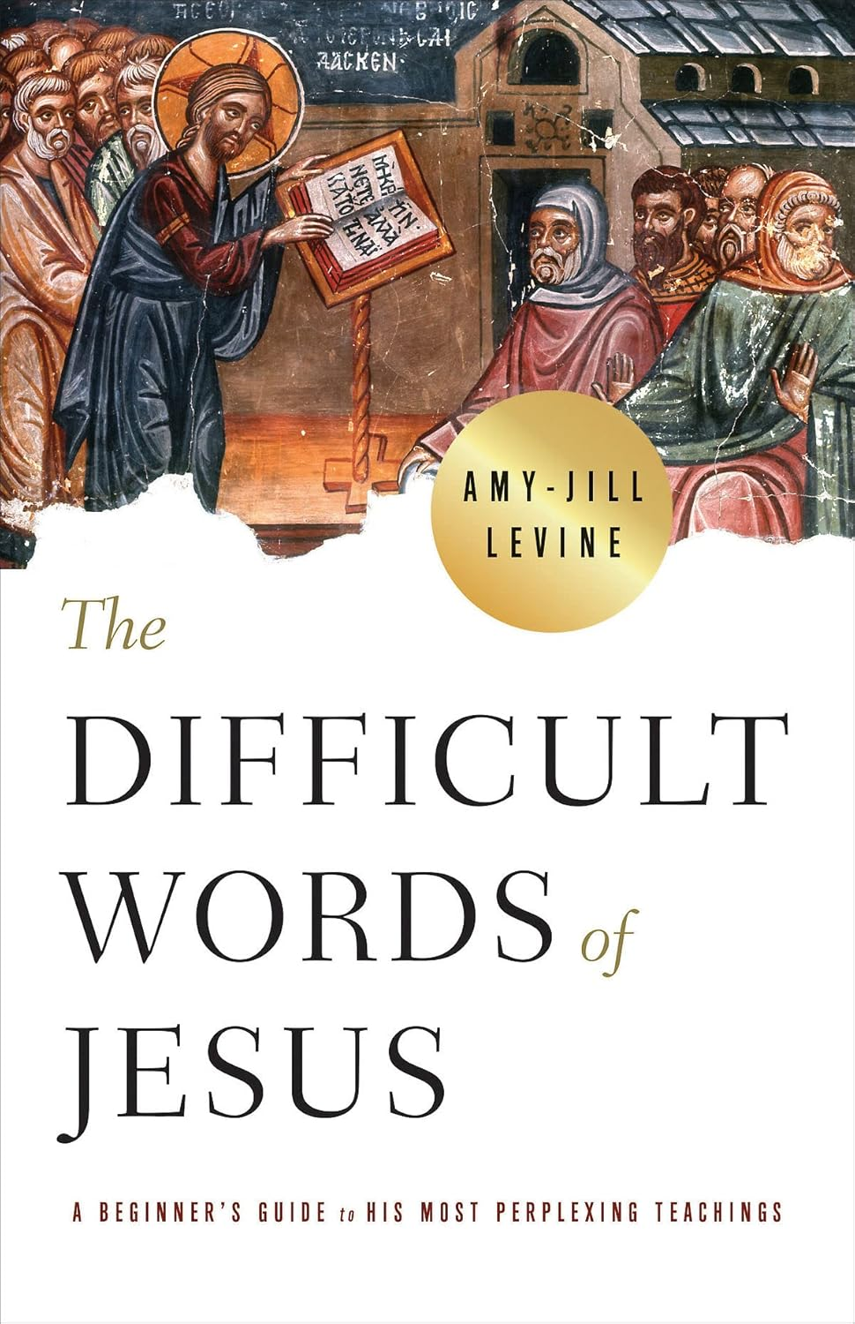start again on Tuesday, January 14th at noon. We will be doing a video series by Amy Jill Levine called, “Difficult Words of Jesus.” Here is a description of the class: Jesus provided his disciples teachings for how to follow Torah, God’s word; he told them parables to help them discern questions of ethics and of human nature; he offered them beatitudes for comfort and encouragement. But sometimes Jesus spoke words that followers then and now have found difficult. He instructs disciples to hate members of their own families (Luke 14:26), to act as if they were slaves (Matthew 20:27), and to sell their belongings and give to the poor (Luke 18:22). He restricts his mission (Matthew 10:6); he speaks of damnation (Matthew 8:12); he calls Jews the devil’s children (John 8:44).

In The Difficult Words of Jesus, Amy-Jill Levine shows how these difficult teachings would have sounded to the people who first heard them, how have they been understood over time, and how we might interpret them in the context of the Gospel of love and reconciliation.

Join us for this very interesting and challenging video study! No reading required. All are welcome! (There will be no class on Tuesday, January 28th.)

# Pastor Book Club

Pastor Book Club will be meeting a week earlier than usual on Monday, January 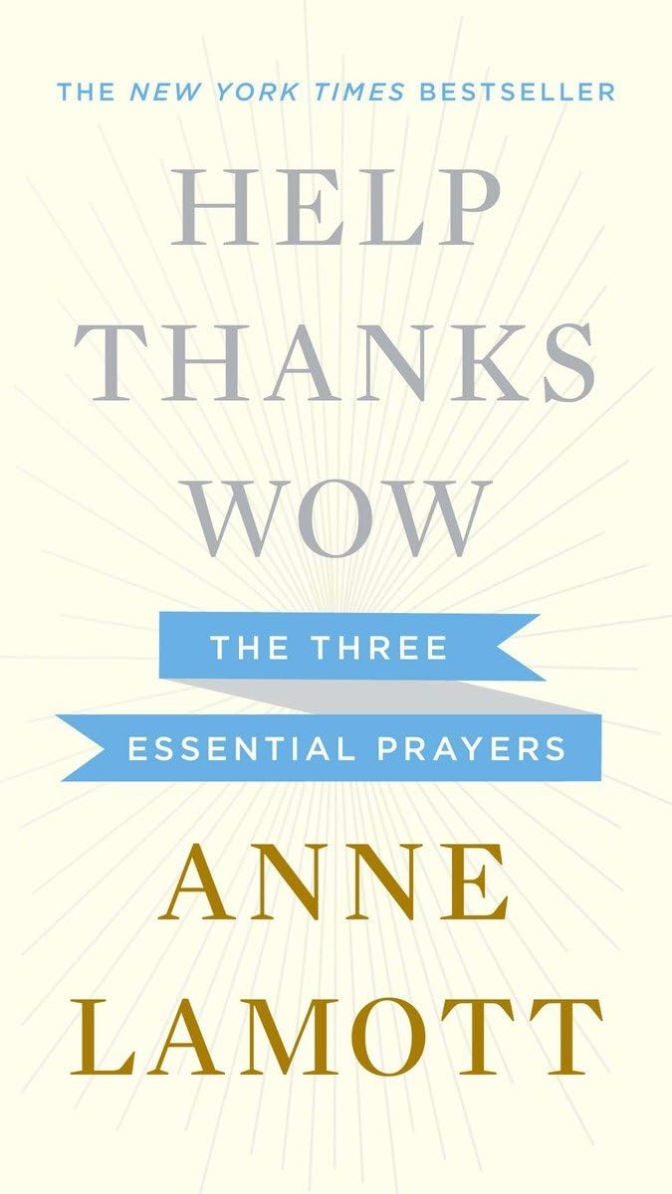20th at 7pm (due to Pastor Katie’s Board of Ordained Ministry responsibilities). The book for January is called *Help. Thanks. Wow. The Three Essential Prayers.* By Anne Lamott. It is these three prayers – asking for assistance from a higher power, appreciating what we have that is good, and feeling awe at the world around us – that can get us through the day and can show us the way forward. In Help, Thanks, Wow, Lamott recounts how she came to these insights, explains what they mean to her and how they have helped, and explores how others have embraced these same ideas.

# United Women of Faith (UMW)

United Women in Faith meeting will be January 6th, 2025.  It will start at 1:30pm in the church lounge. Our program that day is a pledge service by Diane. Lydia has a devotional.  And our hostess is Delores.  All ladies are invited to come

and enjoy a friendly, casual get together.  Start off the new year, hope to see you there.

# Youth Group (7th-12th grade)

Every Wednesday evening from 7:00-8:00

To sign up for Updates and Information, text **@1fumcyouth** to **81010**

Please let Tiffany know if you have any questions

[1stumckidsyankton@gmail.com](mailto:1stumckidsyankton@gmail.com)

**Take the Challenge**

*by Susan Thorson, Faith Community Nurse*

With the New Year beginning, it’s time to tune into what God is saying to each of us. We seem to be overly self-occupied thinking about our day–where we have to be, what our job challenges are, getting the children to school without any outbursts in the car, managing caregiving of our loved one, and taking in everything that is happening in our lives. It seems like we have little time for ourselves.

My challenge to you for 2025, is to take time during the day to stay alone with yourself. Find a sanctuary in your home, close the door and just be with yourself. Plan to do this for ten minutes each day. Take in the “solitude” as a time just for you. You might say “There is no way I can be in a room by myself for that long. I’ll go crazy thinking about what I should be doing, what weaknesses I face in myself, or just taking inventory of the room itself without thinking about it.” You’ll think this exercise is downright boring at first or a waste of valuable time.

During this time alone just say “I am my own being, and just deserve to be with myself.” After a few minutes pass, you will start to feel your body relaxing and the relief of the tensions of the day. It’s at this time, you thank the Lord for His presence in your life. Listen closely, as the Holy one is there just for you. Open your hands and let the spirit enter your body. Our body and mind seem so imperfect with all of the flaws but as the spirit comes you will feel a new freshness. God is forgiving us and caring for us even though we don’t feel we deserve His grace. As the gift of grace is received during this time of solitude, our needs are being met so we may give to those around us more graciously and be good to ourselves. Think about this Bible verse from 2 Corinthians 12:9-10: “But he said to me, “My grace is sufficient for you, for my power is made perfect in weakness.” “Therefore, I will boast all the more gladly about my weakness, so that Christ’s power may rest on me. That is why, for Christ’s sake, I delight in weaknesses, in insults, in hardships, in persecutions, in difficulties. For when I am weak, then I am strong.” Blessings to each of you for the year of 2025

# Thank You

Thank you for your prayers, cards and well wishes since I had knee replacement surgery in October. I really appreciate it.  The healing and rehab continue. A special thank you to Tom Gilmore for seeing that my mom and Mary Johnson got to church on Sunday and to the soup kitchen.

*Have a happy and healthy 2025*

*Paula Keehr*

On behalf of the congregation, the Care Casserole Team would like to thank the anonymous donor for the new upright freezer for Care Casseroles. The larger freezer will make it easier for people to see the offerings available. Also, there is a new bulletin board in the same area for updates on Care Casserole offerings and communication. Again, thanks so much for this gift that will help so many.

# In Our Thoughts & Prayers

For the family of Pat White, Pat passed away.

Dan Swihart, Mary Peirce, Analis Dannen, Prayers for Alexandra Stowe, Sue Strasburg, Doug Baily, Caitlin Jensen, Dawn Kabella, Kate Patrick (Diane Kisch’s niece), Connie Pruitt (Shirley Root's sister)

Church family serving in the military: all men & women serving in the military and their families.

# January Birthdays

2 - Corinne Ditmar

4 - Kaleb Swihart

5 - Steve Pietila

6 - Gary Guthmiller

- Tyler Kaiser

8 - Ken Bevers

- Cooper Cornemann

- Andy Gall

9 - Marlene Konopik

13 - Mary King

- Connie Sawatzke

15 - Ginger Guthmiller

16 - Scott Giziewski

- Paul Pietila

18 - John Wiechmann

19 - Mike Cauwels

20 - Sandy Dennis

21- Jean Droppers

- Kristi Hunhoff

- Rita Rolston

22- Angela Herrmann

- Linda Herrmann

23 - Carol Skonhovd

24 - Hannah Honrath

- Claire Mooney

25 - Tate Beste

- Randy Hummel

- Monte Schavee

- Jaxx Olson

- Abigail Ricke

27 - Rick Daugherty

- Carol Wiechmann

31 - Matt Pietz

- Julius Schaefer

