.

Mission Statement

First United Methodist Church of Yankton:

*“Our mission is to inspire all people to seek God, grow in their faith, discover their purpose, and serve others to make a difference.”*

# From the Pastor’s Desk:

*Bear with each other and forgive one another if any of you has a grievance against someone. Forgive as the Lord forgave you. - Colossians 3:13*

One might not think of November as a month with a lot going on, but there are plenty of notable days during this month: All Saints Day, Veterans Day, Thanksgiving and Election Day. It’s that last one that I had in mind as I prayerfully considered what God might want us to hear for the month and the word that came to me is “forgiveness.”

No doubt with the nature of political discourse in our country at present, all of us have seen, heard or even said things that caused pain and discord in our community, our friendships and maybe even our families. But as we head into a season where we are going to be gathering with our loved ones, we might need to do some work around forgiveness. Forgiving ourselves, forgiving others, asking for forgiveness and accepting the forgiveness found in Christ.

Therefore, we are going to spend November in a series called “Forgiveness” in an effort to reconcile and mend broken or strained relationships in our lives. Forgiveness is often misunderstood to mean that what happened didn’t matter or didn’t affect me or that I have to forget about it. Rather, forgiveness is about not letting the pain of the past dictate our future. Our future is one where we are called to be a community of hope, healing, and belonging that loves and serves all through Christ our Lord. And we cannot live into that vision for the future if we have not done the work of forgiveness in the present.

# So please join me as we take on this difficult, but necessary topic. I would love to see you in worship, but please know there are many ways to catch the sermon: in person, livestream, Facebook video (on Mondays), audio podcasts, radio broadcast (Sunday mornings at 8:30am) and on the local cable television station Saturday nights at 6pm.

# 2025 Estimate of Giving

If you haven’t had a chance to turn in your estimate of giving cards for 2025, you can still turn them into the office at any time. It is vitally important information for the Leadership Team as they look at the budget of the church to have a clear understanding of what is being pledged to give for the year. Please also consider increasing your giving to close the gap between the income and expenses of the church.

It is through our investment together that we fulfill the mission and ministry of this church. Our purpose in existing is to share the love of Christ, to grow disciples and to equip people to send them into the community and into the world to make a difference. It is a mission that we all serve together and work together to fulfill. So please consider your giving as an important part of how we participate in and extend God’s kingdom in Yankton and beyond.

# Leadership Team Openings

The Leadership Team is now accepting applications for the following positions: One member of Staff Parish Relations Team, one member of the Trustees, and one member of Finance. Applications are also open for Annual Conference Delegates. 2025 Annual Conference will be held in Sioux Falls. Applications are due at the beginning of November so they can be reviewed prior to Charge Conference. Any questions, please reach out to Pastor Katie or any of the current Leadership Team members.

# Charge Conference

Mark your calendars to join us for charge conference on Sunday, November 24th at 2:30pm. We are blessed to have Rev. Brandon Vetter, Southeast District Superintendent lead our Charge Conference session. If you are a member of the church, this is your opportunity to have your voice heard as well as attend to the business of our church.

A reminder as well that we will be voting in our next slate for the Leadership Team (as well as Annual Conference delegates). If you are interested in serving the church in one of these ways, please get your application in if you haven’t done so already!

# Tuesday Lunch Study: New Study

Join the Tuesday 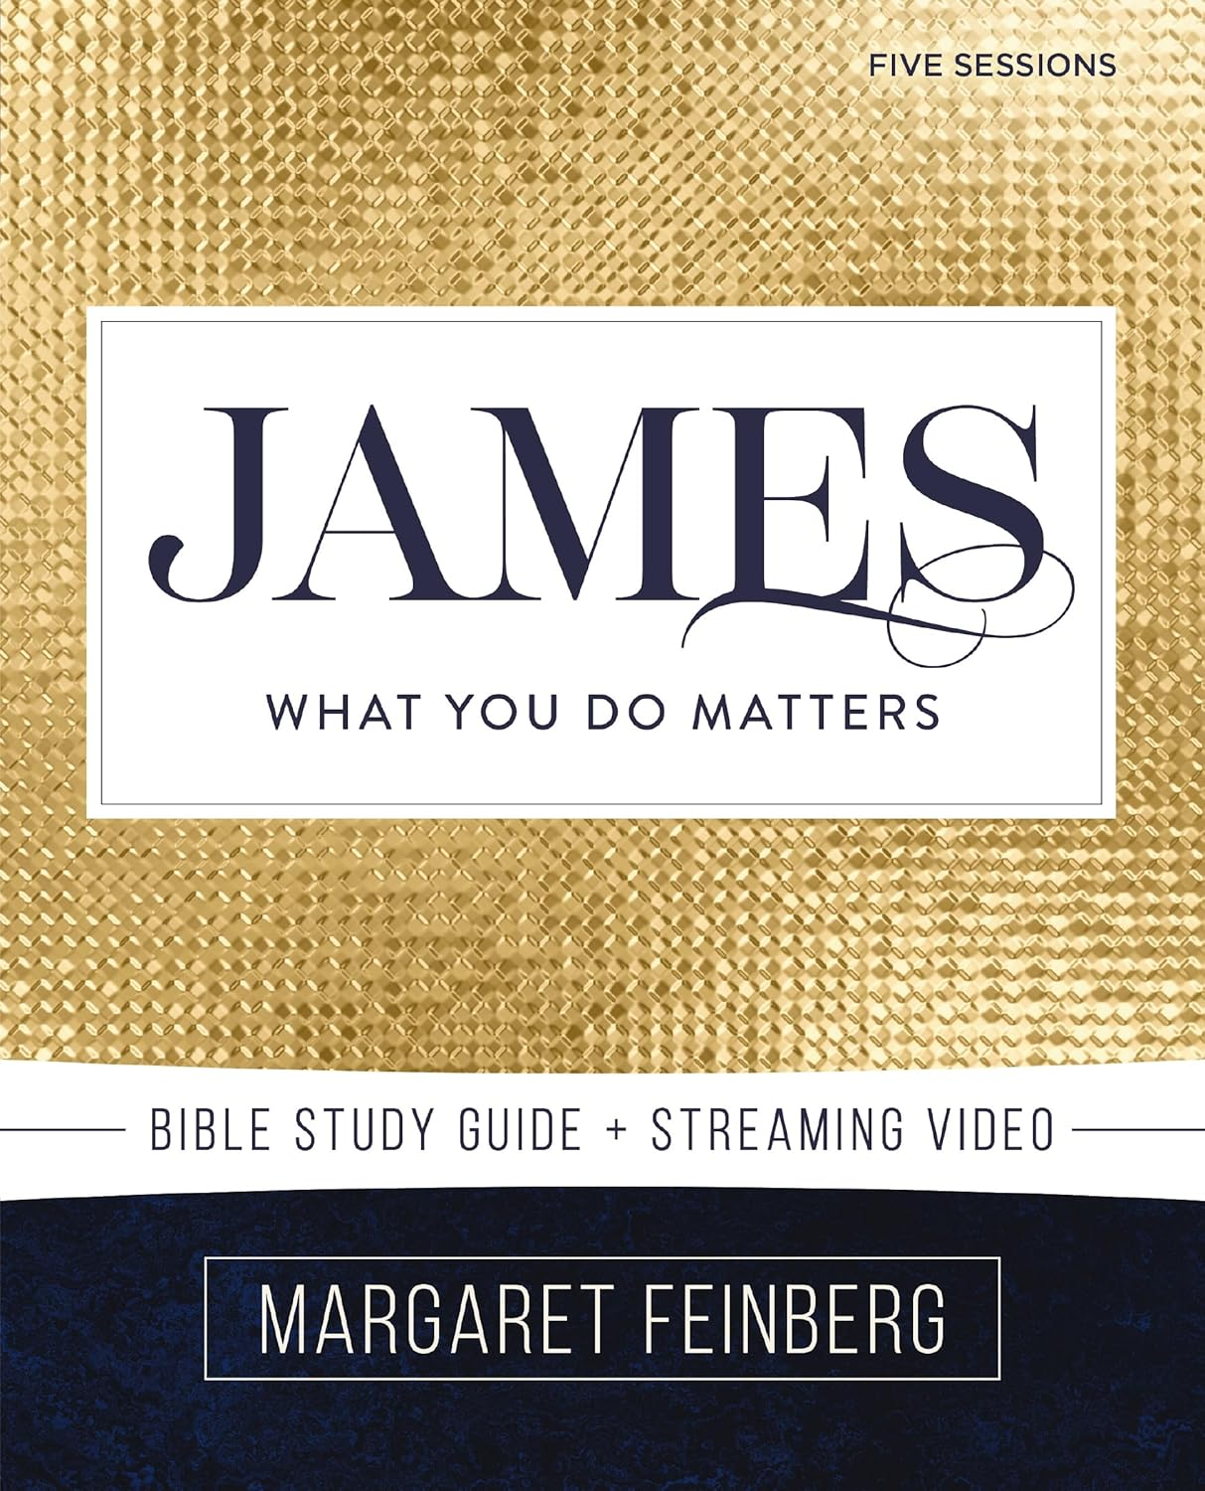Lunch Study crew as we tackle a new video series that started on Tuesday, October 29th at noon. This will be a five-session video study **(NO READING REQUIRED!)** on the book of James called *James: What You Do Matters* by Margaret Feinberg.

“If there's one book that has taught me that what I do matters, it’s the book of James." Beloved author and speaker Margaret Feinberg has been teaching the Bible for over 25 years. In her newest Bible study, she leads you through this treasure trove of wisdom and timely teaching.

Join Margaret in a joy-filled, fresh study of the book of the Bible that sounds more like Jesus than any other letter in the New Testament. You'll discover the genuine markers of true faith, develop new practices of spiritual maturity, and discover how much the Father of heavenly lights treasures you.

# All Saints Sunday - November 3rd

Part of our worship on All Saints Sunday will be to remember and honor the people of our church who have passed away in the last year. We also want to honor and remember your loved ones who have passed away. Therefore, you are invited to bring a flower of your own choosing to add to a very special bouquet during theworship service. In this way, let us honor and rememberall those who have finished their course in faith.

# Veterans Day Wall of Honor

Veterans Day is November 11th, therefore on Sunday, November 10th we will have a Wall of Honor display on the windows at the back of the sanctuary facing the lounge. If you haven’t submitted a photo of a veteran, please send one to the church office the week before.

# Pastor Book Club - November 25th 7pm

We are living in a 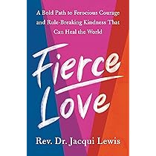world divided. Race and ethnicity, caste and color, gender and sexuality, class and education, religion and political party have all become demographic labels that reduce our differences to simplistic categories in which “we” are vehemently against “them.” But Rev. Dr. Jacqui Lewis’s own experience—of being the first female and first Black minister in her church’s history, of being in an interracial marriage, and of making peace with childhood abuse—illustrates that our human capacity for empathy and forgiveness is the key to reversing these ugly trends. Inspired by the tenets of ubuntu—the Zulu philosophy that we are each impacted by the circumstances that impact those around us, and that the world won’t get better until we all get better—Fierce Love lays out the nine daily practices for breaking through tribalism and engineering the change we seek. From downsizing our emotional baggage to speaking truth to power to fueling our activism with joy, it demonstrates the power of small, morally courageous steps to heal our own lives, our posse, and our larger communities. Sharing stories that trace her personal reckoning with racism as well as the arc of her journey to an inclusive and service-driven faith, Dr. Lewis shows that kindness, compassion, and inclusive thinking are muscles that can be exercised and strengthened. With the goal of mending our inextricable human connection, Fierce Love is a manifesto for all generations: a bighearted, healing antidote to our rancorous culture.

# Soul Scan Groups (Disciples Developing Disciples)

Will meet once a month to support each other in their intended goals. We will meet briefly (10 to 15 minutes) right after the church service in the Upper Room. Nov 3 – Community; Nov 10 Devotions & Nov 17 Service. If you haven’t returned an updated Soul Scan, please do so. They can be returned to the office or Marilyn Elwood.

# United Women of Faith (UMW)

Please come join us for the United Women of Faith meeting Monday, November 4th at 1:30pm. Our group meets in the lounge (behind the sanctuary). We have a short business meeting and some fellowship. The program this month is our annual Memorial Service and World Thanks Offering Program. All women are invited to come see what our group does!

We will be finishing the Shoebox Christmas project at our Nov meeting. Please bring items to include things like a new toy, new age-appropriate books, hats, gloves, mittens, toothbrush and toothpaste. We can do boxes for age groups infants, toddler, 3-5, 6-8, 9-12, 13 and up.  So, things that these age groups would be excited to get in a Christmas gift.  They do have on the directions, DO NOT ADD ANY CLOTHING.  Thanks

*Lydia Giziewski*

# Soup Kitchen

A huge thank you to everyone that donated soup, pies, money and your time to make our annual soup kitchen a success. As of now our profit is over $4,600. There are still items left from the Country Store in the lobby area if you see something you want just make a donation. Some of the ways the United Women in Faith use this money every year are to help pay for children and youth to go to church camp, donations to local charities and help with our conference pledge to mission. Thank you again for your support.

# Youth Group (7th-12th grade)

Every Wednesday evening from 7:00-8:00

To sign up for Updates and Information, text **@1fumcyouth** to **81010**

Please let Tiffany know if you have any questions

[1stumckidsyankton@gmail.com](mailto:1stumckidsyankton@gmail.com)

NO Youth Group – November 27th (Happy Thanksgiving)

Youth & Children’s Christmas Program – Sunday December 15th @10:00am.

# FUMC Children’s Ministry

Thank you for faithfully bringing your kids to 605 every Wednesday evening! The days are getting shorter, and the temps are dipping! We hope to play outside as long as we can!! Thank you to the Kitchen staff and our Teaching staff for providing such wonderful food and fellowship each and every time we get together! (Take a deep breath) start (here it comes) CHRISTMAS PRACTICE PREP!!!! What?!? Yes! it is TRUE! It is coming sooner than a half-price sale on ornaments at Walmart. Our Christmas Service is December 15th.

# Missions…..

What’s coming up in missions you ask?????

We have a lot of great things coming up and we welcome you to be involved!

November 17th – Tree decorating will be in full force.

            We will again have a tree at Mead Museum’s Hall of Trees.  Part of the decorations will be provided by the 605 youth.

            We will also be putting up the tree for the Angels – gifts donated to White Swan.

Loads of Love – WE NEED YOU!  Yes, I am looking for about 3-4 volunteers to help on November 19th.  Please sign up and serve this very valuable mission.

Watch for some great things coming up in December too:

            December Calendar of Giving

            Caroling with Care Caseroles

            Angel Tree Gifts

Thank you to all that help support these areas of great service in our community and more!

# Bob Would Be Proud

The Green Team wishes to thank everyone who helped with the second litter pick up of 2024. The Bob Capell Memorial Litter Pick Up is a biannual event that was resurrected by the Green Team, youth group, and other church volunteers. Bob Capell, a former leader and lay minister at FUMC, initially organized our church’s litter pick up of a 2-mile section of east highway 50 many years ago. With Bob’s passing, our church forgot about our section of the highway east of Yankton. Last spring the Green Team approached the SD Department of Transportation about doing a litter pick up and was surprised to find out that our church had an assigned section from mile marker 366-368 that we had committed to keeping clean. Records indicated that Bob Cappel was the church contact.

We have now cleaned our section (from about the C & B John Deere dealership to the Budweiser distributor building) twice this year. The ditches looked a little cleaner than in the spring, so our efforts are paying off. We had almost 25 participants on October 16th as we enjoyed a pleasant autumn walk along highway 50 as the sun was setting. Thanks to everyone who helped beautify our city’s eastern commercial corridor. We enjoyed some delicious cookies and cupcakes afterwards and are already planning our 2025 springtime litter pick up. Won’t you join us?

*-The FUMC Green Team*

# THANK YOU

Thank you to everyone that donated canning jars.  We no longer need any.

Thanks to my church family for the prayers, checking in on me, and visits as I recover from knee replacement surgery. I appreciate and thank you all.  And a special thanks to all of you (you know who you are), for stepping up to cover for me when needed.

*Susan Schavee*

# In Our Thoughts & Prayers

Pat White who is now at Sr James Riverfront room 316

Mary Peirce, Analis Dannen, Prayers for Shelby & Derek White for the loss of their son. Prayers for Alexandra Stowe, Sue Strasburg, Doug Baily, Caitlin Jensen, Dawn Kabella, Kate Patrick (Diane Kisch’s niece), Connie Pruitt (Shirley Root's sister), Susan Schavee

Church family serving in the military: all men & women serving in the military and their families.

# November Birthdays

2 - Monte Gulick

- Jo Watkins

3 - Sara Olson

5 - Alix Peterka

- Bailey Peterka

- Cassi Pietz

7 - Lisa Irwin

- Jim Strasburg

9 - Mary Olsen

10 - Suzanne Tessier

11 - Delores Moore

12 - Ellen Slowey

13 - Barb Hirsch

- Andrea Tramp

15 - Jenae Norton

- Warren Peterson

18 - Lily Lawrence

- Mary Malchow

- Jason Ricke

19 - Lara Cunningham

- Beckett Kisch

21 - Russell Peirce

22 - Craig Sherman

- Jane Walser

23 - Kenny Doering

- Shar Peterson

24 - Karen Miller

- Sue Strasburg

28 - Julie Moderegger

- Jerry Wilson

30 - JoAnne Roach

