.

Mission Statement

First United Methodist Church of Yankton:

*“Our mission is to inspire all people to seek God, grow in their faith, discover their purpose, and serve others to make a difference.”*

# From the Pastor’s Desk

*Do all the good you can,*

*By all the means you can,*

*In all the ways you can,*

*In all the places you can,*

*At all the times you can,*

*To all the people you can,*

*As long as you ever can.*

* *John Wesley*

For the month of October, we are going to be going through a Generosity Challenge as a church community. Bishop Robert Schnase correctly identified generosity as one of the five hallmarks of fruitful and vibrant congregations. Therefore, we are going to focus on what it means to be generous people. This includes elements of generosity with what we have (coincidentally we are also asking you to fill out your estimate of giving cards in October), but also generosity with who we are. Each week as you come to worship, you will find in your bulletin daily challenges that you can choose to complete each week. This is certainly one of those times that the more effort and commitment you make to the challenge, the more rewarding the challenge will be in your life.

As you contemplate whether or not to accept the Generosity Challenge for the month of October, I want to remind you that Jesus himself modeled extravagant generosity with his time, talents and resources. He freely and fully gave of himself to those around him who were in need of something he could do for them. Jesus also did not deny us his very life when offering it meant that we could find freedom from the bondage of sin in our own lives.

John Wesley also encourages us to be generous by whatever means that we can.

Our generosity is a source of good, not only in the church, but in the world. When we are generous with our resources (money, things, time, energy, attention) we are putting as much good into the world that we can. And we are called to be disciples of Jesus Christ who transform the world - and part of that work is accomplished through your generosity.

So, I pray that you will join me on this 4-week adventure where we will stretch our generosity muscles and see what God is able to do when we offer our very best.

Blessings, Pastor Katie

# Charge Conference

Mark your calendars for Sunday, November 24th at 2:30pm for our Annual Charge Conference. We will be joined by our new District Superintendent Brandon Vetter as well as members from Gayville/Volin UMC.

# October Pastor Book Club:

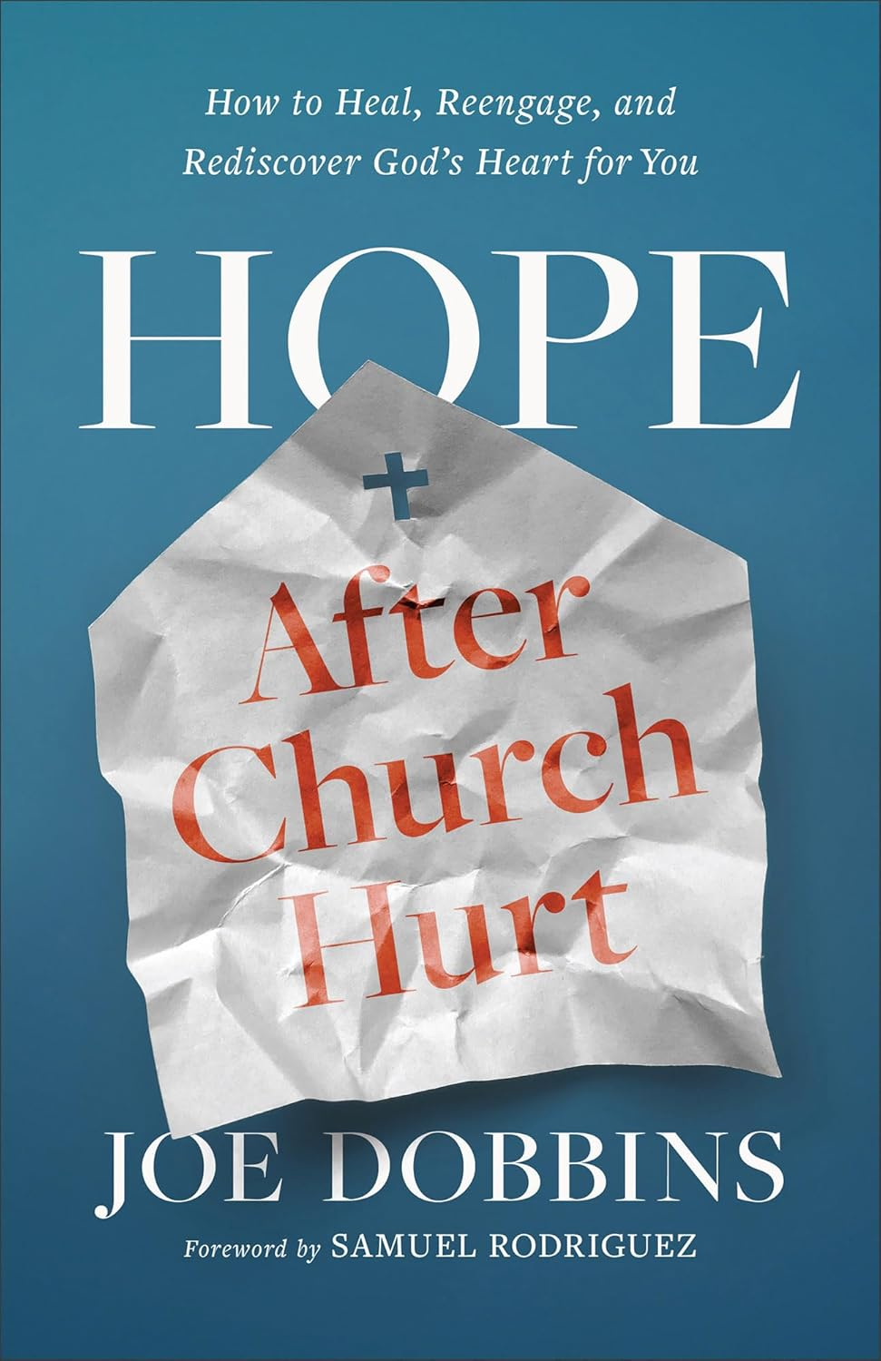Join Pastor Katie on Monday, October 28th at 7pm to discuss the book *Hope After Church Hurt: How to Heal, Reengage, and Rediscover God’s Heart for You* by Joe Dobbins. This particular book is aimed at anyone who has been hurt by the people of the church but is useful for everyone as we understand how the church has hurt people and how we can all work to heal as we move forward. This would be a great book and discussion for people in your life who long for more in their faith but have been hurt by the church. Consider inviting a friend to read this book with you and join in the conversation!

Having helped thousands move from anger, distrust, apathy, and heartache to safely reengaging in their faith--and local church--Pastor Joe Dobbins offers compassion, wisdom, and practical advice to help you

· understand why church hurt is so potent and hard

to address

· break free from bad beliefs, self-defeating pat

terns, and cycles of pain

· discover the way to inner healing

· release your pain and reframe your story

· find the courage to reengage in a faith community

· protect yourself in the future

The pain of church hurt is real. But so is the hope of healing--and that healing can begin today.

**Tuesday Lunch Study: New Study Starting October 15th!**

Join the Tuesday Lunch Study crew as we tackle a new video ****series starting on Tuesday, October 15th at noon. This will be a five-session video study **(NO READING REQUIRED!)** on the book of James called *James: What You Do Matters* by Margaret Feinberg.

“If there's one book that has taught me that what I do matters, it's the book of James." Beloved author and speaker Margaret Feinberg has been teaching the Bible for over 25 years. In her newest Bible study, she leads you through this treasure trove of wisdom and timely teaching.

Join Margaret in a joy-filled, fresh study of the book of the Bible that sounds more like Jesus than any other letter in the New Testament. You'll discover the genuine markers of true faith, develop new practices of spiritual maturity, and discover how much the Father of heavenly lights treasures you.

# Pastor Katie Out of Office

Pastor Katie will be out of the office October 23-25th for her Board of Ordained Ministry Fall Meeting.

2025 Estimate of Giving

At the beginning of October, you will receive the estimate of giving forms in the mail.

(They will also be available on the website and at the church office). Please prayerfully consider what you can give to support the vital mission and ministry of your First United Methodist Church in 2025. Please consider increasing your gift as a step in your faith journey and blessing the ministry.

We ask that you return your Estimate of Giving form by Sunday, October 27th. The Leadership Team will use the information gained from these forms to set a faithful budget for the church for 2025.

# Raise the Roof Celebration

You are invited to the Raise the Roof Celebration following worship on Sunday, October 27th. The Leadership Team is hosting lunch and fun activities for both adults and children as a way to thank the congregation for its faithful generosity to the Raise the Roof campaign. The campaign paid for the necessary work on the roof over the education wing as well as maintenance on the roof above the office suite. The menu includes smoked meat, sides and dessert.

# Bob Cappel Memorial Litter Pickup

Join the Green Team and others keep our section of Highway 50 free of litter. Meet at the church Wednesday night, October 16th at 5:30pm to be a part of this great event. We will carpool to the designated areas to work, and then return to the church for snacks and goodies. Any student under the age of 18 will need a consent form signed (will be available that night.)

Leadership Team Openings

The Leadership Team is now accepting applications for the following positions: One member of Staff Parish Relations Team, one member of the Trustees, and one member of Finance. Applications are also open for Annual Conference Delegates. 2025 Annual Conference will be held in Sioux Falls. Applications are due the beginning of November so they can be reviewed prior to Charge Conference. Any questions, please reach out to Pastor Katie or any of the current Leadership Team members.

# United Women of Faith (UMW)

Please come join us for the United Women of Faith meeting Monday, October 7th at 1:30pm. Our group meets in the lounge (behind the sanctuary). We have a short business meeting and some fellowship. The program this month is presented by the River City Domestic Violence Center. All women are invited to come see what our group does!

*Lydia Giziewski*

# Soup Kitchen

The date has been set for October 22nd. The Country Store is returning for all the “crafters”. Features: The homemade bakery, a canning shelf, holiday items, maybe sewing, knitted items, etc. A donation form is included in this Reminder.   
 This project is a major source of funding for United Women of Faith’s budget which pays for a portion of camping fees for youth and for mission projects. Please pray for the project! Participate by donations. Be present for the event.

# Trunk or Treat

Mark your calendars and put your creative caps on as Trunk or Treat returns to our First UMC Parking Lot October 30th 6-7:15pm. We will be joined once again by trunks from both UCC and Trinity Lutheran Church.  AND once again we will be competing for fan favorite trunk, so let's get as many amazing First UMC trunks in the lot as we can! Contact Tiffany Beste if you have any questions.

# Jubilee Bells and Chancel Choir

Please note changes in the scheduled practice times. Jubilee Bells started Wednesday, September 11th, gathering time at 6pm with Bells in place at 6:15pm. The Chancel Choir started Thursday, September 12th at 4:15pm.

# Youth Group (7th-12th grade)

Every Wednesday evening from 7:00-8:00

To sign up for Updates and Information, text **@1fumcyouth** to **81010**

Please let Tiffany know if you have any questions

[1stumckidsyankton@gmail.com](mailto:1stumckidsyankton@gmail.com)

Wednesday, October 16th - Ditch Clean-Up at 5:30pm

Tuesday, October 22nd - help clean up Soup Kitchen; 6:30pm

Wednesday, October 30th - Trunk OR Treat; 6:00-7:00pm

# Mission Moments

Fall is quickly approaching and with that the garden is bursting with produce.  Please check out the sign-up sheet at the table at the base of the stairs to sign up and help us harvest the abundance!  And when you see extra produce on that table – help yourself.  There is nothing better than having some fresh veggies straight from the garden.

Note that the 5th Sunday offering in September will be going to the garden expenses.  The sign, some tools, and seeds & plants for the 2 plots that we have at the community gardens.

A mission project:  Avera is cleaning out the old Starlite Motel with the donation going to White Swan.  There will be a hauling, packing, and transportation day being planned (hopefully by the end of September).  If interested in being a part of this mission – please let me know.  We will be seeking out as many heavy lifters as we can find!

Loads of Love:  Thank you to the God winks bible study as they covered the 2nd one this year.  God does wink when this group gets involved!  The Bibles and Brews group will be serving at the October Loads of Love.  And we only have one more for the year in November.  Please consider serving this ministry by signing up on the Missions table.  November 19th is the date that we are in need of volunteers.

Thank you for keeping mission a huge part of what our church does – I love to see people serving others!

*Carla Hummel*

*FUMC Missions Coordinator*

# Weekly Watchers for Community Garden Needed

Signup up for a week at a time. Check garden daily for watering, weeding, and picking ripe produce. Plots #69 & #70 (between the two cross and flame signs). Disconnect hose when done. There is a signup sheet on the Missions table for weeks in September. If you have questions, please call Marilyn Elwood (402) 992-4377. There is some of the produce from the garden at the church for anyone to take.

**Helping and Caring Hands**

*by Susan Thorson, Faith Community Nurse*

*Isaiah 41:13 “For I am the Lord Your God who takes hold of your right hand and says to you: Do not fear, I will help you.”*

As I begin writing today, I am thinking about all the things I have done with my hands over my lifetime but also what the hands of others have done for me. I have received a sense of warmth, caring and commitment from touching hands. A feeling of strength and power from a handshake has given me confidence to persevere even when I faced difficulty with little hope of success but remained persistent to keep going. I remember the feeling of my grandmother’s hand and my mother’s hand when I needed tender loving care. I think of the hands of many of the men on my father’s side of the family–the thickness of their fingers and the strength of their hands. Seeing the roughness and the calloused hands common to farmers and laborers but also noting the hypersensitivity on the inside of the hands.

As I begin writing today, I am thinking about all the things I have done with my hands over my lifetime but also what the hands of others have done for me. I have received a sense of warmth, caring and commitment from touching hands. A feeling of strength and power from a handshake has given me confidence to persevere even when I faced difficulty with little hope of success but remained persistent to keep going. I remember the feeling of my grandmother’s hand and my mother’s hand when I needed tender loving care. I think of the hands of many of the men on my father’s side of the family–the thickness of their fingers and the strength of their hands. Seeing the roughness and the calloused hands common to farmers and laborers but also noting the hypersensitivity on the inside of the hands.

As an activity, take some quiet time for yourself, relax, breathe deeply and let your mind calm. When you feel the calmness set in, stop, open your hands and look at your hands. Think about what you see in your hands, what you feel and what those hands have done for others as well as yourself.

(Helping and Caring Hands continued on page 4)

(Helping and Caring Hands, continued)

Each of us can make a difference with the use of our hands in praying, healing, working and caring for one another. Learn to appreciate the connectivity that goes with just holding a hand. We do it every day in prayer with someone in the hospital, in a team huddle, holding a child’s hand or taking a hand to support someone. Remember God is the source of the feeling we receive or give with the touch of our hands. Blessing to each of you!

# October Birthdays

2 - Jane Rodig

3 - Paula Keehr, Jack Stoddard

5 - Bob Thue, Kenzie Giziewski

8 - Don Lepp, Sherry Rabenberg

9 - Garner Brandt, Chuck Ditmar

11- Isabella Downs

12 - Marilyn Holzwarth, Mary Heubaum,

Heather Hirsch, Trevan Palecek

15 - Judy Bevers, Bill Fargo

16 - Terry Norton

17 - Claudia Maska, Naomi Somer,

Mike Erickson, Jack Olson

18 - Elle Guthmiller

19 - Heather Rabenberg, Amanda Gravholt

20 - Chad Herrmann, Kaitlin Guthmiller,

Ryan Bakke

21 - Dave Becker

22 - Samuel Slowey, Loran Moore, Abbi Olson

23 - Marv Withrow

26 - Brooks Ugofsky, Austin Nickles

27 - Evie Sime

29 - Alyssa Herrmann

31 - Tammi Downs

# In Our Thoughts & Prayers

Analis Dannen has requested prayer as she is struggling with depression.

Prayers for Shelby & Derek White for the loss of their son

Susan Schavee had knee replacement surgery

Prayers for Alexandra Stowe, Sue Strasburg Diane Kisch’s mother Evelyn Nohava and her niece Kate, Doug Baily, Caitlin Jensen, Dawn Kabella, Connie Pruitt (Shirley Root's sister)

Church family serving in the military: all men & women serving in the military and their families.

# 

**THE SOUP KITCHEN TUESDAY - OCTOBER 22, 2024**

**From 4:30 PM to 7 PM**

This is a major source of funding for the United Methodist Women’s budget which pays a portion of camping fees for our youth and for missions. We need the assistance of the congregation in donations of food as well as workers for the day of soup kitchen.

If you have not already signed up for a donation of food and to help, **please complete this sheet and leave it in the box on the table in the lounge or in the church office or e-mail to Delores Kafka at** [**delkafka9@gmail.com**](mailto:delkafka9@gmail.com) **no later than Monday, October 7th.**

**NAME:** ____________________________________PHONE**:___________________________________**

I WILL FURNISH FOR THE KITCHEN: FOR THE COUNTRY STORE:

9-inch pies #_____ Baked or home canned goods One & a half gallons of Vegetable Beef Soup Crafts

One & a half gallons of Chicken Soup Other

(broth & chicken only, **noodles will be added**) ____ Cash donation $ ______

One & a half gallon of Chili

I WILL WORK:

____ IN THE KITCHEN, FROM____________________ TO_______________________________

____ IN THE DINING ROOM, FROM________________ TO_______________________________

____ ON THE SERVING TABLE, FROM_____________ TO_______________________________

____ DISHWASHING (MEN, especially) _______________TO_____________________________

____ FOR CLEAN-UP (6:30 PM ON) ________________