.

Mission Statement

First United Methodist Church of Yankton:

*“To grow disciples of Jesus Christ and equip them for ministry in the world.”*

# From the Pastor’s Desk

*I thank my God every time I remember you. In all my prayers for all of you, I always pray with joy because of your partnership in the gospel from the first day until now, being confident of this, that he who began a good work in you will carry it on to completion until the day of Christ Jesus. - Philippians 1:3-6*

Typically, when I sit down to write one of these reflections during Lent, I tend to be reflective and somber as the season dictates. But I will be honest with you, as I reflect on the journey we have taken as a church, I feel nothing but joy and hope. Something has been unleashed within us as First United Methodist Church and that something, I believe, is the Holy Spirit at work. I have been witness to so many things that bring my heart joy. I have been witness to the leadership of this church stepping up and leading with courage and conviction when faced with difficult financial realities. I have seen people inviting and encouraging each other to try new studies or small groups or activities. I have seen the people coming back to church or coming to our church for the first time and finding a home here once again. I have seen God work healing the hearts of those who have been hurt and those who carry a deep burden of grief. I have seen people light up with ideas of things they could do to help the church and extend the kingdom of God. I have seen people get creative when submitting shirt designs. I have seen people working behind the scenes to better our church and our building - making it more energy efficient and environmentally friendly. I have seen people who didn’t know each other before become friends and be open and vulnerable with each other.

We are well on our way to being the church we have envisioned - a church of hope, healing and belonging that loves and serves all through Christ our Lord. And we have only just begun! More is on the way as we continue to focus on how to help people in finding hope in their lives and experience healing they never thought possible - especially from spiritual and emotional damage.

Keep a look out as we will continue to offer opportunities for growth and healing in a variety of avenues. But I believe that God began something in our church when we caught a glimpse of who we could be and God’s spirit is at work in each one of you.

And I am not surprised at all, because our God has a way of taking something that is struggling, that is tired, and that is lost and breathing new life into it. That is what we celebrate at Easter - the resurrection of Jesus Christ from the dead. Our church is also experiencing a resurrection of mission and purpose and evidence of new life, and the kingdom of God can be found everywhere you look. I am so thankful to serve this church and to serve a God of resurrection hope! God is truly doing a good work in us and isn’t done with us yet!

Happy Easter!

Pastor Katie

# New Member Class

If you are interested 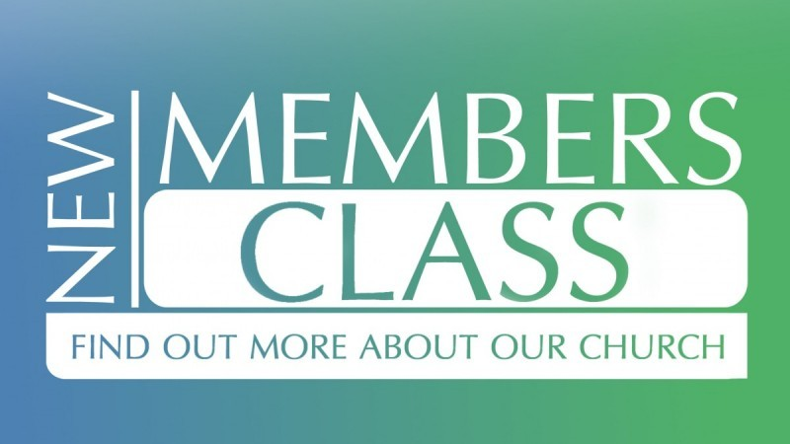in learning more about our church, about what it means to be a follower of Jesus, and how to get more involved, come to the New Member Class in March! New member class will be held for 3 weeks starting on Sunday, March 3rd at 8:30am. Taking the class is a pre-requisite for membership in the church. This will take the place of Christianity 101 for the month of March.

# Christianity 101 - On Break for March

Christianity 101 will be taking a break for the month of March to allow for a New Member class on Sunday mornings. We will come back again after Easter so let Pastor Katie know topics that you’d like to see covered!

# Raise the Roof!

As of the end 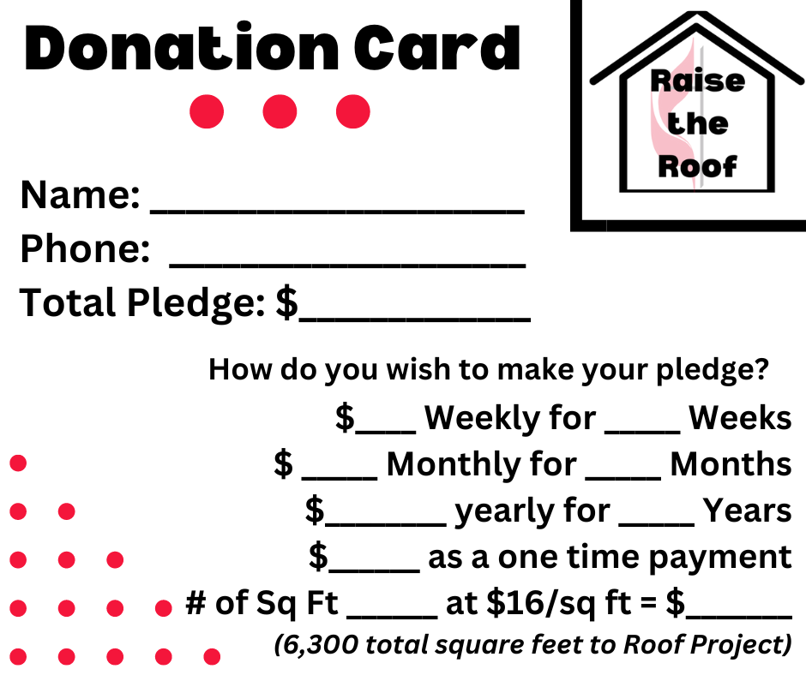of February, between donations and pledges, we are over half-way to our $100,000 goal to fund necessary repairs and updates to the roof of our church. If you haven’t done so already, please consider making your pledge known to the church or making your donation now. Every donation matters!

We will be holding a Rummage Sale at the church the first Weekend in May as a Raise the Roof fundraiser. As you do your spring cleaning, please donate your items in good condition to the church rummage sale. If you have larger items (like furniture) please let us know as we can arrange for pick up, if needed. We will start taking in donations for the sale toward the end of April. Clothing is included in this rummage sale as well.

If you would like to volunteer, please let Pastor Katie or Jane Gilmore know. We will need plenty of hands-on deck for this fundraiser! If you have your own idea for a Raise the Roof fundraiser, please talk to Pastor Katie or one of the members of the Leadership Team!

# No Confirmation: March 27th

Confirmation Students should plan to attend one or both of the Holy Week Services. Sunday, March 31st - Easter Sunday Worship @ 10am

# Holy Week Services

Sunday, March 24 - Palm Sunday Worship @10am Thursday, March 28th - Maundy Thursday Service @ 7pm at United Church of Christ.

Friday, March 29th - Good Friday Service @ 7pm at First United Methodist Church

# New Tuesday Lunch Study: Starting March 19th

Join Pastor Katie as we begin a new study on Tuesdays at Noon based on the book *Courage: Jesus and the Call to Brave 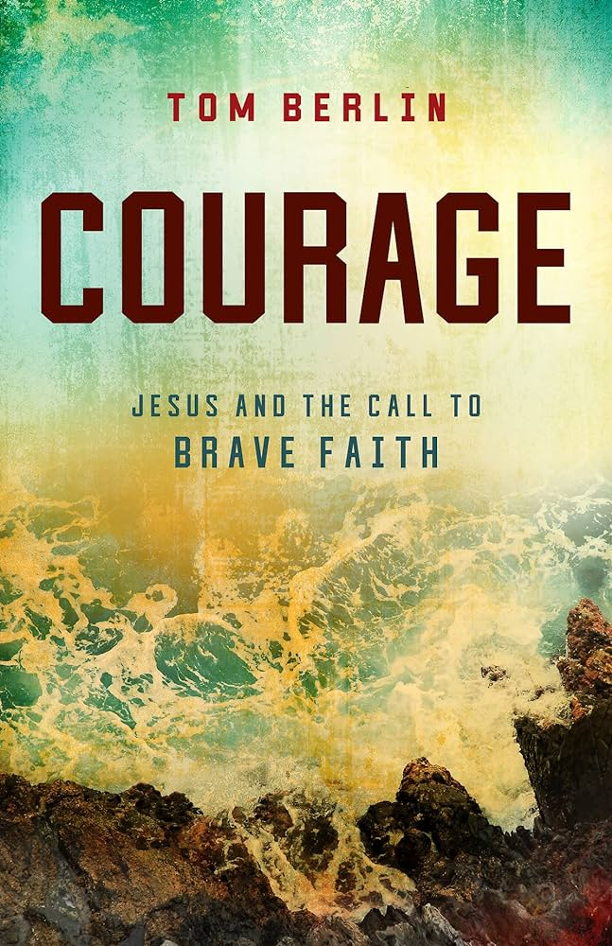Faith* by United Methodist Bishop Tom Berlin. In *Courage: Jesus and the Call to Brave Faith*, Bishop Berlin challenges us to unlock the courage that we already possess as Christ followers. By examining the life of Christ, we will begin to understand what true courage is and how God works in the lives of Christ followers as they exhibit a brave faith. Once we have eyes to hear what Jesus is showing us, once have ears to hear, we can begin to find the remarkable life Jesus offers us. You can find the book on your own (available in paperback or kindle) or sign up at the church and we will order one for you. Please read the first chapter (The Clarity of Courage) prior to the first meeting. ALL ARE WELCOME!

# Winning First UMC Shirt Designs!

A special shout out and thank you to everyone who submitted designs for our new church shirts. We have decided to go with 2 different shirt designs: one designed by our First UMC kids and one designed by our First UMC adults. The designs are front & back. These shirts are available to order at the church, so stop by and get yours today! Order forms can be found in the office or in the lounge behind the sanctuary.

# United Women of Faith (UMW)

I’m inviting all women to come to the United Women of Faith meeting Monday, March 4th at 1:30pm in the church lounge. Our program is from the Yankton Police Department, discussing safety in our church, scams, and frauds.  Followed by a short business meeting and lunch.

*Lydia Giziewski*

# 605 Update

605: for kids Preschool-6th grade runs from 5:30-6:30 every Wednesday evening with supper served at 5:30!  It is an evening of lessons, crafts, songs and games to teach our children more about Jesus and the bible. For more information contact Tiffany at [1stumckidsyankton@gmail.com](mailto:1stumckidsyanktin@gmail.com) or sign up for Remind messages by sending the message ***@1stumckid*** to the number 81010

# Youth Update

Youth group: for kids 7th grade-12th grade runs from 7:00-8:00 every Wednesday. We offer lessons, games and videos to help our youth further their knowledge of Christ and develop their faith. For more information contact Tiffany at [1stumckidsyankton@gmail.com](mailto:1stumckidsyanktin@gmail.com) or sign up for Remind messages by sending the message ***@1fumcyouth*** to the number 81010

# Summer Camp Information

**Summer Camp – Time to start planning!** Camp brochures are here – if you did not get one in the mail, you can find them in the lobby downstairs. Deadline for the Early Bird price is April 30th.  The church will take care of ½ of the early bird cost of one camp per **youth**. If your youth is going to more than one camp, you are responsible for the cost of the other camps.  If you register after April 30th – the church & UMW will only pay for ½ of the early bird cost. You will be responsible for the difference between early bird and full price. To register, you will need to call the office to get the church code that you will enter on the registration form, this code will automatically subtract the church’s portion from your payment.

You will be able to register more than one person at a time but if you are registering the same person for more than one camp you need to do a separate registration online for the second camp.

<https://www.dakotasumc.org/camping/camps-and-events>

If you have questions about this process, you can talk to Tiffany at church or call (605) 695-0178.

# Up to $210 covered for students coming out of 2nd grade!!

Check out the ***LPC Mini-Camps, Summer's Last Blast or Grandparents & Me camps***

**Mini-Camp A & B**: Sun, June 16-Wed, June 19 ($315.00)

**Mini-Camp C & D**: Mon, July 1-Wed, July 3 ($210.00)

**Summer's Last Blast/Grandparents & Me**: Sun, July 28-Wed, Aug 31 ($315.00)

**Grandparents & Me**: Wed, July 31-Fri, Aug 2 ($210.00)

All the fun of a weeklong camp packed into a fraction of the time! Get ready for waterfront fun, crafts, games, outdoor chapel, and more. While the mini-camps give first time campers a taste of the ultimate overnight camp experience, we have campers that return to mini-camp summer after summer!  Please let Tiffany know if you have any questions.

    For the K – 3rd graders we need to have 1 adult attend camp with every 5 campers. Remember the grade listed for each camp is the grade the camper is currently in.

# Camp Scholarship Funds with the Dakotas Foundation

            This fund was established to assist youth with camping registrations and/or expenses. The main sponsor of this scholarship came from Ethel Schenk who originally contributed $3,750. This amount, along with other memorial gifts from various people who designated the funds to be used towards camp scholarships, made up the balance. This money is invested with the Dakotas Foundation. This money is intended to assist families that have youth (1st grade through graduating seniors) attending camp that express the need for additional financial support to cover their share of the cost.

Any family that would like a little extra financial help needs to fill out a Camp Scholarship Card located in the church office and place it in the decorated box by Sunday, April 24th.  It is the hope of the Finance and Education Committees that people will contribute to this fund and the size of our investment will grow so that the amount of money we are able to distribute grows.

# Mission Moments

**Spring Forward Fundraiser** Sunday, March 10th (following church services). Baked Potato Bar – free Will Donation – Dessert Auction. Signup sheets are available on the Missions table.

**Dessert Auction:**

Peanut Butter Pie by Susan Schavee

Mile High Cream Pie by Connie Sawatzke

Swedish Almond Cake by Liza Larson

Blueberry Muffins by Alicia Cornemann

Turtle Cheesecake by Jill Sage

Praline Rum Bundt Cake by Susan Schavee

Peanut Butter Pie by Jane Gilmore

Lemon Bars & Lemon Cake by Karen Miller

Breads by Carol Becker

If anyone else would like to add a favorite to the Dessert Auction, just let Carla Hummel know.  Also note – the signup sheets are out to help work the event and provide some supplies for our baked potato feed😊.

# Bucket Sunday

Bucket Sundays are held whenever we have 5 Sundays in one month. If you have an organization, you’d like the offering to go to, let the church office know or Carla Hummel.

# Healthy Nutrition

*By Susan Thorson, Faith Community Nurse*

March is National Nutrition Month, sponsored by the Academy of Nutrition and Dietetics since 1973. This year’s theme encourages everyone to “Go Beyond the Table.” It encourages individuals and families to be mindful about the impact daily nutrition choices can have on personal wellbeing and the environment in the present and in the future. It addresses the farm-to-fork aspect of nutrition from food production and distribution, navigating grocery stores and farmer’s markets, home food safety and storage practice, various ways to eat at home, on the go, at work and school and decreasing food waste. There are several educational handouts, word searches, and fill in the blank activities to help you learn about all aspects of nutrition at the website: eatright.org. My favorite handout gives you 20 Health Tips covering nutrition.

Some of these handouts will be available in the church lounge for you during the month of March. These handouts can help you begin to make changes to stay healthier. Making changes in our nutrition takes time but it can be done even at our church activities. This brings to mind “How can we make our coffee hour healthier?” It might be a controversial subject as we know food brings people together, but we also want to offer healthier choices. Our coffee hour after church does bring everyone together for a time of fellowship which helps decrease loneliness which is a major risk to health. But we need to consider offering healthier food choices for our congregation. We can start just by offering healthier cookies next to the current cookies and offer a handout with a comparison of nutritional content. We could look for healthier recipes for dessert type snacks and cookies. We could make servings smaller like making mini muffins and cupcakes, or smaller cookies. How about offering bagels cut into smaller pieces or other low-fat breads for “healthy tastings”? We might offer fresh fruit in small pieces served in smaller containers. Whole grain crackers with small pieces of cheese are a good snack. The drinks we offer include decaffeinated coffee and juice. We could offer 100% Vitamin C fortified juices and avoid surgery drinks. We could offer beverages in smaller portions by using smaller cups and glasses. We also want to label items which might include peanuts and other nuts which some people are highly allergic to be safe. These are just a few ideas to get started and we welcome your ideas for healthier choices. Making the right choices in nutrition and being mindful about portions can make a difference in each of us.

# Thank You

Thank you for your generous donation to our Angel Fund! We appreciate your help in supporting struggling families in our community.

*Yankton School District Child Nutrition Staff*

Thank you for helping us make an impact on everyone in our community. Your generous donation of $209.88 and $802.05 will go a long way to help us ensue everyone in our community has access proper health care.

# In Our Thoughts & Prayers

Prayers for Dawn Kabella, she was diagnosed with cancer.

River Brown, Doug Baily, Brenda Asher, Vivian Van Essen’s niece, Caitlin Jensen for healing

# March Birthdays

1 - Morgyn Jaquith

4 - Delores Kafka, Tim Irwin

9 - Ketty Cornemann, Gabe Slowey

11 - Jeffery Mraz

12 - Carol Peterson

13 - Kyle Hirsch

14 - Pastor Katie Ricke

16 - Pippa Pietila

18 - Jack Slowey

19 - Mark Peterson, Johnathan Stowe,

Ezra Lancaster

21 - Conner Nickles, Dawn Kabella, Ken Nebola

22 - Amber Reaney, Camden Pietz

23 - Eric Lancaster

24 - Katie Rodig

25 - Carla Hummel, Daylie Pietila

26 - Linda Hagen

28 - Allan Wieseler

29 - Lindsey Davidson

# FUMC Financials

by Diane Kisch (Financial Assistant)