.
Mission Statement
First United Methodist Church of Yankton:

“To grow disciples of Jesus Christ and equip them for ministry in the world.”

From the Pastor’s Desk
For to us a child is born, to us a son is given; and the government shall be upon his shoulder, and his name shall be called Wonderful Counselor, Mighty God, Everlasting Father, Prince of Peace. -Isaiah 9:6
As we enter into the Advent season once again, I am always struck by the words of Isaiah, written 800 years before the coming of the Christ child. These words spoke of a longing for God to intercede in a broken world. They were words of hope that God had heard the cries of the people and was sending someone who could change everything.
Once again, I read these words of Isaiah and they are the answer to the very longings that I have in my own heart. It is clear that hundreds of years before Jesus came to Earth, the world needed him. People were lost, angry, bitter, oppressed, downtrodden and more. And it is clear to me that thousands of years after his coming, even though we have been given Christ, we are still a world full of people who are lost, angry, bitter, oppressed, downtrodden and more. And the answer is still the same: Jesus Christ. Isaiah longed for a day when the Messiah would come. Today, we long for a day when the Messiah would be followed.
Once again, as we look around the world, we need the Wonderful Counselor to guide us on paths of righteousness and love. We need the Mighty God to overthrow the powers that be in this world that cause more harm than good. We need an Everlasting Father whose love for us knows no bounds. And we need a Prince of Peace that can show us a way to live without war, without division, without sides, and without hatred. May we find in this Christ child the answers to our deepest longings and hopes. And may we truly celebrate all that God has done for us this Christmas.
Merry Christmas!
Pastor Katie

Estimate of Giving Cards
If you haven’t had a chance to turn in your estimate of giving cards for 2024, you can still turn them into the office at any time. It is vitally important information for the Leadership Team as they look at the budget of the church to have a clear understanding of what is being pledged to give for the year. Please also consider increasing your giving to close the gap between the income and expenses of the church.
It is through our investment together that we fulfill the mission and ministry of this church. Our purpose in existing is to share the love of Christ, to grow disciples and to equip people to send them into the community and into the world to make a difference. It is a mission that we all serve together and work together to fulfill. So please consider your giving as an important part of how we participate in and extend God’s kingdom in Yankton and beyond.

Special Thank You!
Special thank you to Katheryn Hickey for making the invitations to our December 3rd worship service. Thank you as well for everyone who used those to invite someone to worship with us for the season of Advent! May we always be on the lookout for people who need a church home!

United Women of Faith (UMW)
You are invited to the December meeting of United Women of Faith. Please join us for a Christmas Party on December 4th at 1:30 in the church lounge. Please bring a special souvenir from a trip, family heirloom, or a gift you've received to tell the group about. We'll have a game or two and Christmas goodies. Hope to see you there. Happy Holidays!!
Lydia Giziewski

Blue Christmas Service
The Blue Christmas Service will be held on Tuesday, December 19th at the United Church of Christ. The service will begin at 7pm, with a light supper beforehand. This service is for all who are experiencing any type of grief during the holiday season. It is a time of acknowledgment, healing and hope. This year begins our joint services with UCC, and each year we will rotate the location of the service. All are welcome and encouraged to attend!

Christmas Eve Services
There will be two Christmas Eve service options on Sunday, December 24th: 4:30pm and 7pm. There will also be worship that morning, but that will be the 4th Sunday of Advent worship - at our regular time at 10am. There will be no Christmas Day service.

Advent Sermon Series: Heaven and Earth
It’s not within our own power to make a fresh start. If we’re to have a future different from the past, it must come as a gift, something not of our devising. What we need is a God who refuses to be trapped in eternity, a God who not only cares about us but is willing to show up among us and do something with us, here, now.
In Heaven and Earth: Advent and the Incarnation, we will learn about the God who does just that, bringing heaven to earth and changing everything. In Advent we celebrate and anticipate the earth-shaking, life-transforming good news that God is coming to us. Watch out. Get ready. God is on the way.

Right Now Media
This December marks the end of our one-year subscription to Right Now Media. If there is anything you would like to watch, please do so before Christmas.

Community Garden Salsa
Salsa will be available to purchase on December 10th following our church service. Once again, the proceeds will be used to supplement the Angel Fund that helps pay for delinquent lunch money for our local schools. Quarts and pints will be available.

Care Casseroles
Traditional Thanksgiving meals are now available (turkey, dressing, potatoes, gravy, green bean casserole, and cranberry sauce).
(Care Casseroles continued on page 2)
(Care Casseroles continued)
Also available are soups with crackers and Cheesy Southwestern Rice. There are also sweet treats. These casseroles are available to church members for themselves or to give to a friend, neighbor, or family member who is grieving, ill, overwhelmed, or because they need to know someone cares about them. We are approaching 300 casseroles prepared and distributed since this mission project was started in May 2023.

Wednesday evening Kids & Youth Schedule
5:00-5:30pm Kingdom Bells (1st-6th Grade)
5:30-6:30pm 605 (PreSchool-6th Grade)
*Supper will be served
5:45-6:45pm Confirmation (7th-9th Grade)
7:00-8:00pm Youth Group (7th-12th Grade)

Important Dates
Youth Group Angel Tree Shopping - Sunday, Dec 10th

Children and Youth Christmas Program and Brunch
Sunday, December 17th at 10:00 am
Please join us for our 'Journey to Bethlehem' program and brunch following the service.

Children and Youth Christmas parties Wednesday, December 20th!!

There will be NO children or youth activities Wednesday, Dec 27thor Jan 3rd.

Missions Moments
- Enclosed in the newsletter this time is a “Month of Giving” calendar for December. This is a great way to celebrate December! You don’t have to do them all but there are lots of options for service, donations, awareness, prayer, etc. There are some instructions on the other side of the calendar to help you know where to go with donations and sign up for service.
- A huge shout out and thank you to the Men’s Night Out group – they are going to serve at Loads of Love on November 21st from 4-6pm. The new sign up is out for the next year and is sitting on the mission table.
- The Angel Tree is up! When you select an angel – please put your name next to the corresponding number on the sheet next to the tree. There should be a number on the angel for reference. For Angel Tree shopping, add 1-2 to the age for the size of clothing and have a game or toy as well. Once you have it wrapped, please return it to the tree with the Angel attached to the package. We have 68 kids to shop for this time so your willingness to give goes a long way in making sure some kids have a Christmas! Thank you for your generosity! Angel Tree gifts are due by December 11th.
- On December 10th – Caroling with Care Casseroles. We are trying something new. If you know of someone that would appreciate a care casserole but is homebound, please let either myself or the office know so we can create a list. I can’t sing a note in tune, but we also thought it would be nice to bring a little cheer with our delivery. If you would like to Carol, please come and join us on that date. We will be going after church. And when we return, we will have some cocoa together. So also let us know if you are willing to join us on this day. It should be fun for all!
- December also brings the Banquet for our calendar. We will need food donations, we will need people to serve, and we have a special gift to give this year. We are going to hand out our FUMC coffee mugs with hot chocolate in them. We will need a few extra helpers to make this possible.
- Mead Museum is having a festival of trees! And we have a tree there. Please go and check it out and give our tree a vote of support! Oh and there should be some candy canes to take to help encourage the spirit of Christmas.
These are just a few of the highlights on the calendar. I hope that you join us in the celebration of all of the different ways you can give!
Carla Hummel
Missions Coordinator

Soup Kitchen
Thanks to the work and donations of the congregation 2023's Soup Kitchen was a success. The profit was $3,475.12 which will go towards camping scholarships and local charities. Pat yourself on the back as the comments we heard were about the great quality of the food and the example workers set of working together. Planning has already begun for Soup Kitchen 2024 made possible by all of you.

Charge Conference & Leadership Team
Charge Conference 2023 welcomed District Superintendent Reverend Rebecca Trefz who also joined us for worship and gave the message on November 5th. Business was discussed including new Leadership Team members: Laurie Bailey, Trustees; Laura Slowey, Finance; and Tammi Downs, SPPR. Susan Schavee will continue on SPPR. The 2023 Leadership Team provided lunch and were pleased to have 48 people participate.
The next Leadership Team meeting will be Monday December 4th at 5:30 to approve the 2024 budget and discuss other issues. We thank Marc Mooney, Amber Reaney, and Dan Swihart who will be leaving the Leadership team for their work during their time working on behalf of the First UMC congregation.

Gratitude
by Susan Thorson, Faith Community Nurse
Lately, I have been spending time thinking about gratitude. It is sometimes defined as a feeling of appreciation by another’s kindness. This kindness can be shown by gifts, help, favors or other forms of generosity. I am thinking about what I have received and what I have given. This past week I received several Thanksgiving blessings that brought tears to my eyes. One received said simply “kindness matters.” Another one talked about how we need to look at the blessings and not the depressing things in life. An older friend sent me a note saying, “you are a blessing.” If we share our gratitude with one another, it strengthens our relationships. We need to let people know we appreciate them when they do something for us. A sincere “thank you” goes a long way.
Maybe we should start a gratitude journal to remind ourselves of the gifts, grace, benefits and the good things of life. I have a small notebook that I write little notes to myself from time to time. When I get some negative feelings flowing through my mind, I head to the notebook and start reviewing my happy times and it seems to get me back on track. With the season of Christmas coming, maybe instead of spending time shopping for gifts, spend some time writing notes of gratitude to people who have made a difference to you over the past years. It will make a difference in your life as well as the life of others. During this busy time, take a moment and be thankful for the good things in life and be thankful. Above all “Give thanks to the Lord, for he is good, for his steadfast love endures forever. Praise the Lord.” Psalm 118. Blessings to you this Christmas season

A Green Message
God has directed us to be good stewards of our planet.
The newly formed Green Team at FUMC invite you to partner with them as they strive to adopt measures that will decrease the carbon footprint of our church, homes, and workplaces. Heating and cooling our homes require the most energy and significantly contributes to global carbon emissions. We can reduce the energy burden by setting the thermostat to a lower temperature in the winter and setting it to a higher temperature in the summer. What’s also great is you’ll save money on your monthly energy bill as well!
What temperature is your thermostat currently set at? Can you change it to a temperature that requires less energy (ex. Warmer temperature in summer, colder temperature in winter)?
Most people don’t know what their monthly energy consumption is, and this is a great place to start because what gets measured gets changed! You can log into your energy provider to learn about your monthly usage and changes over time or take a look at your energy bill and start writing down or recording your energy usage in a place you can easily see!
What was your energy consumption last month? In the last 12 months, which month had the highest energy consumption? Which had the lowest?
The climate challenges can seem so daunting that one may feel the situation is hopeless. The solution to the hopelessness is to do what we individually are able to do to practice sustainability.
Be an example to your friends and family and your efforts will multiply exponentially. Credit: Some information from the United Nations

In Our Thoughts & Prayers

For the families of Marbeth Nyquist and Chrissie Wieseler. Marbeth passed away.

For the family of Merle & Virginia Larson. They lost their son Brad unexpectedly.

Jack Stoddard

Joyce Myers, friend of Katheryn Hickey

Prayers for Dawn Kabella, she was diagnosed with cancer.

River Brown, Doug Baily,

Brenda Asher, Vivian Van Essen’s niece

Caitlin Jensen for healing

December Birthdays
1 - Emma Gobel
- Dustin Gusso
3 - Tyan Beste
- Loy Gravholt
4 - Liza Lancaster
5 - Merle Brandt
- Jordyn Cunningham
- Jane Gilmore
6 - Bonnie Gusso
- Shaylor Platt
7 - Mary Hladky
9 - Robert Burgel
11- Lindsay Flannery
12 - Mary Lepp
13 - Mike Miller
14 - Chris Jacobsen
17 - Steve King
19 - Jeff Skonhovd
- Nnea Garvey
20 - Jim Sawatzke
22 - Dan Guthmiller
23 - AJ Downs
26 - Dennis Kisch
- Jeff May
- Brook Thurman
- Bailey Wieseler
27 - Elly Gall
- Jace Guthmiller
- Andrea Jaquith
- Madisyn Jaquith
- Gene Kisch
29 - Lance Palecek
30 - Susan Becker
- Linda Fox

FUMC Financials by Diane Kisch
(Financial Assistant)
2023 Income | Cash Flow
Month | Income | Expenses | Amount
January | $70,623.95 | $45,095.94 | $25,528.01
February | $33,283.73 | $31,574.79 | $1,708.94
March | $24,117.27 | $34,263.61 | ($10,146.34)
April | $29,432.81 | $34,010.70 | ($4,577.89)
May | $25,581.96 | $30,606.20 | ($5,024.24)
June | $24,021.33 | $34,274.20 | ($10,252.87)
July | $30,771.07 | $30,744.61 | $26.46
August | $25,851.88 | $39,837.54 | ($13,985.66)
Sept | $22,066.18 | $32,518.23 | ($10,452.05)
October | $28,664.79 | $30,946.02 | ($2,281.23)
Totals | $314,414.97 | $343,871.84 | ($29,456.87)
Projected 2023 Expenses are $447,961.00.00
* Income for January is generally higher than other months as we have some members that give their annual pledge in one month.

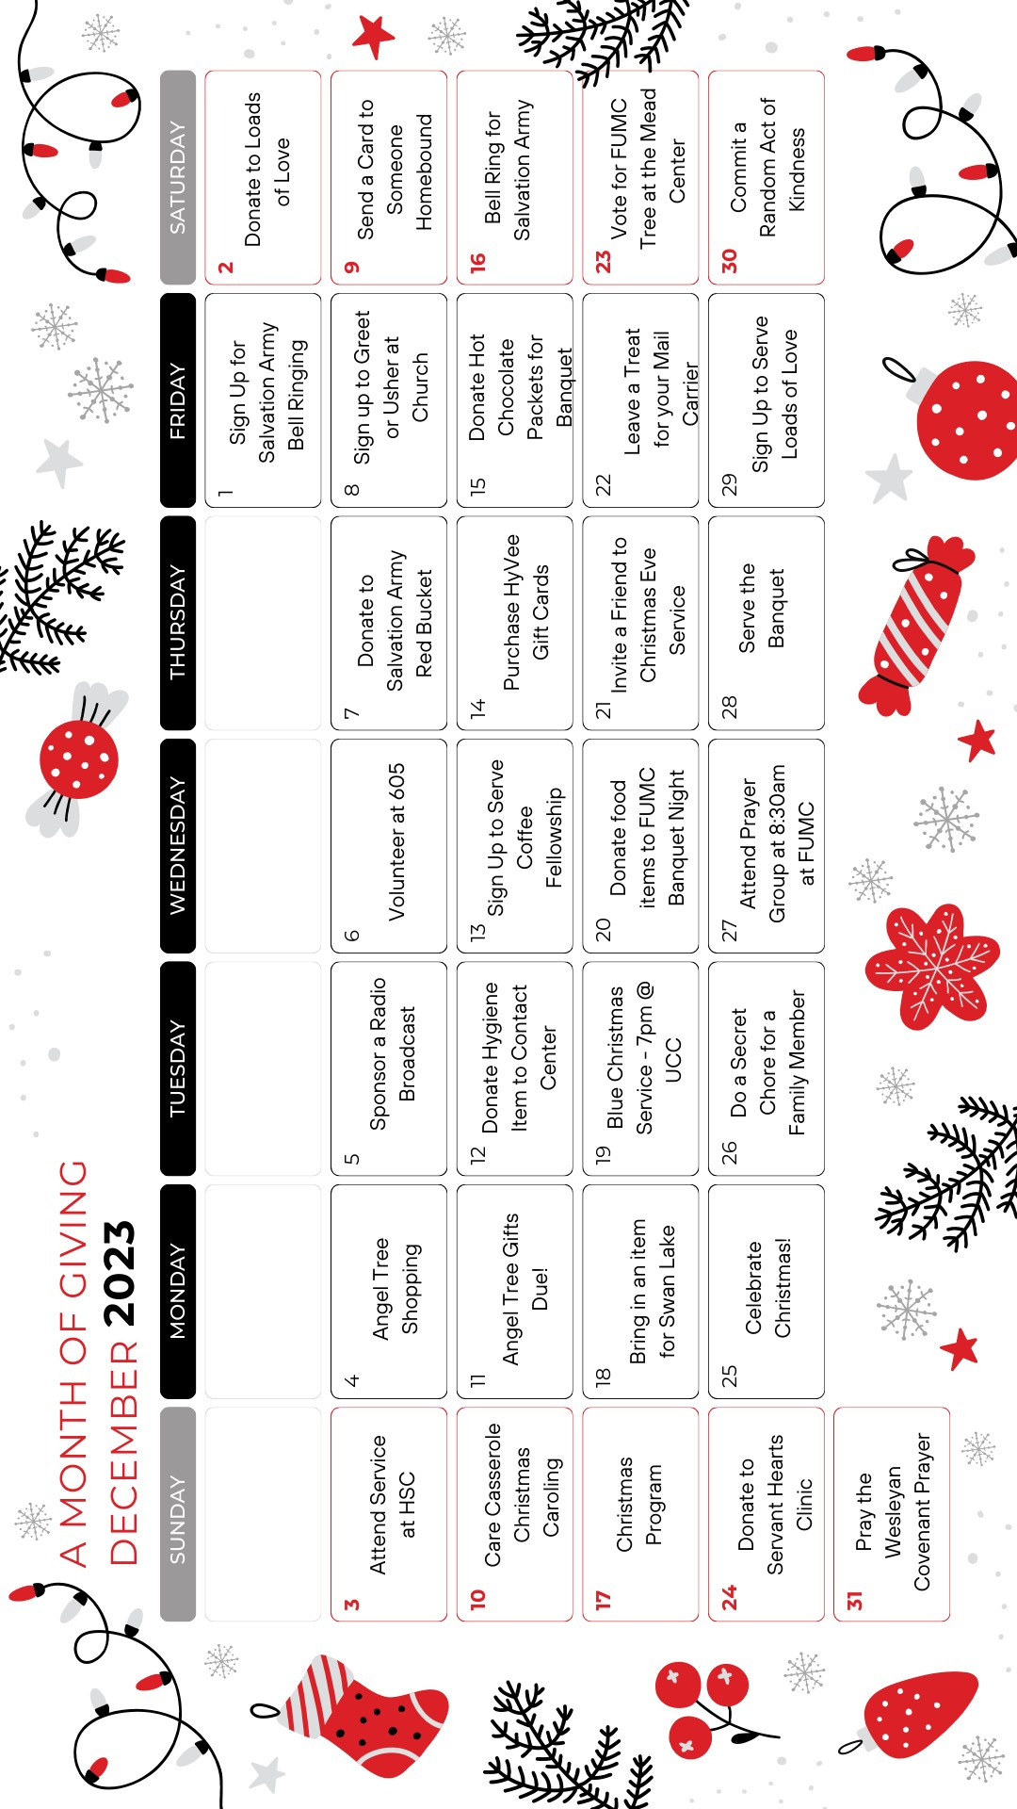
Instructions
Sign up for Bell Ringing---Go to sign up genius for available times on Thursdays, Fridays, and Saturdays through the month of December.
Donate or sign up for Loads of Love---Signup sheet on mission table. Donations can be accepted in the box on the table or through the regular giving methods but designating it for Loads of Love.
HSC Service is at 4:00pm.
Angel Tree shopping---Take an angel, write your name on the signup sheet next to the number that is located on your angel. Shop for a piece of clothing and a toy/game. Wrap them, put the angel on the gift(s) and return to the Angel tree by December 11th.
Sponsor a Radio Broadcast by signing up in the binder located in the lounge and/or call Lisa in the office.
Volunteer at 605 – Check with Carol Becker on the volunteer needs for serving and clean up.
Sign up to Greet or Usher---Signup sheets are located in the church lounge.
Care Casserole Christmas Caroling---Send names and addresses of homebound people in need of a visit to the church or to Carla Hummel. We will be taking a care casserole and will be singing a Christmas tune. If interested in delivering and caroling – please let Carla Hummel know as well.
Donate Hygiene items for contact center---There will be a bin in the church by the mission table.
Sign up to serve fellowship---Signup sheet is located in the church lounge.
Purchase Hy-Vee cards---Can purchase cards after service on Sundays or through the church office.
Donate hot chocolate packets for gifts at the Banquet---Mission table bin.
Items for Swan Lake---Mission table bin.
Donate to the FUMC Banquet night---Signup sheets will be out by December 20th. Please see if there is something that you can help provide and sign up to serve as well!
FUMC has a tree decorated at Mead Museum---Enjoy all of the trees at Mead Museum and don’t forget to vote for our tree!
Offering on Christmas Eve will be given to Servant Hearts Clinic.
If you have any questions on any of the opportunities for giving on this calendar, feel free to contact either Pastor Katie or Carla Hummel. Thank you for using this guide to help serve others!

