.
Mission Statement
First United Methodist Church of Yankton:

“To grow disciples of Jesus Christ and equip them for ministry in the world.”

From the Pastor’s Desk
Likewise, every good tree bears good fruit, but a bad tree bears bad fruit. A good tree cannot bear bad fruit, and a bad tree cannot bear good fruit. Every tree that does not bear good fruit is cut down and thrown into the fire. Thus, by their fruit you will recognize them. Matthew 7:16-20
During the month of October, we are diving into a new sermon series called The Five Practices of Fruitful Congregations. This series is based on the best-selling book by Bishop Robert Schnase which has been recently updated and re-released. In this book. Bishop Schnase outlined the ways in which vital and effective congregations produce good fruit. Much like the teaching of Jesus, when we live into our faith and our calling, we will bear good fruit. This is true of the individual, but it is also true of the church.
So, over the next 5 weeks we will be considering five different fruit that all vital congregations have in common: Radical Hospitality, Passionate Worship, Intentional Faith Development, Risk-Taking Mission and Service, and Extravagant Generosity. During this time, may we all be challenged to open our eyes to how we can continue to grow as a church and in bearing good fruit through our work together.
We will end the month talking about “Extravagant Generosity” and on that day we will also be receiving your pledge cards for the upcoming year (2024). Please be praying for how God is inviting you to participate and support the ministry and mission of the church. I would encourage you to consider upping your giving for the next year so that we can meet the budget that our Leadership Team has prayerfully set. If you haven’t already made a practice of regular giving (either in person or using direct deposit or Vanco) please consider doing so for 2024.
God is moving in our congregation, and I am excited for the ways in which God works through each one of us and all of us together. Good things are in store! So let us all invest in this community through our prayer, our presence, and our generosity!

Blessings! Pastor Katie

Christianity 101 Class - Sundays 8:30am
Join Pastor Katie in Wesley Hall on Sunday mornings at 8:30am for Christianity 101. This weekly class will be talking about all things related to theology, the church and our faith. Looking for a primer on basic Christian beliefs? Looking for a refresher on theology? Looking for an opportunity to get to know other people? This class is for you!! See you starting October 1st!

Human Services Center Worship
Join Pastor Katie every 1st Sunday of the month as she leads worship out at the Human Services Center. Come join the congregation and let your presence speak the love of Christ to the patients of HSC. The service is at 4pm. Please let Pastor Katie know if you are interested in going so, she can expect you.

October 1st - World Communion Sunday
Breads will be sold to help raise funds for 605 meals. Please donate breads (yeast & quick) to be sold and purchase one to bring home!

Charge Conference Date: November 5th, 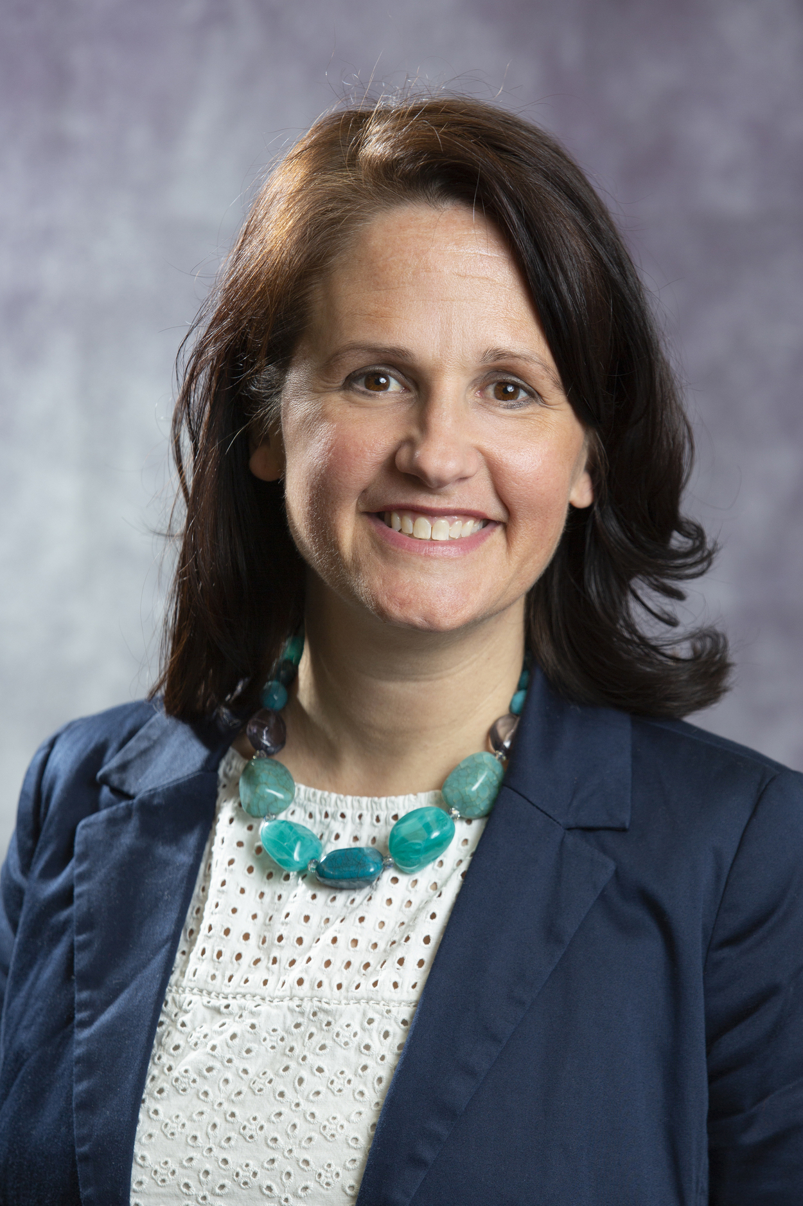2023
Please mark your calendars for this year’s Charge Conference: Sunday, November 5th at 11am. Join us for worship that day as our District Superintendent, Rev. Rebecca Trefz, will be sharing the message and then we will follow up the service with the Charge Conference meeting. The Charge Conference is our equivalent of an all-church meeting that happens once a year. Please also get in your applications for Leadership Team and Annual Conference Delegate to the Leadership Team prior to this date, as we will need to approve those persons at Charge Conference.

Leadership Team Openings for 2024
We have some opportunities for you to serve on the Leadership Team and Annual Conference! If you are a member of First United Methodist Church, you are eligible to serve on our Leadership Team or as a delegate to Annual Conference (in Bismarck, ND). Our Leadership Team has openings in Trustees, Finance and SPPRC. We also open the position of Lay Leader and Annual Conference Delegate every year. We can have 3 lay delegates from the church. If you are interested, please pick up a paper copy of the application or find it on our website and submit your application by the end of October. This is a wonderful way to serve our church!

Pastor Katie Out of the Office
Pastor Katie will be out of the office on the following dates: October 11th-13th: Board of Ordained Ministry Fall Meeting in Mitchell October 20th-23rd: Vacation. (Rev. Karl Watkins will lead the service on October 22nd.)

Chili Cook-off and Silent Auction a Success!
Thank you to everyone who attended the Chili Cookout and Silent Auction after worship on Sunday, September 24th. The Chili Cook-off raised over $1,100 for FUMC missions. The top rated chilis were:
1st: Jason Ricke
2nd: Monte & Susan Schavee
3rd: Sherry Daugherty
The Silent Auction raised over $1,000 to help fund the new playground being installed in the church’s east parking lot.
Special thanks to Carla Hummel, Sherry Daugherty and others for all the work to make it a special day!

Wednesday evening Kids & Youth Schedule
5:00-5:30pm Kingdom Bells (1st-6th Grade)
5:30-6:30pm 605 (PreSchool-6th Grade)
*Supper will be served
5:45-6:45pm Confirmation (7th-9th Grade)
7:00-8:00pm Youth Group (7th-12th Grade)

Important Dates
Sunday, October 1st: MS Youth group - Pumpkin Patch from 2-4pm
Tuesday, October 24th: Youth Group helps clean up Soup Kitchen 6:30pm
Wednesday, October 25th: Trunk-Or-Treat 6:15-7:15pm
Wednesday, November 1st: Youth SackPacks @ Calvary Baptist/DQ 5:15pm

United Women of Faith (UMW)
You are cordially invited on October 2nd at 1:30pm here in our church lounge for October's meeting. Our program will be Lori Anderson from Hy-Vee Floral. Everyone is invited. If you have any questions, please let me know.
Lydia Giziewski

Soup Kitchen
Yankton's "best" Soup Kitchen is scheduled for Tuesday, October 24th from 4:30 to 7pm. Once again, we need the congregation's help and support to continue this tradition. Donations of 9-inch pies, one and half gallons each of chili, chicken broth with chicken (noodles added later), and seasoned vegetable beef soup are needed as well as cash donations to purchase supplies. Send your donation information of pies and soup to Delores Kafka delkafka9@gmail.com no later than October 9th. A Donation form is in the reminder for your convenience. Cash or check donations should be sent to the church office noting Soup Kitchen and made out to United Methodist Women.
You may get a call to work or donate. Please say yes! Donations may be dropped off as early as 7am the morning of the Soup Kitchen. This project is a major source of funding for United Methodist Women's budget which pays for a portion of camping fees for youth and for mission projects. Please pray for the project. Participate by donations. Be present for the event. If you have questions, please contact Lydia Giziewski or Susan Schavee.

Trunk or Treat,
Join us for Trunk or Treat Wednesday, October 25th 6:15-7pm in the Church Parking. Please Park in the east parking lot. congregation members: Decorate your trunks with a theme, balloons, streamers, music, etc. Have some pre-packaged candy to pass out to our kiddos.

Deep Roots
by Susan Thorson, Faith Community Nurse
Fall is here and we begin to see the changes of seasons again. As I go for a morning walk, I notice how the Big Bluestem on our property was green and now it is turning a rusty red with maturity. I see the stems glistening as the sun shines upon them, then I follow the stem with the leaves almost a half inch wide. The stalk produces several hairy three to six fingered “turkey foot” spikes which can grow to one- and one-half inches to four inches long. The indigenous people of the tallgrass prairie used the stems to support earthen roofs and children fashioned arrow shafts which were used in play to practice manly skills. The lower leaves were used for medicinal purposes by the Native Americans. My ancestors who came to the prairie used the Big Bluestem for the sod placed on the roof of their first home. Big Bluestem grows 3-10 feet tall and is the dominant grass of the Tallgrass Prairie. Its roots can reach from 3 to 12 feet into the earth, stabilizing the soil as well as regenerating the soil. The benefits of Big Bluestem are many from providing food bison, cattle and birds, attracting wildlife and insects including skipper butterflies, providing nesting for songbirds, and the roots to prevent soil erosion.
As I walk, I am thinking about what God created and how this all fits together. The roots of the Bible, like the Big Bluestem are deep and provide us with spiritual sustenance and help us renew and strengthen our faith. The Bible reveals who God is, and who we are. It has God’s plan for our salvation, how we should live and what happens when life is over. Like the Bible, the soil in which the Big Bluestem stabilizes and regenerates, is vital for sustaining life on earth. It seems like to me we must live in harmony with the earth and with the Bible as guidance as we go through life. From 2 Timothy 3:16-17 these words say: “All scripture is God-breathed and is useful in teaching, rebuking, correcting and training in righteousness, so that the servant of God may be thoroughly equipped for every good work.” We must keep our deep roots in the Bible, faith in God and be good stewards of the earth which are all vital for our life. Blessing to you for this Fall season

Thank You
Thank you to the Bibles and Brews crew and to all of you who supported the Sole Hope mission. We mailed 78 pairs of cutout patterns for shoes to Uganda, along with a check for $591 for medical foot care. You are all a blessing!
Marilyn Elwood

In Our Thoughts & Prayers

Ed Durst, Alicia Cornemann’s dad passed away

Marbeth Nyquist, Chrissie Wieseler’s mother

Prayer for the Joyce Kollars family, she passed away.

Prayers for the family of Bill & Nancy Fargo, their granddaughter passed away.

Joyce Myers, friend of Katheryn Hickey

Prayers for Dawn Kabella, she was diagnosed with cancer.

River Brown, Doug Baily,

Brenda Asher, Vivian Van Essen’s niece

Caitlin Jensen for healing

October Birthdays
2 - Jane Rodig, Lawrence Sweet,

3 - Paula Keehr

5 - Bob Thue, Kenzie Giziewski

8 - Don Lepp, Sherry Rabenberg

9 - Garner Brandt, Chuck Ditmar

11- Isabella Downs

12 - Marilyn Holzwarth, Mary Heubaum,
Heather Hirsch, Trevan Palecek

15 - Judy Bevers, Bill Fargo

16 - Terry Norton

17 - Claudia Maska, Naomi Somer,
Mike Erickson, Jack Olson

18 - Elle Guthmiller

19 - Heather Rabenberg, Amanda Gravholt

20 - Chad Herrmann, Kaitlin Guthmiller,
Ryan Bakke

21 - Dave Becker

22 - Samuel Slowey, Loran Moore, Eve Gall
Abbi Olson

23 - Marv Withrow

26 - Brooks Ugofsky, Austin Nickles

27 - Evie Sime

29 - Alyssa Herrmann,

31 - Kathy Wibbles, Morgan Bakke

FUMC Financials
by Diane Kisch (Financial Assistant)
2023 Income | Cash Flow
Month | Income | Expenses | Amount
Jan | $70,623.95 | $45,095.94 | $25,528.01
Feb | $33,283.73 | $31,574.79 | $1,708.94
Mar | $24,117.27 | $34,263.61 | ($10,146.34)
Apr | $29,432.81 | $34,010.70 | ($4,577.89)
May | $25,581.96 | $30,606.20 | ($5,024.24)
Jun | $24,021.33 | $34,274.20 | ($10,252.87)
Jul | $30,771.07 | $30,744.61 | $26.46
Aug | $25,851.88 | $39,837.54 | ($13,985.66)
Totals | $263,684.00 | $280,407.59 | ($16,723.59)
Projected 2023 Expenses are $447,961.00.00
* Income for January is generally higher than other months as we have some members that give their annual pledge in one month.

