.
Mission Statement
First United Methodist Church of Yankton:

“To grow disciples of Jesus Christ and equip them for ministry in the world.”

From the Pastor’s Desk
But seek first his kingdom and his righteousness, and all these things will be given to you as well. -Matthew 6:33

Have you ever dwelt on the word “Fall”? As the calendar turns to September, I find myself eager to embrace all that fall has to offer - the cooler weather, the turning of the leaves, the hot apple cider and so much more. I love fall as a season and when I think of fall in that way, it is one of my favorite words.
But fall can also be a verb, as in “to fall” and that experience is less pleasant. But we all face that reality as well. -sometimes we fall down. Sometimes our hopes fall or our face falls. Sometimes our revenue falls or our attendance. Fall, when understood in this way - is not my favorite word. But it is a reality of the world.
But I am reminded of another way to think about the word “fall” as when something “falls into place.” This is using the verb fall in a different, more positive way. We might use it when describing the last puzzle piece as it fits into the final hole in the puzzle. We might say it as we watch all the dominoes tumble one after another into an intricate design on the floor. And we might use that very phrase to talk about what it looks like when we have our priorities in order. The gospel of Matthew says, “seek first his kingdom and his righteousness [Jesus] and all these things will be given to you as well. (6:33)
Sometimes it feels like things are not as they should be. Sometimes it feels like our life can be out of sorts and chaotic. Sometimes it feels like we cannot get our ducks in a row. But scripture reminds us - Seek first the kingdom of God, then the rest will fall into place. Make God your priority and the rest will sort itself out. Worship God first in your life and you will find that everything else will find its proper place in our priorities.
So, blessings this fall! May you find your life “fall”ing into place this season!

Pastor Katie

XYZ: Wednesday, September 13th at 10am
Join Pastor Katie for a time of fellowship for those retirement age and above! Have something interesting you’d like to reminisce about? Read something curious in the paper? Bring it along and share it! Coffee is provided.

D3 Soul Scan
Start your discipleship journey by taking your D3 Soul Scan today! Pastor Katie will use the scan to personalize support for you as you grow in your discipleship. Once you take the scan, Pastor Katie will reach out to you for next steps.

Worship at the Human Services Center
Pastor Katie leads worship at the Human Services Center on the first Sunday of each month at 4pm. This is an incredible opportunity for our church to be a blessing (while being blessed) by those that HSC serves. If you’d like to help out with the service, please let Pastor Katie know.

New Wednesday Night Small Group - 7pm
Join Pastor Katie starting August 30th for a small group study on Wednesday nights. This group is open to anybody, and we will begin with a video series found on Right Now Media called Love in Chaos featuring Bob Goff. We will be meeting in the confirmation room.
This study will also be available on Tuesdays at noon starting on September 5th. All are welcome to that option as well!

Questions with Pastor Katie
Got burning questions about God? Faith? The Church? Ask Pastor Katie! Summit your questions using the box found outside of the church office or ask Pastor Katie directly and she will design a class based on your question! Nothing is off limits. If you are wondering it, others might be too! Classes will be scheduled once Pastor Katie has 2-3 questions.

Special Session of Annual Conference Recap
By: Doreen Gosmire, Director of Communica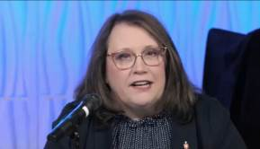tions, Dakotas UMC
“Faith brings surprises. Faith offers us connection with people near and far. Faith tells us of God’s power and grace; both ever in motion, constantly beckoning us, and moving us forward. Faith finds truth in the immortal words of John Wesley: ‘best of all, God is with us!’”
These were the words of the call to worship during the 2023 Called Special Session of the Dakotas Annual Conference on August 15, 2023.
The purpose of the session was to consider the ratification of 15 disaffiliation agreements. The Book of Discipline’s ¶ 2553 allows churches to leave The United Methodist Church with property if they meet certain financial and procedural requirements, including at least a two-thirds vote by the congregation and approval of the disaffiliation agreement by the congregation’s annual conference. All fifteen of the disaffiliation agreements were ratified during the session held virtually.
After decades of increasingly rancorous debate about LGBTQ inclusion at the denominational level, the 2019 special General Conference added a church law that allows U.S. congregations to leave the denomination with property if they meet certain financial and procedural conditions.
As a result, what largely had been a debate among denominational leaders has seeped into local congregations as well as false accusations that The United Methodist Church is abandoning core Christian doctrines.
Church exits have accelerated since last year’s launch of the Global Methodist Church, a conservative, breakaway denomination that aims to maintain bans on same-sex marriage and noncelibate gay clergy.
To date, United Methodist News Service reports there have been 6,240 United Methodist congregations in the United States that have disaffiliated. The number represents about 20% of the UMC churches in the United States.
In the Dakotas, 58 churches have chosen disaffiliation representing 25% of the number of churches reported in 2021, and 8,600 members or 25% reported in 2021. All data is self-reported annually by each congregation.
This ends the disaffiliation process for the Dakotas Conference under ¶ 2553. The legislation authorizing disaffiliation for local churches wishing to leave the denomination expires at the conclusion of 2023.
Presiding at the session, Bishop Lanette Plambeck, offered this prayer. “I pray for all who have chosen to separate from the Dakotas Conference and all ministries related to the United Methodist Church that as you step out in faith on new paths, that God would bless you and your ministry and that you would indeed reach those that we who remain in the United Methodist Church would not be able to reach. Amen.”
She also thanked and offered words of hope to those who choose to remain United Methodist. “For the 80% of United Methodists across the world who have determined that God has called us to remain in the United Methodist Church, thank you. Thank you for the ways in which you love God and love each other. Thank you for the ways in which you bear witness in the world through ministries of compassion, mercy, justice, and service. It is good for us to proclaim who we are called to be the church, the body of Christ in the world.”
Bishop Lanette closed the session reminding everyone of the theological task for The United Methodist Church, ¶ 105, of The Book of Discipline, that ends with Ephesians 3:20-21: “Now to God who by the power at work within us is able to do far more abundantly than all that we ask or think, to God be glory in the church and in Christ Jesus to all generations, for ever and ever. Amen.”

Wednesday Evening Kids and Youth Schedule
5:00-5:30pm Kingdom Bells (1st-6th Grade)
5:30-6:15pm 605 (PreSchool-6th Grade) - Supper will be served!
5:45-6:45pm Confirmation (7th-9th Grade)
7:00-8:00pm Youth Group (7th-12th Grade)
Sunday, September 17th @10:00
4th grade bibles handed out during service
To receive important information about Kids (preschool-6th) and youth group (7th -12th grade):
FirstKids: Text @1stumckid to the number 81010
Youth Group: @1fumcyouth to the number 81010

United Women of Faith (UMW)
Hi, I'm Lydia Giziewski, president of our United Women of Faith Group. You are cordially invited on Sept. 11, 2023 at 1:30pm here in our church lounge for September's meeting. We have a program each month and a short business meeting and a light lunch. Our meetings run about an hour. This month our program is Jane Gilmore and the Swan Lake Ministry. Please come love to have you join us. If you have any question, please let me know.

Chili cookoff!
Sunday, September 24th after Church. There will also be a silent auction stemming from a FUMC member’s reverse offering! Looking for teams to compete in – friendly competition of course! Voting will be done with dollars. Dollars work well for bidding on the silent auction too. 😊All proceeds go towards the missions supported by FUMC. For more information, please contact Carla Hummel at 605-660-7390.

Worship Team
Worship Team is a ministry dedicated to leading worship through music. We pray for God to help us inspire everyone to join us in praise that helps us all see God's message more clearly, encourages a joyful noise and maybe even lift our hands in Hallelujahs. If you have any questions about worship team, please feel free to call and ask me, Sara Klawonn, after 2 pm at 605-254-7070.

Kingdom Chimes
Grades 1-6 Wednesdays from 5:00-5:30pm upstairs in the music room at the far end of the Education wing. We will learn to read music and play chimes together and share in worship services once a month. Practice starts Wednesday, September 6th.

Jubilee Bells
Our existing adult bell choir that plays bells and chimes will meet on Wednesday nights from 5:30-6:30 starting September 6th. We have lots of fun ringing together and sharing our love of music with the church in worship once a month.

Chancel Choir
Chancel Choir offers opportunities for those who love to raise your voice in thanks and praise to God. There is a place for you in this music ministry. If you have been thinking of joining the choir, or if you are new to town or to the church, the Chancel Choir family within our larger church family is an excellent starting point. We are eager for you to join us as we sing a wide variety of music from contemporary to gospel. Practice starts Wednesday, September 6th at 7 – 8pm in the Sanctuary.

Volunteering Opportunities
"Behold, how good and how pleasant it is for brethren to dwell together in unity!"
~ Psalm 133:1
Reminder to please look at the sign-up sheet for Ushers and Greeters, it is located on the shelf before entering the worship service. There is a sign-up sheet for Coffee Fellowship that is located in the kitchenette as well. Thank you for your dedication to First United Methodist Church, your compassion and kindness is an inspiration to all members of our congregation.

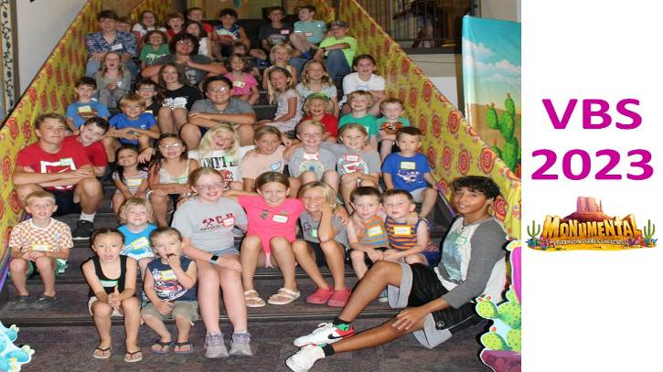

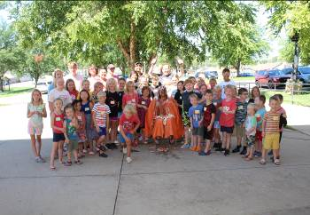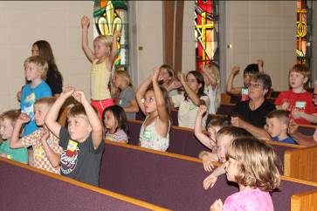

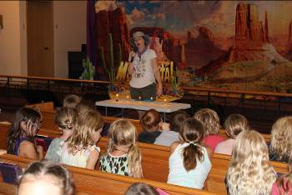

Leadership Team Updates
The job opportunities at First UMC have been filled. As previously announced, Tiffany Beste will take over responsibility for Kids Hope, Sara Klawonn will assume responsibility for all youth musical activities including bell choirs for youth. Dani Frahm will be Member Care Coordinator. Carla Hummel has volunteered to be Mission Coordinator. Jill Wilson will assume duties for Adult Bell Choir. We thank all of these individuals for stepping into these roles to further the mission of First UMC. We are counting on congregation members to assist when asked or to volunteer to help when activities dictate.
Just for clarification, Member Care work will involve internal church activities like coffee fellowship, maintenance of the 3 Libraries, recruiting greeters and ushers, and nursery maintenance. Mission work will involve working with external activities like the Banquet, Loads of Love, working with Habitat for Humanity and many more. If you have questions, concerns, or ideas, please direct them to any of these individuals, Pastor Katie, or anyone on the Leadership Team.
And finally, thank you to Sue May, who led our Bell Choirs for many years and to Julie Moderegger for her worth with Kids Hope and Parish Care and Outreach. Your work made a difference in so many lives. Best wishes to you both and again our thanks.

Care Casseroles
In the freezer, are newly prepared additions. New offerings include Tuscan Chicken Pasta Bake and Cheesy Southwestern Rice Casserole. We also have cookies and breads. Remember these are for anyone who is facing medical issues, grief, stress, or just because. Two hundred plus have been gifted so far. We've received many positive comments plus notes including these two. “How incredibly nice of you to show up at our door with delicious casseroles and banana bread.” You not only brought delicious food but happiness for your kindness." And “the casseroles were used during my radiation treatments. Thank you so much.”
We will continue filling the Care Casserole freezer as long as the need exists. Watch the Reminder and bulletins for updates including cook dates and supply needs. Food is love and a way to continue the mission of First UMC to the congregation and to the community.

Staying on Track
by Susan Thorson, Faith Community Nurse
Summer is winding down and soon students K-12 and college will all be back to school. Summertime offers each family more time to be together. When school starts, schedules change and everyone starts going in different directions. Even though many families have been through this time of change, it is often a time of adjustment for everyone again. There are several specific things a family can do to stay on track. As Christians, we can focus on what we have been taught by our faith leaders and what we practice each day. Beginning each day, we can pray individually and as a family. Prayer is necessary every day, not just when we are in a crisis. You can pray at mealtimes, on the way to school, after school or at any time. Place a short prayer in your child’s lunch box or in their backpack. By praying we are investing in a relationship with Jesus.
Become involved in each other’s lives. Let your children know about the excitement of your job accomplishments. Be a part of your child’s life by showing up at their activities at school and church. Take an interest in their friends and open your home up to their friends. Take time each day or several times a week for devotions for yourself and your family. Once you start and stick with it, devotions will be a part of everyday life. Helping your children with school activities is important but also reading the Bible is a top priority.
Your children are going to be exposed to others with different faiths and some who have no faith background at all. Help your children understand and know what being a Christian means and specifics about your faith tradition. Plan weekly family meetings where you discuss schedules, chores, concerns, and to establish a “fun” time each week. Plan the evening meals so everyone can be home together. Try scheduling Saturday morning breakfast by going out or having Dad make breakfast at home. Empower children to participate in church activities each week whether it is children’s time on Wednesday evenings or youth group. Perhaps it is a mission project where the whole family is involved. Maybe it is being involved in choir or with the bell choir. The key is to help them become disciples.
I leave you with this Bible verse: Philippians 3 16:21 “Now that we’re on the right track, let’s stay on it. Stick with me, friends. Keep track of those you see running the same course, heading for the same goal.” Blessings to each of you.

Church Library
Volunteers have organized the library off the upstairs lounge. The library now has church history books, bibles, reference books, group study books and other church history. Check it out, we found very interesting books.

The Childrens Library
New Childrens Library located in the Childrens Gathering Room, lower level. Books are to read, share and exchange anytime. Gently used children’s books appreciated for this project. The bookshelves were donated by the Scott Giziewski family.

Computer and Sound Volunteers
We are always looking for additional volunteers to join our sound and visual team to help stream our worship services. Please contact Tiffany if you are looking for a place to volunteer your time and talents. She will train and mentor you through the process.

Church Directory
We will be working to update our church directory with accurate information and new family pictures! Please fill out the form with updated information at the link provided: https://forms.gle/KAvPnBw4E97N1vuVA
Or scan the QR code with your camera's phone to complete the form. You may email a family picture to Tiffany @ 1stumckidsyankton@gmail.com or upload it through the form or line up a time for her to take a picture at church.

Canning Items Needed
FUMC needs canning jars and lids for our produce from the community garden. Pint and quart size. Donations can be left in the church
office.

Thank Yous
It’s true – prayer does make a difference! Thank you for your prayers and kindnesses. Merle had both Covid and Influenza at the same time and was hospitalized. Your support meant a lot and we thank you!
Merel and Virginia Larson

I would like to thank my church family for all the beautiful cards and messages sent to me for my 90th birthday. I would also like to thank those of you that were able to attend my open house celebration. It was a very special day for me, and I appreciate your thoughtfulness.
Mary Johnson

Thank you to our congregation for acknowledging my birthday and the United Way volunteer of the month recognition. Your thoughtful words are appreciated!
Susan Thorson

In Our Thoughts & Prayers

Marbeth Nyquist, Chrissie Wieseler’s mother

Joyce Myers, friend of Katheryn Hickey

Prayers for Dawn Kabella, she was diagnosed with cancer.

Ardis Henderson’s family. Ardis passed away.

River Brown, Doug Baily,

Brenda Asher, Vivian Van Essen’s niece

Caitlin Jensen for healing

September Birthdays

1 - Jess Dennis, Gage Guthmiller

2 - Morgan Rodig

3 - Maren Nedved

4 - Sam Mooney, Ken Olsen, Kylie Rodig,
Larry Guthmiller, Stetson Brandt

5 - Brinnleigh Novak

6 - Denise Erickson

7 - Harlan Teichroew

8 - Carol Becker, Brady Jaquith

10 - Kim Larsen, Lydia Giziewski, Alison
Karnes, Randy Heisinger, Nicholas Doby

11 - Parker Kisch, Rick Petersen, Anna Nickles

13 - Anne Withrow, Tom Downs

14 - Lindsey Hale, Shirley Root

15 - Harper Den Herder

17 - Darian Tramp

18 - Bob Walser

19 - Marilyn Elwood

20 - Chris Peterka, Chrissie Wieseler,
Brennan Novak

21 - Kirsten May

22 – Arlys Cauwels

25 - Toby Gall, Deklan Olson, Will Dangler

26 - Paul Nielson, Kody Kyriss, Joyce Kollars

28 - Josey Kaiser

29 - Kami Cornemann, Dave Holzwarth,
Bev Larsen, Preston Nedved, Scott Enfield

30 - Curt Dykstra

FUMC Financials

by Diane Kisch (Financial Assistant)
2023 Income | Cash Flow
Month | Income | Expenses | Amount
January | $70,623.95 | $45,095.94 | $25,528.01
February | $33,283.73 | $31,574.79 | $1,708.94
March | $24,117.27 | $34,263.61 | ($10,146.34)
April | $29,432.81 | $34,010.70 | ($4,577.89)
May | $25,581.96 | $30,606.20 | ($5,024.24)
June | $24,021.33 | $34,274.20 | ($10,252.87)
July | $30,771.07 | $30,744.61 | $26.46
Totals | $237,832.12 | $240,570.05 | ($2,737.93)
Projected 2023 Expenses are $447,961.00.00
* Income for January is generally higher than other months as we have some members that give their annual pledge in one month.

