Mission Statement

First United Methodist Church of Yankton:

*“To grow disciples of Jesus Christ and equip them for ministry in the world.”*

# From the Pastor’s Desk

*"So we fix our eyes not on what is seen, but on what is unseen, since what is seen is temporary, but what is unseen is eternal.”*

*- 2 Corinthians 4:18*

I find myself easily overwhelmed these days about the amount of things that I can see. When I sit at my desk, I can see the task list in front of me grow ever longer and the hours seem insufficient to cover what needs to get done. I pick up my children and see their needs for food, for attention, for affection that seem never-ending. I return home to see chores that need to get done - laundry to put away, dishes to be washed, cats to be fed, and so on. I look at my calendar and see the days fill up with activities and opportunities that I need to do or think I need to do. There is no shortage of things that I can see demanding something from me - especially my time and my attention.

It is so easy for the things that can be seen to overtake the things that cannot be seen. So, we fill our days trying to fulfill all the needs we can see and often it leaves very little room, if any, to tend to the needs that cannot be seen. In particular our spiritual needs and the spiritual needs of our families. And yet, when we think about it, our spiritual needs may be some of the most important needs that we have because our faith is about things eternal. Things that will matter always.

Many of the things on my to-do lists are things that are important, but I will not think about again given a day, a week, a year, 10 years or 50 years down the line. But our faith is eternal. When we neglect to grow in our faith and our discipleship, it has ramifications for our eternal lives. It is extremely important that we invest time in the things unseen - in our relationship with God through Jesus Christ. It is extremely important that we spend time in God’s presence in the fellowship of other believers. It is extremely important that we set an example of faith to our children, our grandchildren and to all our loved ones.

When we focus on what is immediate, what is urgent, what is right in front of us to the point that we forget to focus on the things of God - we have gone astray. This Lenten season, commit yourself to fixing your eyes on what is unseen - and encouraging others to do the same. Dedicate this time leading up to Easter as a time to reconnect and revitalize your faith so that when we celebrate the resurrection - it can truly be a celebration for us all.

Blessings!

Pastor Katie

# Thank you from Pastor Katie

Just wanted to write a thank you to all who came to the Homosexuality & The Bible course this January. Homosexuality can be a difficult topic to talk about and discuss, but everyone in the class did a wonderful job of being curious, respectful and courageous. I look forward to more open, honest and heartfelt conversations with all of you in the future!

# Town Hall Meeting

# (January 30th, 2023)

The Leadership Team of First United Methodist Church hosted a Town Hall Meeting in Wesley Hall on Monday, January 30th, 2023. Susan Schavee, Chair of the Leadership Team, opened the meeting with a devotion and introductions to the Leadership Team along with a brief description of their roles and responsibilities.

Dave Cornemann, a member of the Finance Team and Vice Chair of Leadership Team gave a report of the end-of-the-year finances in 2022 and the approved budget for 2023. In November of 2022, we were projecting that FUMC would end the year with a shortfall of $50,000. However, thanks for the generosity of our members and the frugality of our staff and committees, we ended the year with a shortfall of only $15,000. This $15,000 was covered with a previous year’s end of the year surplus, so we did not have to use any of our savings to cover finances for 2022. For 2023, the budget was reduced from the figures in 2022, but Leadership Team still approved a budget with a shortfall around $50,000. The Finance Team has approved budgets with shortfalls for many years. The church will need to evaluate their giving and increase to meet this budget for 2023.

Pastor Katie gave an overview of the United Methodist Church leading up to the Special Session of General Conference in 2019 and what has transpired since. She then had a time of Q&A.

Q: What will happen to the pastors of our churches if we disaffiliate from the UMC?

A: Pastor Katie explained several scenarios that could take place.

Q: Of the 17 churches in the Dakotas Conference that have disaffiliated, how many are traditional or progressive?

A: All 17 are traditional.

Q: Where will the Global churches get pastors?

A: Katie guessed that they would get pastors by various ways, but the conference would not supply them.

Q: Will disaffiliated church members be allowed to attend UMC camps in the Dakotas?

A: Yes, our UMC camps are open to all, even non-Methodists.

Q: If traditionalists want to keep the language as it is in the Book of Discipline, why are they voting to leave (since it hasn’t happened yet)?

A: They “have seen the writing on the wall” and don’t want to keep having this conflict and discussion in the future.

Q: Will the UMC continue in the belief that Jesus Christ is Lord? Will God still be called Our Father?

A: Pastor Katie serves the conference on the Board of Ordained Ministry in the Pastor as Theologian subgroup and stated that the UMC will always teach the basic principle that Jesus is Lord, and that God will be called Our Father.

|  |  |
| --- | --- |
| Traditional Incompatibilist | Does not want to be in a church/denomination where homosexuality is accepted anywhere. |
| Traditional Compatabilist | Personally do not affirm homosexuality, but can be in a church where it is accepted if I am not forced to change my belief. |
| Progressive Compatabilist | Personally affirm homosexuality, but can be in a church where it is not accepted if I am not forced to change my belief. |
| Progressive Incompatabilist | Do not want to be in a church where homosexuality is not affirmed anywhere. |

Q: How many UMC’s in the Dakota’s Conference?

A: 245

Q: There were 3 plans to solve this question back in 2019. Explain those plans and what happened to those plans?

A: There was discussion about the 3 plans to stay united and steps churches could take, but due to COVID and disruptions, those plans were not supported and eventually fell apart.

Following, Pastor Katie defined the 4 categories used across the UMC in reference to the topic of homosexuality and the church: Traditional Incompatible, Traditional Compatible, Progressive Compatible, Progressive Incompatible.

Everyone was then invited to take an informational poll, marking which category with which they identified. They were also asked to mark if they were a member or not a member. The results were counted and shared with the group.

(This poll was also given to the youth group and made available as a link on Pastor Katie’s “What’s Going On” weekly podcast for anyone to participate.)

**The Leadership Team has reviewed these results. We will be having another Town Hall Meeting on Monday, May 1st at 6:30pm. We will be offering one more straw poll on this subject.**  Other topics that will be covered at that meeting include a budget update, Discussion on worship times and days, and more. If you have a topic that you’d like included in the town hall discussion, please let Pastor Katie or Susan Schavee know. Definitions of the 4 Categories

# Results of the INFORMATIONAL POLL

(These results include the Town Hall Meeting, Youth Group & Responses submitted via the link from the “What’s Going On” podcast.)

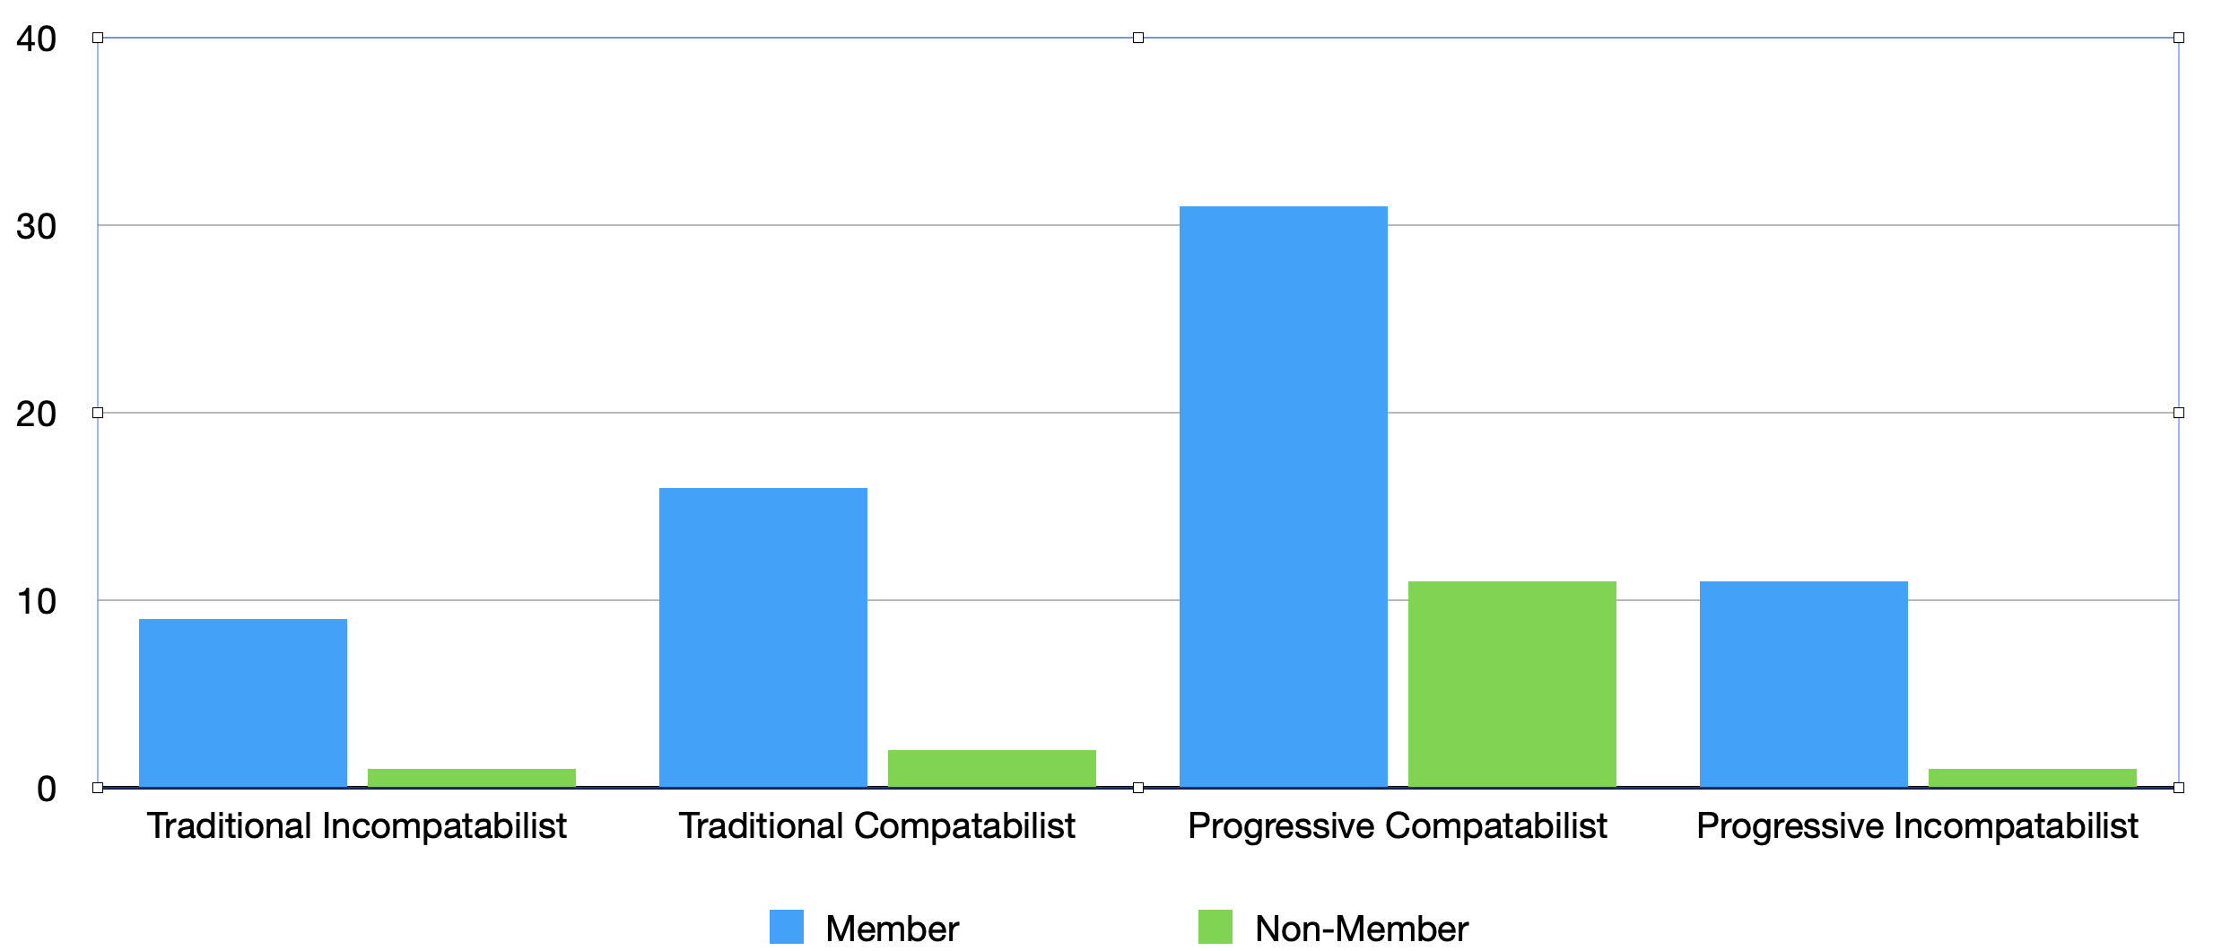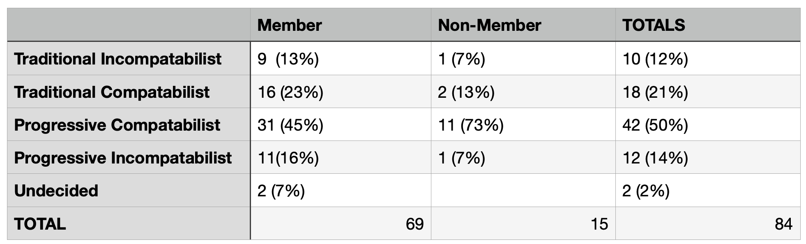

# 

# Questions with Pastor Katie Schedule

|  |  |
| --- | --- |
| * Sunday, March 5th @ 8:30am | * The United Methodist Book of Discipline |
| * Sunday, March 12th @ 8:30am | * Therapy |
| * Sunday, March 19th @ 8:30am | * Angels |
| * Sunday, March 26th @ 8:30am | * Church & Politics |

# Right Now Media Recommendations

Have Right Now Media but not sure what to watch? Marilyn Elwood has kindly given some recommendations of studies you should check out!

**The Discipleship Pathway by Anthony Delaney**

This is a great video for both youth and adults. It uses Bible stories as

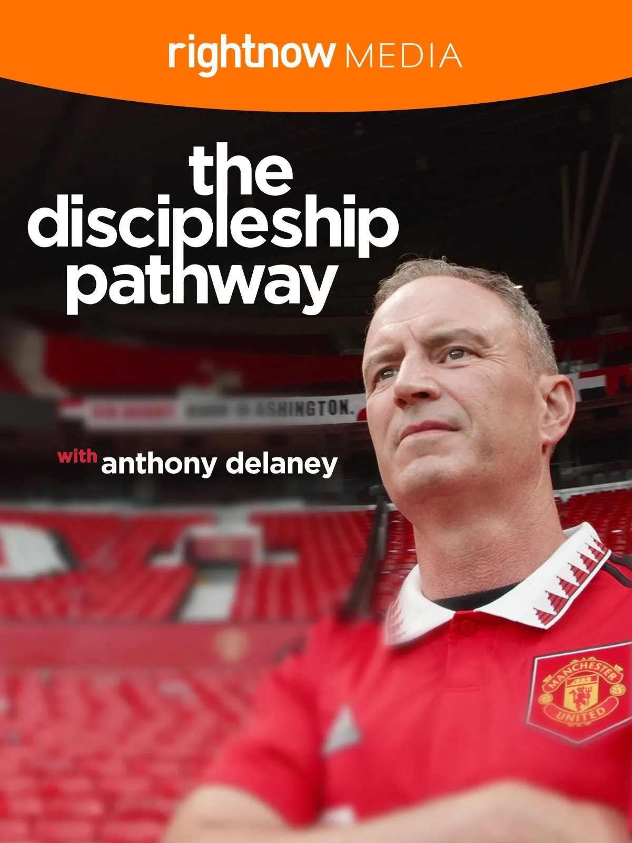

examples of how Jesus shows us that everyone matters to God. It points to taking ownership of our relationship with Jesus and how we can be faithful in sharing this with people God has brought into our lives.

**Mission Possible by Tim Tebow**



Who doesn’t love Tim Tebow?! Tim does a great job of sharing Gospel stories that teach us to trust God’s plan in our lives and how to live the purpose. He has for each of us —to love God and to love people.

**The Bible by Brody Jespersen**

This study hits the mark for explaining the “big picture “of the Bible. It is listed in the Youth section but is good for anyone. The Bible is presented as one story from Genesis to Revelation (with story elements: set-up, introduction and conflict, rising tension, climax, resolution, and ellipsis. It is the story of God’s relentless pursuit of us. And we are still continuing that story today.

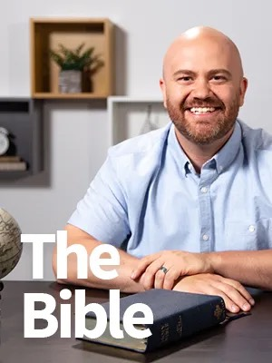

**Redeeming Your Time by Jordan Raynor**



This is a good study for adults with very busy schedules (especially in the business world). Jordan gives practical advice based on Bible stories and examples of how Jesus prioritized His time. Jesus was busy, but never hurried or anxious about what He had to do.

# World Day of Prayer

World Day of Prayer will be observed on Friday, March 3rd at 2pm at Walnut Village. The program sponsored by Church Women United was written by the Women of Taiwan. This day is celebrated worldwide on the first Friday in March, this year, March 3rd. Please join women of many faiths in offering prayers for our world and its people. Representatives of our church from United Methodist Women are Dee Carson and Mary Alice Halverson.

# United Methodist Women

UMW will meet Monday, March 6th at 1:30pm. We will meet in the Church Lounge by the sanctuary, 2nd floor. Our program this month is sharing information on the outreach of our community garden.  Come and join us! Look forward to seeing you there!

# March is Camp Month

**Summer Camp – Time to start planning!** Camp brochures are here – if you did not get one in the mail, you can find them in the lobby downstairs. Deadline for the Early Bird price is April 30th.  The church will take care of ½ of the early bird cost of one camp per **youth**. If your youth is going to more than one camp, you are responsible for the cost of the other camps.  If you register after April 30th – the church & UMW will only pay for ½ of the early bird cost. You will be responsible for the difference between early bird and full price. To register, you will need to call the office to get the church code that you will enter on the registration form, this code will automatically subtract the church’s portion from your payment. You will be able to register more than one person at a time but if you are registering the same person for more than one camp you need to do a separate registration online for the second camp.

The Conference runs an across state bus to Storm Mountain – if you plan to have your youth ride the bus you must mark it on your registration form. We encourage you to attend camps that other youth in your grades are going to – hopefully we can carpool whenever possible. Remember if your child is riding with someone it is common courtesy to help cover the cost of gas. If you plan to use the church van – it needs to be half full (8 people or more – if you only have 7 and feel you need to use the church van check with Tiffany).

Those riding in the van are responsible for gas. Tiffany needs to know if you would like your youth to ride in the church van or carpool with others.  She will be able to tell you if anyone else is signed up for a camp you are thinking about. It is very helpful if Tiffany gets a copy of your registration forms, so she knows what camps your youth are going to.

For the K – 3rd graders we need to have 1 adult attend camp with every 5 campers. There is a cost for Shepherds to attend the Mini Camps, SonSeekers and Summer's Last Blast camp. Remember the grade listed for each camp is the grade the camper is currently in.

<https://www.dakotasumc.org/camping/camps-and-events>

If you have questions about this process, you can talk to Tiffany at church or call (605) 695-0178.



# Camp Scholarship Funds with the Dakotas Foundation

            This fund was established to assist youth with camping registrations and/or expenses. The main sponsor of this scholarship came from Ethel Schenk who originally contributed $3,750. This amount, along with other memorial gifts from various people who designated the funds to be used towards camp scholarships, made up the balance. This money is invested with the Dakotas Foundation. This money is intended to assist families that have youth (1st grade through graduating seniors) attending camp that express the need for additional financial support to cover their share of the cost.

Any family that would like a little extra financial help is to fill out a Camp Scholarship Card located in the church office and place it in the decorated box by Sunday, April 24th.  It is the hope of the Finance and Education Committees that people will contribute to this fund and the size of our investment will grow so that the amount of money we are able to distribute grows.

# Church Directory



We will be working to update our church directory with accurate information and new family pictures! Please fill out the form with updated information at the link provided: https://forms.gle/KAvPnBw4E97N1vuVA

Or scan the QR code with your camera's phone to complete the form. You may email a family picture to Tiffany @ 1stumckidsyankton@gmail.com or upload it through the form or line up a time for her to take a picture at church.

# FirstKids (PreSchool-5th grade)

605: runs Wednesday evenings from 5:30-6:10

- Supper is served ahead of time. Join us for service at 6:15pm

- To receive updates, text **@1stumckid** to **81010**

# Youth Group (6th-12th grade)

Youth Group: runs Wednesday evenings from 7:00-8:30

- Join us ahead of time for our service at 6:15pm

- To receive updates, text **@1fumcyouth** to **81010**

# Computer and Sound Volunteers

We are always looking for additional volunteers to join our sound and visual team to help stream our worship services. Please contact Tiffany if you are looking for a place to volunteer your time and talents. She will train and mentor you through the process.

# Spring

*By Susan Thorson, Faith Community Nurse*

Goodbye winter, bring on spring. Probably many of you are thinking the same thing I am. Even though I like the changes of season in South Dakota, I will admit that I will look forward to spring after a difficult winter this year. Spring brings new beginnings in the world of nature. We look forward to seeing God’s creations revive after a long winter. The green grass comes up, the flowers show their colors, the trees begin to bud, the birds return from the south, and we see new life from the animals of our world. Spring gives us a season of hope in the world of nature but also in ourselves. We are coming out of darkness with longer daylight hours. I like to say “we spend more time in the light” during this time.

Through several years of the pandemic and with the past long winter in our region we have spent many hours inside. Now, it is time to go outside, enjoy the country, feel the sun on our skin, and see what nature has to offer us. I consider this time to recapture the “light” or sometimes we refer to it as the “happiness” within ourselves. The extended hours of daylight gives us energy, boosts our moods and wellbeing. It’s a time we can get rid of things we don’t need around our houses but also a time to spring clean our minds and declutter thoughts that deter us from being well-grounded and happy people.

We can plan new things like planting a garden, going for more walks, visiting more with others and helping one another. The possibilities are endless as to what we can each do with new springtime energy. Spring is a symbol of fresh beginnings and a reminder of the resurrection of Christ. Spring is “God’s way of saying one more time.” Happy spring and peace be with each of you.

|  |  |  |  |
| --- | --- | --- | --- |
| FUMC Financials by Diane Kisch (Financial Assistant) | | | |
|  |
|  |
| 2023 Income | Cash Flow | | |  |
|  |
| Month | Income | Expenses | Amount |  |
| January | $70,623.95 | $45,095.94 | $25,528.01 |  |
| Totals | $70,623.95 | $45,095.94 | $25,528.01 |  |
| Projected 2023 Expenses are $447,961.00.00 * Income f or January is generally higher than other months as we have some members that give their annual pledge in one month. | | | |  |
|  |
|  |
|  |
|  |

# In Our Thoughts & Prayers

The family of Beverly Larson. Beverly passed away

The family of Jack Bartels, Jack passed away.

Brother to Bill Bartels and Jill Huetig

Doug Baily

Marilyn Elwood’s sister Jan

Mike Miller

Carolyn Teichrow for healing

Caitlin Jensen

# March Birthdays

1 - Morgyn Jaquith, Molly Nedved, Maya Nedved

4 - Delores Kafka, Syndee Droppers, Tim Irwin

7 - Emily Gulick

8 - Rob Hale, Nicole Stotz

9 - Ketty Cornemann, Gabe Slowey, Reid Dutrow

11 - Jeffery Mraz

12 - Carol Peterson, Sue May

13 - Kyle Hirsch

14 - Pastor Katie Ricke

15 - Pat Kraft

16 - Lexie McCorkell, Pippa Pietila

18 - Jack Slowey

19 - Mark Peterson, Johnathan Stowe,

Ezra Lancaster

21 - Conner Nickles, Dawn Kabella, Ken Nebola

22 - Amber Reaney, Camden Pietz

24 - Katie Rodig

25 - Carla Hummel, Daylie Pietila

26 - Don Hurley, Linda Hagen, Marsha Johnson

28 - Allan Wieseler

29 - Lindsey Davidson