Mission Statement
First United Methodist Church of Yankton:

“To grow disciples of Jesus Christ and equip them for ministry in the world.”

From the Pastor’s Desk
Happy are those who find wisdom and those who gain understanding. Her profit is better than silver, and her gain better than gold. (Proverbs 3:13-14)
This past weekend Jason and I took our children to Mazing Acres for the third year in a row. We are so grateful to Scott and Molly Nedved for having this dream and making it a reality. Each year I see so many families who are blessed each fall by their visits to the farm. But what strikes me about Mazing Acres is how it captures my children’s attention and imagination without the use of the latest technologies, videos or phones. Each year I am truly amazed at what my children are drawn to - what they love the most. For Ethan - it’s a wooden cutout of a cow fitted with a water container so that he can “milk the cow.” For Benjamin, this year it was the rubber duck race where you pumped water out of a tank to get rubber ducks to flow around a track made of PVC pipe. Simple things. And yet, they brought my children so much joy.
If we as adults could just remember that in our own lives - that it is not having the latest things or the biggest or fastest things that bring real joy. Too often we get caught up in the race of needing and wanting and having more thinking if we just reach that next threshold - we will be happy. If we just have that thing - that will be enough. But it never is enough. So too many of us find ourselves in debt in order to get what we think we need to be happy. But true joy comes not from the constant pursuit of more but being content with what we have and what we need. This month, we are going to be diving into a sermon series called “Defying Gravity” by UMC Rev. Tom Berlin where we will talk about how to break free from the rat race. How we can have a better relationship with not only our stuff, but with our finances (since they go hand in hand.).
Ultimately, we can learn to find true joy in giving generously - of participating in kingdom work and leaving a lasting legacy.
Join me as we seek to live into our discipleship a little deeper by learning to defy the gravity of the trappings of this world.

Pastor Katie

XYZ Date Change
XYZ fellowship will be moving to 10am on the SECOND WEDNESDAY of the month. Therefore, in October, join Pastor Katie on Wednesday, October 12th at 10am. We can visit, play a game, have some treats and get to know one another better! XYZ stands for “Extra Years of Zest” and is a fellowship opportunity for those who are retired.

Charge Conference Scheduled
Charge Conference (our annual church meeting led by District Superintendent Rebecca Trefz) is scheduled for Thursday, November 10th at 6:30pm. Please mark this date on your calendar and plan to attend!

Leadership Team Applications Available!
If you are interested in serving our church via the leadership team, please get your applications in! There is an opening in each of the sub teams: Finance, Trustees and SPPRC. You can also apply to be the lay leader or one of our three conference delegates for 2023. Annual Conference will be in Sioux Falls in 2023. Applications are available on the website or in the church office. Only requirement is that you are a member of FUMC.

Habitat for Humanity Chili Cook-Off
First UMC will be having a team compete in the Habitat for Humanity Chili Cook-off on October 27th at the NFAA Easton Archery Center.

United Methodist Women

UMW will meet Monday, October 3rd ^{at} 1:30pm. We will meet in the Church Lounge by the sanctuary, 2nd floor. Our program this month is with Virginia Lambert from Abbott House. Lunch will be served following a brief meeting. All interested women are invited and encouraged to attend.

The Annual Soup Kitchen
Soup Kitchen is Tuesday, October 18th, from 4:30 until 7:00pm. It is an opportunity for our entire congregation to enjoy great fellowship while working together toward a very worthy goal. The event is a project of the United Methodist Women, but it needs everyone to successfully raise funds designated for camping scholarships and local missions. How can you be involved? Your donations of food are needed as well as your willingness to work during the event.
If you have not filled out a volunteer form, they can be found the worship bulletin and church office. We count on your help to make this a very successful event.
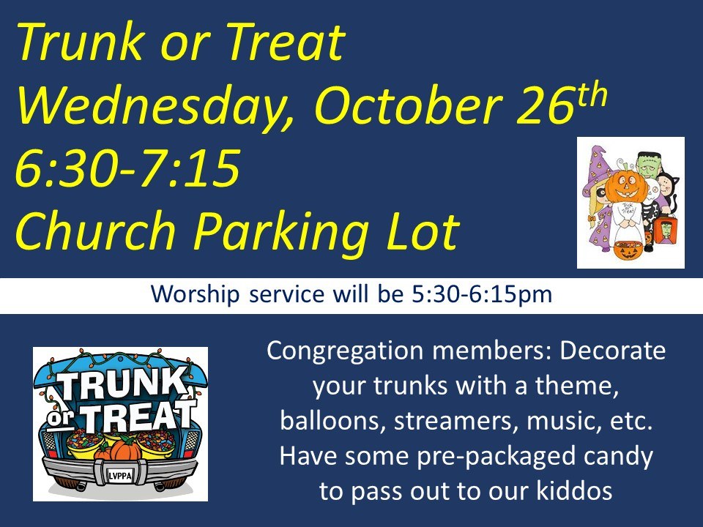

Parish Care & Outreach
“For even the Son of Man came not to be served but to serve others and to give his life as a ransom for many.” – Matthew 20:28
- In September, Marilyn Elwood and a group of volunteers made salsa and marinara sauce with vegetables harvested from the church's community garden plot. We appreciate those who were willing to share their gardening and canning gifts!!
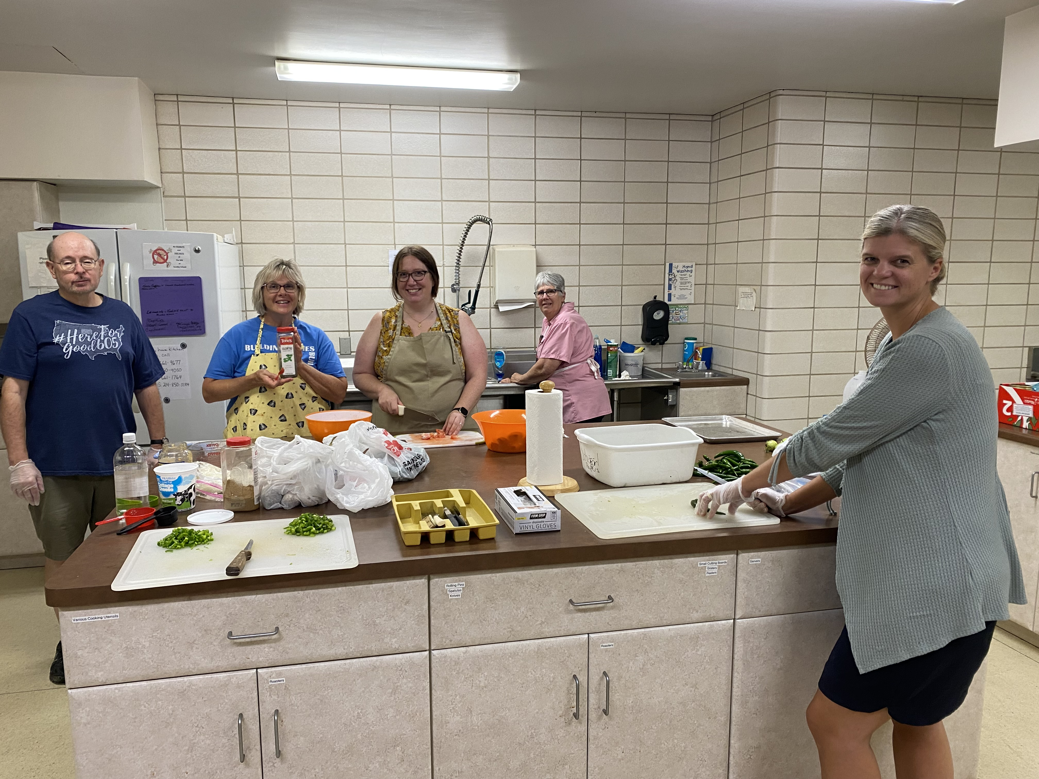
- 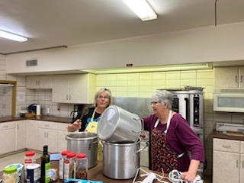The Parish Care & Outreach Team sent cards of encouragement signed by members of the congregation to students that are away at college. We included gift cards to Scooters and Jimmy Johns!!
- FUMC sponsored Loads of Love on August 30th and September 20th. These were the busiest Tuesdays of sponsoring Loads of Love since we started in January. On August 30th, we spent $170.75 to wash and dry laundry for 18 people and on September 20th, we spent $297.25 to wash and dry 23 people's laundry!! This ministry has grown and grown this year and we are thankful for the opportunity to show God's love to people in our community. What we've experienced is that some who come are our "regulars" and know that they can rely on this ministry being available to them each week on Tuesdays. We can relieve some of their financial burden. There are also others who come and don't know about Loads of Love and have been equally grateful for the unexpected act of kindness. As the needs of this ministry increase, please consider giving financially and volunteering on the weeks that FUMC sponsors. We will sponsor again on November 15th and November 29th. There is a sign-up sheet for volunteers and a donation box on the missions and outreach table in the downstairs lobby.

SOCKtober for Loads of Love
During the month of October, Parish Care and Outreach will be collecting donations of NEW socks to be donated to those we serve at Loads of Love. There will be a donation tub on the table in the lobby beginning on October 1st until the end of the month. ALL kinds of socks (men's, women's, children's) will be accepted.

Wednesday Evening Worship & Activities
4:45-5:15pm - Kingdom Chimes (1st-5th grade)
5:00-6:00pm - Supper
5:30-6:10pm - Jubilee Bells (Adults)
5:30-6:10pm - Children's 605 (PreS-5th grade)
6:15-7:00pm - Worship Service
Immediately Following Worship - Confirmation
Immediately Following Worship - Agape Bells (6th grade - adult)
Immediately Following Worship - Chancel Choir
Immediately Following Worship - HS Youth Group

Youth Update
Youth Group meets Wednesdays from 7:00-8:30. There is something for all Middle School and High School students to be involved in.

Important upcoming dates:
Sunday, October 2nd from 2-4pm - Middle School gathering at Mazing Acres Pumpkin Patch. All Middle School kids are welcome.
Wednesday, October 12th - Early Bird Registration for DakYouth 2022 in Aberdeen (Nov 11th-13th).
Tuesday, October 18th at 6:30 - All youth kids will help at the Soup kitchen. We are helping to clean up.
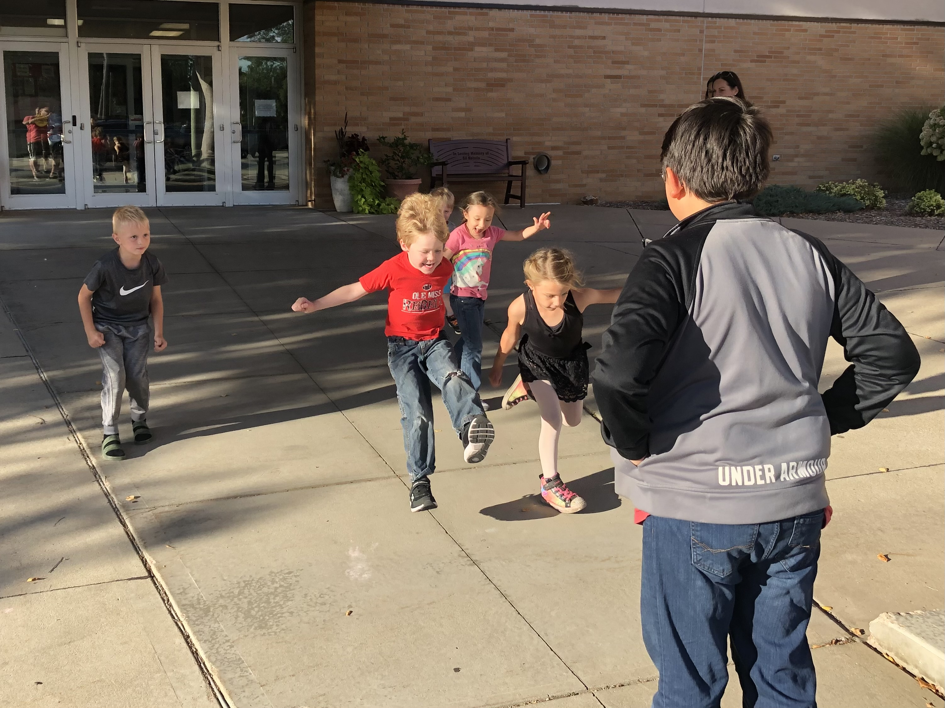Wednesday, October 26th - Trunk-Or-Treat. Youth will decorate vehicles and pass out candy. Church is 5:30-6:15, Trunk-Or-Treat 6:30-7:15.

Text the number 81010 with the message @1fumcyouth to receive information and announcements for our youth.

Children's Update
605 meets Wednesdays from 5:30-6:10. There is something for all PreSchool-5th graders.

Important upcoming dates:
Wednesday, October 26th - Trunk-Or-Treat. Church is 5:30-6:15, Trunk-Or-Treat 6:30-7:15.

Text the number 81010 with the message @1stumckid to receive information and announcements for our children.

Prayer Chain
If you would like to stay up to date with the prayer concerns for the church, you can be added to the email prayer chain list by contacting Lisa in the church office.

Kids & Youth Happenings
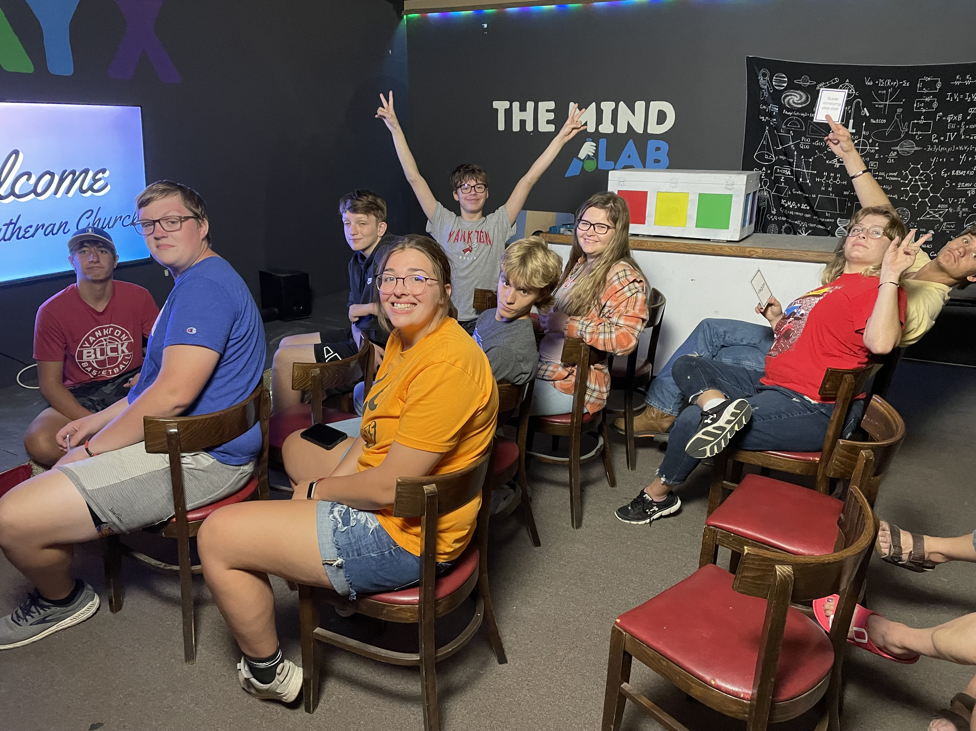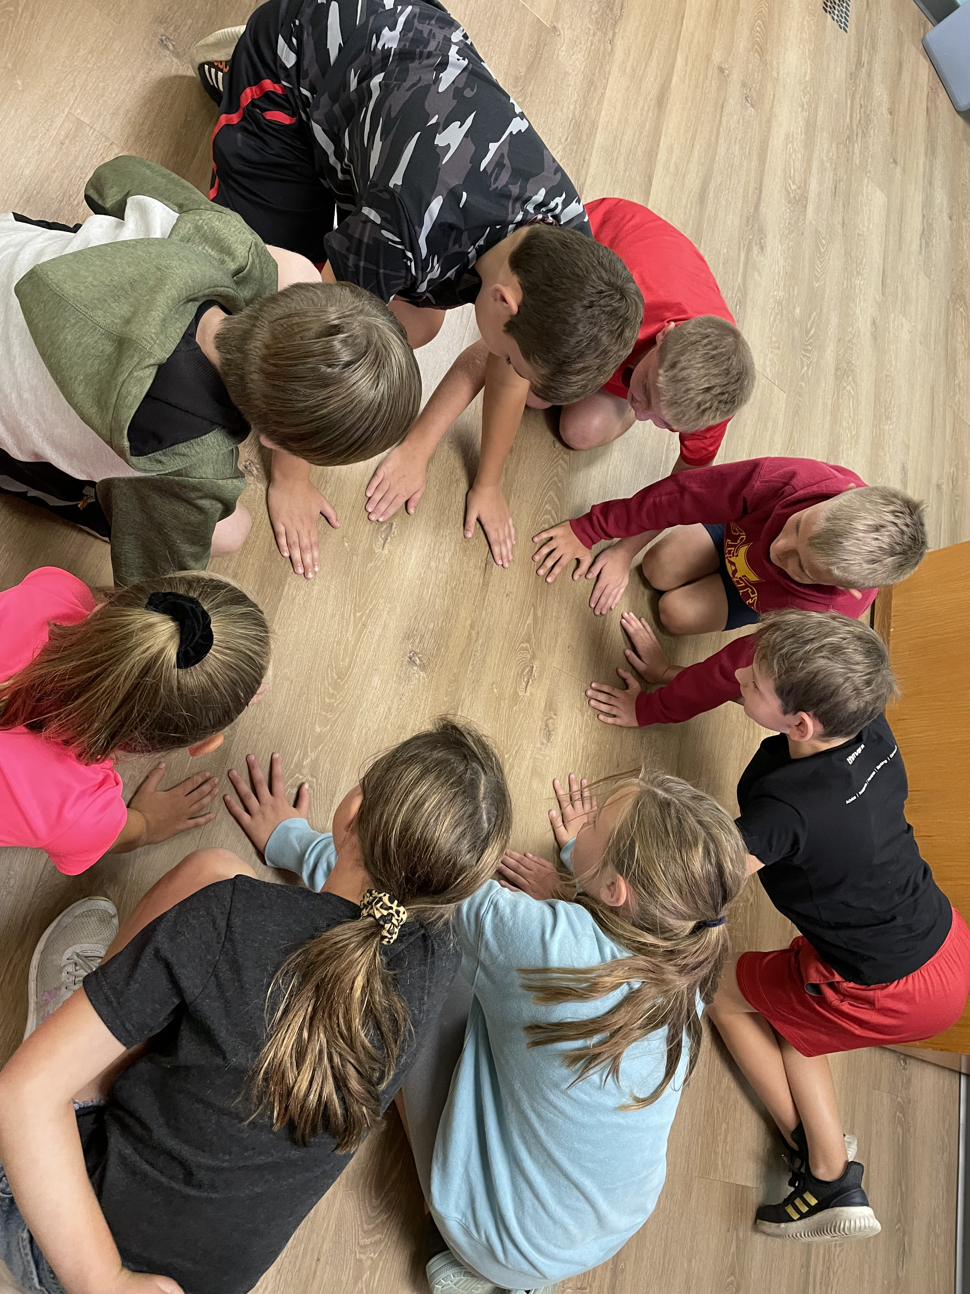

Technology Volunteers
We are still looking for people to be part of our technology team. This would entail helping to run the computer for our Worship services on Sunday mornings and Wednesday evenings.
Tiffany will train and help in any way that she can. Contact Tiffany at 1stumckidsyankton@gmail.com or stop in the office.

Living in the Moment
By Susan Thorson, Faith Community Nurse
During my time as a nurse, I have journeyed with many individuals and families who have experienced catastrophic illness, long term chronic diseases, sudden deaths, and those who are in the dying stages of their lives. Each situation is unique depending on the person and the dynamics of the family situation. Here are some thoughts of my own as I look back at some of my own caregiving experiences in my family. It may look similar to your experience and hopefully you will see what I have learned. “There were times when it seemed like one more procedure and some type of calamity after another. We just wanted to get back to a sense of normalcy, but it looked like a future full of possible disappointments and setbacks. The future didn’t seem to look very promising and that is what we focused on each day.
Many people just live out their lives in this crisis and we were on that road. Others seem to see the “light” and start being better at living, planning, and moving to a day-to-day basis. So as a family, we made a decision to quit living in the “dark” and instead try to live in the moment and then enjoy a series of moments making up our days and weeks. Because our loved one had a catastrophic illness didn’t mean we or they could not go on living each day. We just stopped thinking about the future and started living each day. We began focusing on each moment and each day enjoying life instead of looking at the end. Everything that happens doesn’t mean impending doom and worrying about the worst-case scenario doesn’t have to be the norm. By thinking this way, it just robs us of living in the moment and the beauty of our lives in the present.”
When I was with my mother even in the last hours of her life, we lived each moment. We talked, we comforted each other, we prayed, we laughed some and we cried some. She knew and I knew her time was limited on this earth and the time had come to receive peace from the Lord. We held hands until the last moment feeling the warmth of each other's love, not wasting a moment of our time together. No matter what the situation is, we never know what minutes we have left, so try not to waste those precious minutes. When we look back, it's those moments we cherish–the last grip of a hand, the gentle smile on the face, a soft voice saying, “love you,” the warmth of a soft hand, and just being with each other. Peace be with you, live in the moment, and enjoy those precious moments of life

In Our Thoughts & Prayers
Prayer for Gwynn Stiles family. Gwynn passed away.

Charles Kowis to the prayer list for open heart surgery.

Prayer for Dorothy Johnson’s family. Dorothy passed away.

Prayers for Marlene Konopik and daughter Sarah

For all those struggling with mental health issues

Prayers for Bob Thue’s friend Monte. He was in a serious motorcycle accident.

Prayers for the family of Maxine Rogers. Maxine passed away.

Prayers for Caitlin Jensen

Prayers for Loren & Delores Moore’s step granddaughter’s baby

Prayers for Joyce

Carolyn Teichrow for healing.

Prayers for Ukraine

October Birthdays
2 - Jane Rodig, Lawrence Sweet,
Megan McCorkell

3 - Paula Keehr, Raelene Broz

5 - Bob Thue, Kenzie Giziewski

8 - Don Lepp, Sherry Rabenberg

9 - Garner Brandt, Chuck Ditmar

12 - Marilyn Holzwarth, Mary Heubaum,
Heather Hirsch, Trevan Palecek

15 - Judy Bevers, Bill Fargo

16 - Terry Norton

17 - Claudia Maska, Naomi Somer,
Mike Erickson, Jack Olson

18 - Elle Guthmiller

19 - Heather Rabenberg, Amanda Gravholt

20 - Chad Herrmann, Kaitlin Guthmiller,
Ryan Bakke

21 - Dave Becker

22 - Samuel Slowey, Loran Moore, Eve Gall
Abbi Olson

23 - Marv Withrow

26 - Brooks Ugofsky, Austin Nickles

27 - Evie Sime

29 - Alyssa Herrmann,

31 - Kathy Wibbles, Morgan Bakke

FUMC Financials
by Diane Kisch (Financial Assistant)
FUMC Financials by Diane Kisch (Financial Assistant)
2022 Income | Cash Flow
Month | Income | Expenses | Amount
January | $64,058.98 | $35,827.92 | $28,231.06
February | $50,015.62 | $33,689.58 | $16,326.04
March | $25,607.04 | $40,707.57 | ($15,100.53)
April | $29,877.51 | $32,121.62 | ($2,244.11)
May | $34,489.40 | $33,435.48 | $1,053.92
June | $29,069.85 | $39,389.98 | ($10,320.13)
July | $32,022.83 | $34,451.60 | ($2,428.77)
August | $26,504.62 | $43,813.91 | ($17,309.29)
Totals | $291,645.85 | $293,437.66 | ($1,791.81)
Projected 2022 Expenses are $477,337.00.00
* Income for January is generally higher than other months as we have some members that give their annual pledge in one month.

