Mission Statement
First United Methodist Church of Yankton:

“To grow disciples of Jesus Christ and equip them for ministry in the world.”

From the Pastor’s Desk
Rejoice in the Lord always. I will say it again: Rejoice! - Philippians 4:4
This summer we have been journeying through the story of Moses leading the Israelites out of Egypt and into the promised land. In Moses’ journey we saw that things don’t always go according to plan, that change can be hard and that we will go through challenging days. We know this to be true in the church as well - there are challenging days and times when things do not go according to plan. However, just as we saw with Israel, God is with us on the journey! And God is doing great things in and through us! As we look to this next month, I am excited about the possibilities and opportunities that God has given us to be the church.
I am excited for Vacation Bible School and our children having that incredible experience once again. Tiffany and her children’s education team have done a wonderful job every year of making that an experience you don’t want to miss! I am excited for the return of XYZ (Extra Years of Zest) this month and the much-needed fellowship that will provide. I am excited about the coffee fellowship in the lounge that has begun after worship thanks to the work of Dave Cornemann. I am excited for the “Mom’s Night Out” fellowship and worship opportunity for the moms of our First Kids and First Youth. I am excited for the new Wednesday Night worship service starting at the end of this month and the ways we are expanding 605 to meet the needs of the whole family. I am excited about the success of our Loads of Love Ministry in conjunction with Trinity Lutheran Church and the UCC church. I am excited as we see produce coming in from our garden plots!
There is a lot going on in the life of the church and it causes me to praise the Lord. It causes me to rejoice in God’s goodness and faithfulness. I hope you are rejoicing in the work the Lord is doing in and through our church. I also hope that you are finding ways to be an active part of this ministry.
If you haven’t already, sign up for our Remind text or emails so you are getting up to date information. We also send out a Friday worship email including the bulletin information and announcements. And finally, don’t forget to check out Pastor Katie’s weekly Podcast “What’s Going On” released every Wednesday on our YouTube channel. We don’t want you to miss out on what God is up to here at First UMC Yankton!
Blessings!

Pastor Katie

XYZ is Back!
XYZ (Extra Years of Zest) is coming back in August! Join Pastor Katie the first Wednesday of the month at 10am for a time of coffee, fellowship and games! This is a ministry aimed at those who are later in life looking for some extra community and fun. Looking forward to seeing you on August 3rd!

Kids Mission Offering
Starting in August we will be taking a “kids mission offering” during our worship services. Anyone is invited to donate to this offering by bring change or bills up to the metal buckets during the service. During the year the children of the church will determine what mission or missions that offering will benefit. It is our hope that through this offering opportunity we can help teach our children and youth about the joy of giving and how what we give can be used to glorify God!

Bridge Walk on August 7th
Following the ONE SERVICE in the church at 9am on August 7th we will be heading down to Meridian Bridge to walk across the bridge. This will conclude our summer series “Let Go: Leaning into the Future without Fear” to symbolize our leaving a wilderness period and heading into God’s blessings in the promised land. We may not be crossing the Jordan river, but we can cross the Missouri into God’s abundant future!

Mom’s Night Out
First UMC is hosting a Mom’s Night Out for the mothers of our children in First Kids and First Youth. We all know how difficult, time-consuming and draining it can be to try to balance motherhood with careers, with activities and with spiritual development. We want to give you a night with a nice meal, some pampering and some worship to fill your soul and start this school year off right. We will also be sharing the ways we have been working as the church to meet you where you are! August 10th - RSVP to Tiffany Beste if you haven’t already!

Back to School Backpack Blessing
On Sunday August 21st we will be having our Back-to-School Backpack Blessing. We invite all students to bring their backpacks to worship that day. We also invite teachers, staff and administration that work with the schools to also bring in a bag. We will bless the bags and more importantly the people who have them to have a great school year!

Worship Changes Starting August 24th!
We will be offering a Wednesday night worship service beginning August 24th at 6:15pm. This is being offered in conjunction with our 605 programming including children’s ministry, confirmation, youth ministry and some of our music ministry as well. Our goal is for the whole family to attend church on Wednesday nights, eat a meal together, have fellowship and discipleship and worship!
Beginning August 28th, we will be having one service on Sundays at 10am with coffee and snacks in the lounge to follow.

Confirmation Changes!
Confirmation letters will be going out in the month of August to our 7th and 8th grade students. This year we will be starting our 2-year confirmation program, which will be explained in the letter. If you’d like your student to be a part of confirmation this year - please contact Pastor Katie or Diane Kisch.

Leadership Team
The Leadership Team will meet on Monday, August 22nd to conduct the business of the church. If you would like the leadership team to address any topic, please let Pastor Katie or Leadership Team Chair Steve Pietila prior to that date. They will also continue working through the book Normalizing Next by Olu Brown in an effort to continue moving forward as a church into God’s future.

Interested in Joining First UMC Yankton?
Pastor Katie is planning to hold a new members’ class in September. Please contact her if you are interested in joining the church or just learning more about who we are and what we believe! More information will be available in next month’s newsletter.

Fifth Sunday Bucket, July 31st
Bucket Sundays are held whenever we have 5 Sundays in one month. This month’s offering will go to the Contact Center – Backpack project. Drop your loose change (bills accepted also) in the bucket.

Coffee Fellowship
There will be coffee fellowship in between services (10-10:30am) in the Church Lounge. This is a time for us to sit down, have a cup of coffee and a treat, and visit with our guests and friends.

Join Worship Team
If you have ever had that tug on your heart to be a part of worship team, this is a great time to get involved!! We are having rehearsals in August for the upcoming months of September through November! Please pray about joining worship team either as part of every week worship or plugging into special music! Call or text Sara at 605-254-7070. Ask me anything!! All ages encouraged!!

Women’s Social Lunch
Come and enjoy lunch Monday, August 1st at Noon at the Fryn Pan. This social luncheon is for any and all women of First United Methodist Church member or not. A chance to get to know each other better and enjoy a fun lunch with our sisters in Christ. (No program-just social time) Lunch is Dutch treat. If you have questions, please call Vivian Van Essen 655-4893

Kids Corner
It's hard to believe but August is upon us and that means lots of things will start to gear up for our children and youth here at FUMC.
Please contact Tiffany if you are available to help with any of the following Children's and youth activities. 1stumckidsyankton@gmail.com or (606) 695-0178

VBS 2022 - God's Wonder Lab is being held:
Friday, August 12th from 5:30-8:30pm
Saturday, August 13th from 8:30-11:30 pm
and kids will sing Sunday morning at our 9:00 service.
Meals will be served on Friday and Saturday. If you have not done so already, please register your kiddos at:
https://forms.gle/2GLVzxhpvvoEQtGd9


Food Donations for VBS are being collected at church. Please stop in to see what you might be able to donate. Thanks!!

605/Children's Church
Our Wednesday evening and Sunday morning Children's opportunities will start up on Wednesday, August 24th.
605 (PreSchool-5th grade) will be held on Wednesday evenings from 5:30-6:10 with supper being served at 5:00.
We will have some sort of children's activity/opportunity during our 10:00 service on Sunday mornings (PreSchool-3rd grade)

If you would be interested or are able to help with VBS, 605 on Wednesday evenings or Children's activities on Sunday mornings, please contact Tiffany at 1stumckidsyankton@gmail.com or (605) 695-0178.

Youth Group
Youth group (6th -12th grade) will start meeting regularly on Wednesday evenings starting Wednesday, August 24th from 7:30-8:30.
Please contact Tiffany if you would be willing to help out once a month with our youth group.

Technology Volunteers
Please call the office or contact Tiffany if you might be interested in joining our rotation of volunteers to run the computer for our Wednesday evening Service and our Sunday morning service.

Upcoming Events for Children and Youth
Tuesday, August 9th: Youth Gathering (6th-12th Grades)

VBS: God’s Wonder Lab (PreSchool-5th Grade)

August 12th - 5:30-8:30pm

August 13th - 8:30-11:30am

August 14th - Sing at 9:00 service

Sunday, August 21st: Blessing of the Backpacks

Wednesday, August 24th: Evening Schedule
5:00-6:00 Supper (Everyone is welcome)

5:30-6:10 605 (PreSchool-5th Grade)

6:15 Wednesday Evening Service

7:30-8:30 Youth Group (6th-12th Grade)

Ways to Stay Connect
To Sign up for Remind messages:
Text the number 81010 and the message:

@1stumckid - for First Kids Remind messages
@1fumcyouth - for Youth Group Remind messages
@yanktonumc - for FUMC Remind messages
If you’d like to receive the Friday email with announcements and bulletin, contact Lisa in the church office.

Parish Care and Outreach
“For we are His workmanship, created in Christ Jesus for good works, which God prepared beforehand so that we would walk in them.” Ephesians 2:10
- FUMC donated $500 to the Boys & Girls Club Yankton with our May 29th Bucket Sunday offering.
- Our Miracle Offering for the Annual Conference totaled $2,097.00
- A donation of $551.00 was made with our Peace with Justice special offering in June.
- FUMC sponsored Loads of Love on 05/17, 05/31 and 07/19. On those days, we paid for 47 loads of laundry!! Thanks to volunteers: Alex Swihart, Merle & Gena Brandt, Mary Alice Halverson, Barb Hirsch, Heather Hirsch, Amber Reaney, and Marilyn Elwood. The next date to volunteer is Tuesday, August 30th. The signup sheet is in the lobby.
- Our plots at the Community Garden are beginning to produce! MANY hands have been a part of planting, weeding, and watering. THANK YOU everyone!! Please check the signup sheet in the lobby for when volunteers are needed. More information will be available as we begin to harvest.

KIDS HOPE IS BACK!!
Kids Hope USA is a national mentoring program that FUMC has been a part of since 2008. Churches across the country partner with a local elementary school and members of their congregation’s volunteer to mentor a child at their partner elementary school for one hour each week. Our Kids Hope partnership with Beadle Elementary was put on hold two years ago due to the pandemic, but this fall mentors will begin meeting with students again and we are looking forward to THE BEST YEAR EVER!!!
If you are interested in being a Kids Hope USA mentor or would like more information, please email 1stumckidshopeyankton@gmail.com or contact the church office. There is also a signup sheet on the mission and outreach opportunities table in the lobby.
ONE CHURCH ONE SCHOOL ONE CHILD ONE HOUR

Kids at Camp

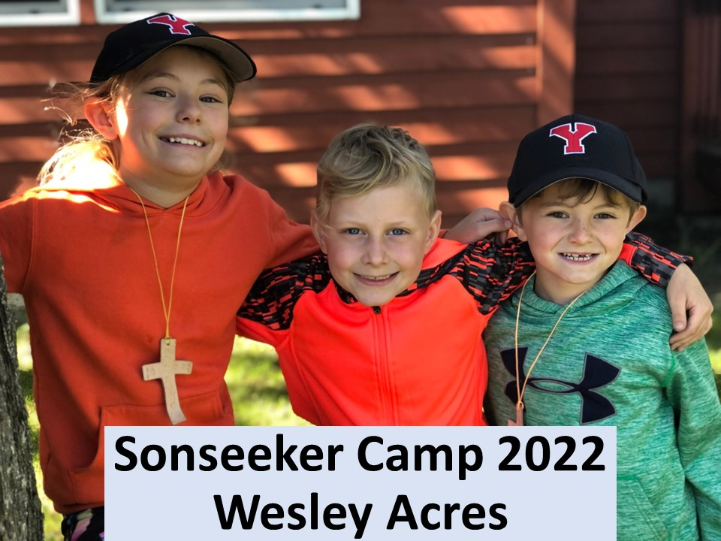

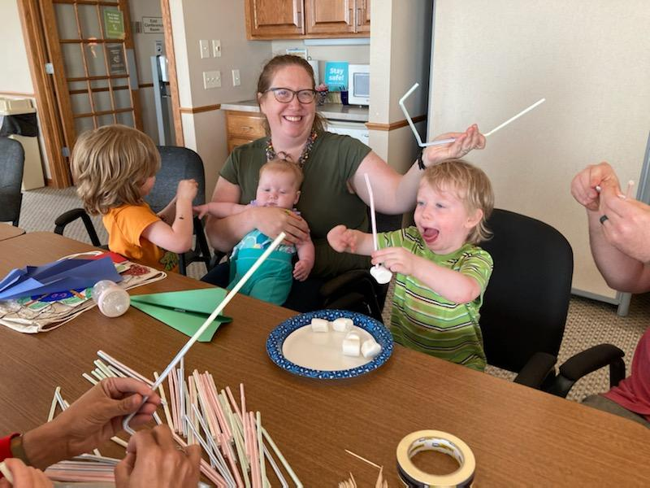

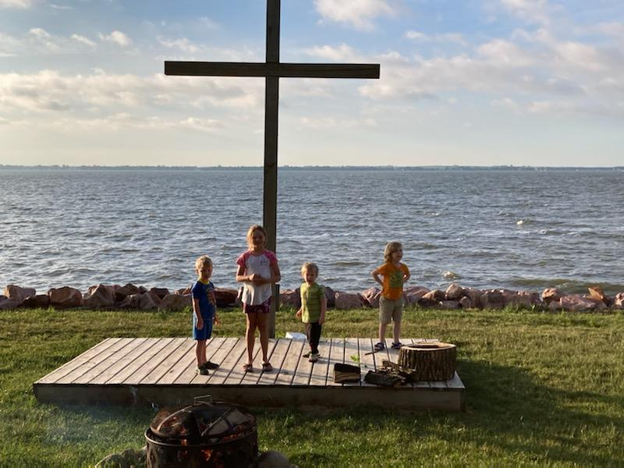

God Moments


Liza Larson and son Andrew at Redwoods in CA.

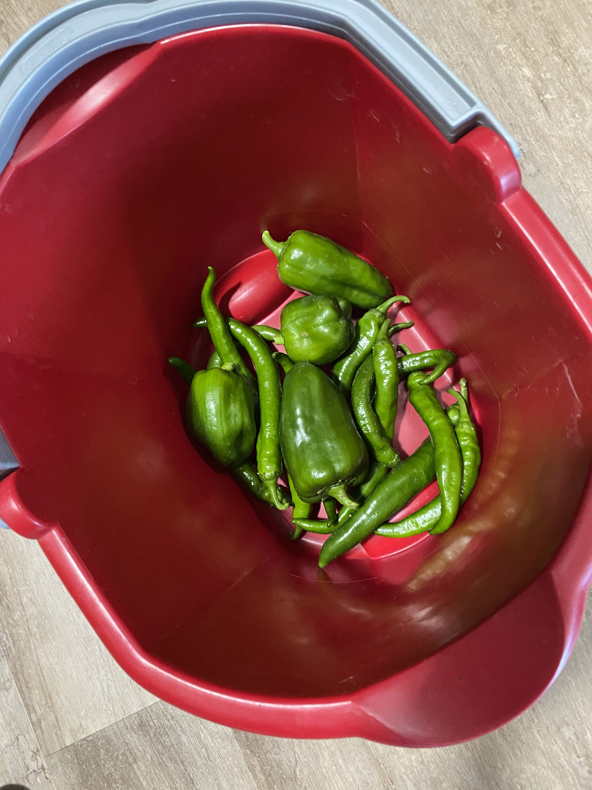
From FUMC
community Garden

Linda Fox’s new great grandchild, Malachite Theo
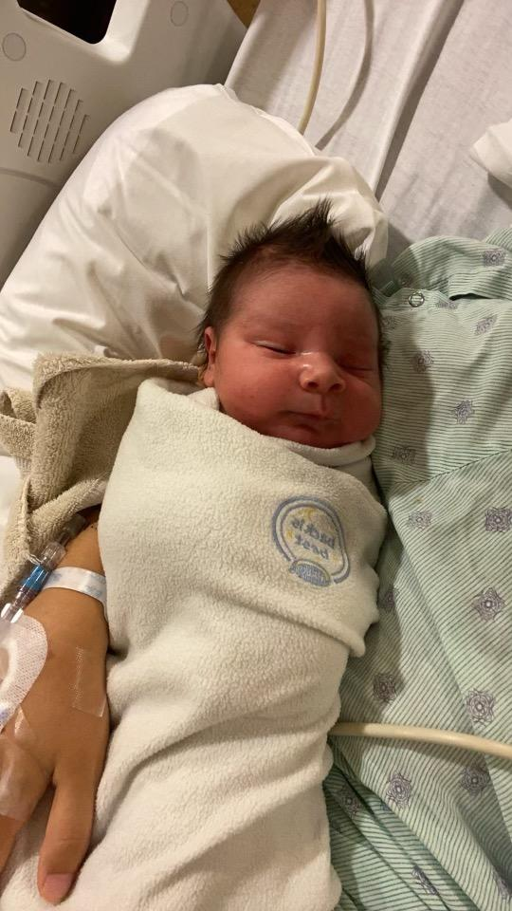

Bibles and Brews Bible Study
Starting Tuesday, September 13th. Contact Carla Hummel at 660-7390 for more information.

Remember Sunday
By Susan Thorson, Faith Community Nurse
As I begin to write early this morning, I am thinking about what Sunday was like for me when I was growing up. Sunday was a day of rest for our family except during harvest time when everyone did their part to harvest the crops. We all had jobs with getting the equipment ready, driving the combines or the trucks, preparing the meals for the harvesters and making sure everyone was safe. Other Sundays were quiet on the farm. Our mother often fixed a special breakfast. We would put on our best clothes to go to church and make sure everyone had some money to place in the offering. As we took off to church driving to town, the usual hustle-bustle of the town was quieter. Most stores were closed, and we noticed there were many cars parked around the various churches in town. Being in church together at worship service was a center part of our life. After the service we shared time with our own family but also with other families. We ate special meals together, played together, and visited with family friends. We spent the day just relaxing and being with each other. There was a rhythm to our life.
We worked hard but there was always a day of rest on Sunday. It seemed to gather us as a family and provide a time to catch up after a busy week. It was a time we looked forward to as a family. Individually, it was a time to get spiritually nourished at church and Sunday school. It was also a time to see others that perhaps we had not seen during the week. The fellowship of being together and supporting one another was great. Our world has changed due to many social forces. There is a push to produce, maintain and enhance our lives more than ever. We seem to be accumulating more and more and are driven to do more in our jobs, in helping others and even in our leisure activities. We are sometimes overwhelmed with our responsibilities but also with what we think society expects of us.
My questions during these present-day times are: When do you just stop to smell the flowers? When do you stop to renew your body, mind and spirit? When is your day of “rest” or your “sabbath” time? What have you done to model and teach your family about a day of rest to renew your body, mind and spirit? Are you present to life as a gift from God? Take time to ponder these questions and also to think about your past, present and future. Be open to caring for yourself and your family by giving all some “sabbath” time. You will be renewed if you just take the time to worship and rest. Psalm 31:15 “My times are in your hands.” See you in church on Sunday!

God Moments
We would LOVE for you to share your God Moments with us!! All of us take pictures of the things that bring us joy and happiness every day. And each of these moments is provided to you by God. We would love for you to share those pictures with us, so we can share them with the church on Sunday mornings and also on a display we have in mind for here at church. Please text your pictures to (605) 695-0178 or email them to 1stumckidsyankton@gmail.com.

2022 KYNT Broadcast Sponsors Needed
On Sunday morning the service is recorded and then edited to 30 minutes. The following Sunday it is broadcast on KYNT 1450AM from 8:30 – 9:00am. We do this so that our members or others who for some reason cannot attend services, can still listen to God’s message. Each Sunday we need someone to sponsor this broadcast. The cost is $45.00. Please consider sponsoring a broadcast. Call Lisa in the office 665-2991 or email
1stumcyankton@gmail.com

In Our Thoughts & Prayers

Jean Droppers son-in-law Ken Buysman. He’s having a lot of health issues.

May Gall

Margie Stengle is at Sr. James Rm 111

Carolyn Teichrow for healing

Prayers for Ukraine

Church family serving in the military: all men & women serving in the military and their families.

August Birthdays
2 - Mikael Pietila, Ben Ricke

3 - Jill Sage

5 - Miya Noecker

6 - Huck Flannery

7 - Ruth Gravholt, Mary Alice Halverson,
Dennis James

9 - Wanda Branson, Collins Den Herder

10 - Mary Johnson, Burklynn Novak

11 - Dan Johnson, Chris Hathaway

12 - Tyler Irwin

14 - Peggy Doering, Gary Johnson,
Joel Karnes

16 - Liza Larson, Melania Enfield

17 - Misty Davis

18 - Hannah Irwin

19 - Treyton Bakke

20 - Laura Slowey, Kayln Peterka, Margret
Stewart

21 - LaVila Tessier, Derek Moderegger

22 - Jody Brady

23 - Susan Thorson

24 - Andrew Tramp, Cole Sawatzke, Rose Nedved

25 - Dalton Crisman

26 - Luann Saunders, Dan Slowey

27 - Sue Frick

28 - Brett Sime, Rob Taylor

29 - Rhonda Arens, Gwynn Stiles, James Micah

30 - Miranda Crisman

FUMC Financials by Diane Kisch (Financial Assistant)
2022 Income | Cash Flow
Month | Income | Expenses | Amount
Jan | $64,058.98 | $35,827.92 | $28,231.06
Feb | $50,015.62 | $33,689.58 | $16,326.04
Mar | $25,607.04 | $40,707.57 | ($15,100.53)
Apr | $29,877.51 | $32,121.62 | ($2,244.11)
May | $34,489.40 | $33,435.48 | $1,053.92
Jun | $29,069.85 | $39,389.98 | ($10,320.13)
Totals | $233,118.40 | $215,172.15 | $17,946.25
Projected 2022 Expenses are $477,337.00.00
* Income for January is generally higher than other months as we have some members that give their annual pledge in one month.

Update from the Leadership Team to the Congregation

We are now six months into our new governance structure at the church, which created a Leadership Team of thirteen members along with Pastor Katie. The intention of the new structure was to streamline the administration of church business and allow our staff and membership to dedicate more time to our missions and worship activities. Follows is a brief overview of the new structure.

The Leadership Team consists of three sub-teams of three persons each. The Trustees oversee buildings and grounds. The Finance team monitors the budget and monthly cash flows. Meanwhile, the Staff Pastor Parish Relations Committee provides oversight of church personnel matters. I have asked each sub-team chairperson to provide an update to the congregation over the next few months, so keep an eye out for those reports.

These nine members along with a lay leader and a delegate to annual conference have voting authority on administrative matters. The team also has two non-voting members with voice but no vote. The church’s Financial Secretary prepares monthly reports and manages the outlays as directed by the Finance Team. The leadership advocate serves as a liaison between membership and the Leadership Team.

I have witnessed the success of the new governance working efficiently to handle administrative affairs, such as upgrades to the audio-visual system and security systems, along with quick response to staffing issues, facility repairs, and financial matters. All Leadership Team members are doing a study session around the book Normalizing Next. The book is to help us recognize the current challenges the church faces, along with helping us strategize about the future of our congregation.

Administratively the Leadership Team is functioning exceptionally well. The next step is to engage our membership in worship and missions. We are blessed with a lot of talented and high energy members, and we want to enable all of you to do what you do best. Let any Leadership Team members or staff know of your ideas for missions work or improvements to our worship service. We are here to fulfill the mission of our church, which is “to grow disciples of Jesus Christ and equip them for ministry in the world”. We are here to help!
Lastly, I encourage all of you to watch Pastor Katie’s YouTube videos titled What’s Going On. I find this to be the best method to stay updated on activities at the church along with updates from annual conference. The video update on 6.29.22 from the delegates to annual conference was very compelling.
Sincerely,

Steve Pietila
Chairperson

Trustees:
Scott Giziewski
Merle Brandt
Dan Swihart

Finance Team:
Steve Pietila
Marc Mooney
Dave Cornemann

SPPRT:
Chad Herrmann
Susan Schavee
Amber Reaney

Lay Leader:
Dan Johnson

Delegate to Annual Conference:
Bob Thue

Leadership Advocate:
Rhonda Arens (voice no vote)

Financial Secretary:
Diane Kisch (voice no vote)

Senior Pastor:
Katie Ricke (voice, vote in case of a tie)

